Agricultural crop maps

Dutch Environmental Indicator for Pesticides (NMI 3)

Based on land-use map LGN6 and crop statistics (CBS, 2008)

Map type 1 with equal area per legend class

Contents

|  |  |
| --- | --- |
| Arable farming | |
|  | Winter wheat |
|  | Sugar beets |
|  | Ware potatoes |
|  | Starch potatoes |
|  | Seed potatoes |
|  | Spring barley |
|  | Grass (seed) |
|  | Onions |
|  | Peas |
|  | Onions (bulbs) |
|  | Chicory |
|  | Haricot beans |
|  | Field beans |
|  | Summer wheat |
|  | Rape seed |
|  | Flax |
| Flowerbulb cultivation | |
|  | Tulips |
|  | Lilies |
|  | Daffodils |
|  | Gladiolas |
|  | Hyacinths |
|  | Irissen |
| Glasshouse floristry | |
|  | Roses (glasshouse) |
|  | Chrysanthemum |
|  | Pot plants (flowers) |
|  | Pot plants (green) |
|  | Bed plants |
|  | Freesias |
|  | Lilies (greenhouse ) |
|  | Gerberas |
|  | Orchids |
|  | Carnation |
|  | Alstroemeria |
| Tree cultivation | |
|  | Tree nursery |
|  | Floriculture |
|  | Shrubberies |
|  | Conifers |
|  | Fruit trees |
|  | Perennial plants |
|  | Roses |
| Fruit cultivation | |
|  | Apple trees |
|  | Pear trees |
| Greenhouse vegetables | |
|  | Tomatoes |
|  | Sweet pepper |
|  | Cucumbers |
|  | strawberries (greenhouse) |
|  | Radish |
| Open air vegetables | |
|  | Green beans |
|  | Carrots (winter) |
|  | Brussels sprouts |
|  | Industrial chicory roots |
|  | Leeks |
|  | Cabbage |
|  | Carrots |
|  | Asparagus |
|  | Strawberries |
|  | Salsify |
|  | Cauliflower |
|  | broccoli |
| Cattle farming | |
|  | Grass |
|  | Fodder maize |

Arable farming

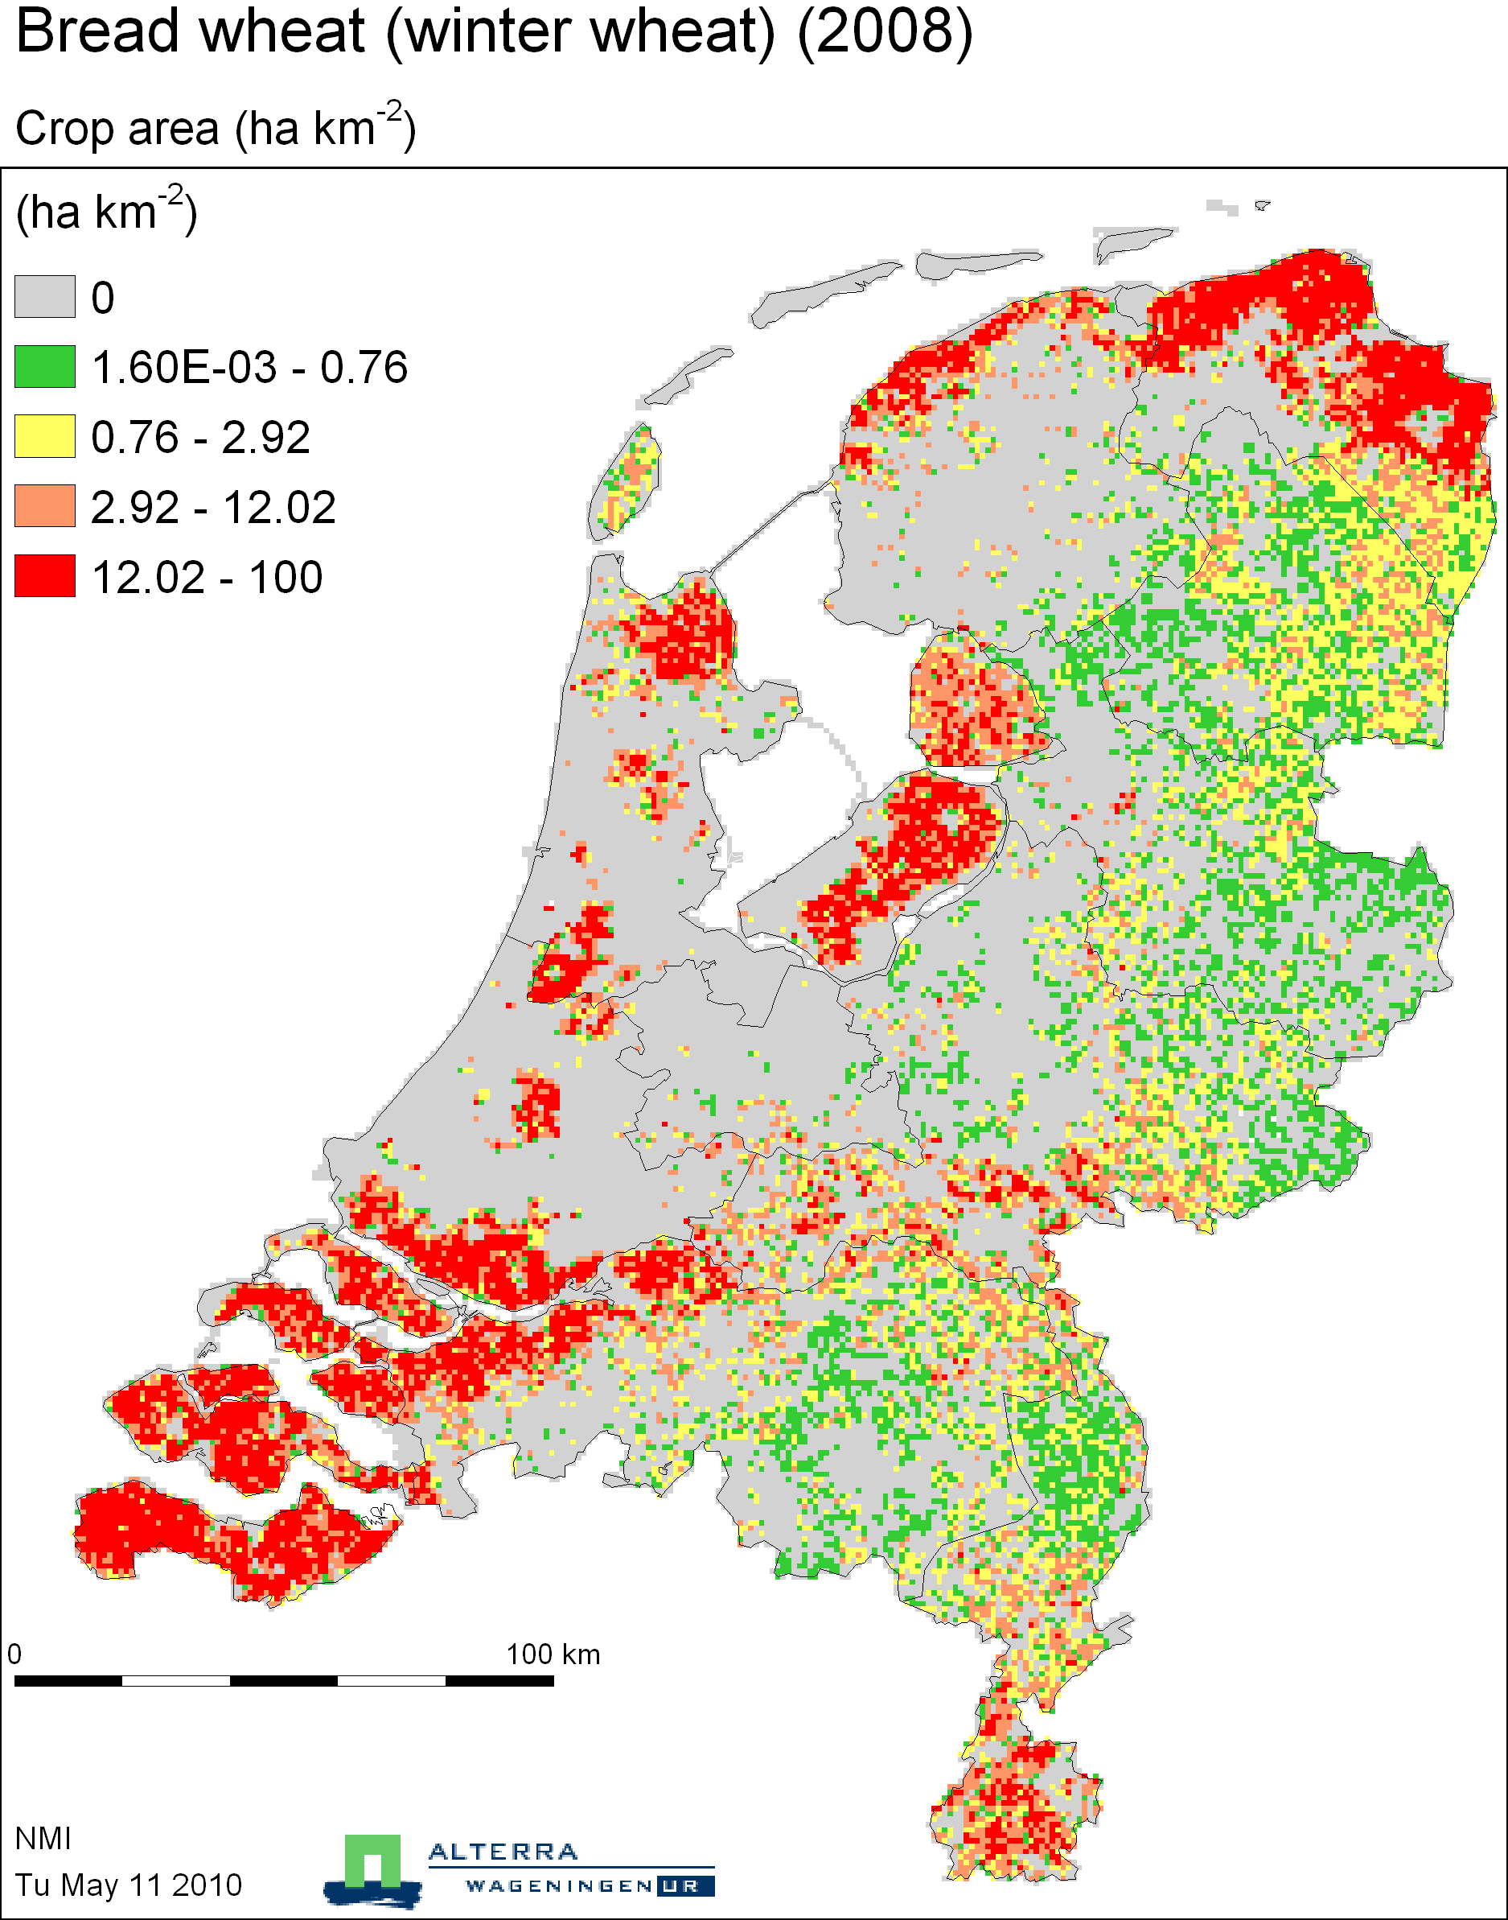

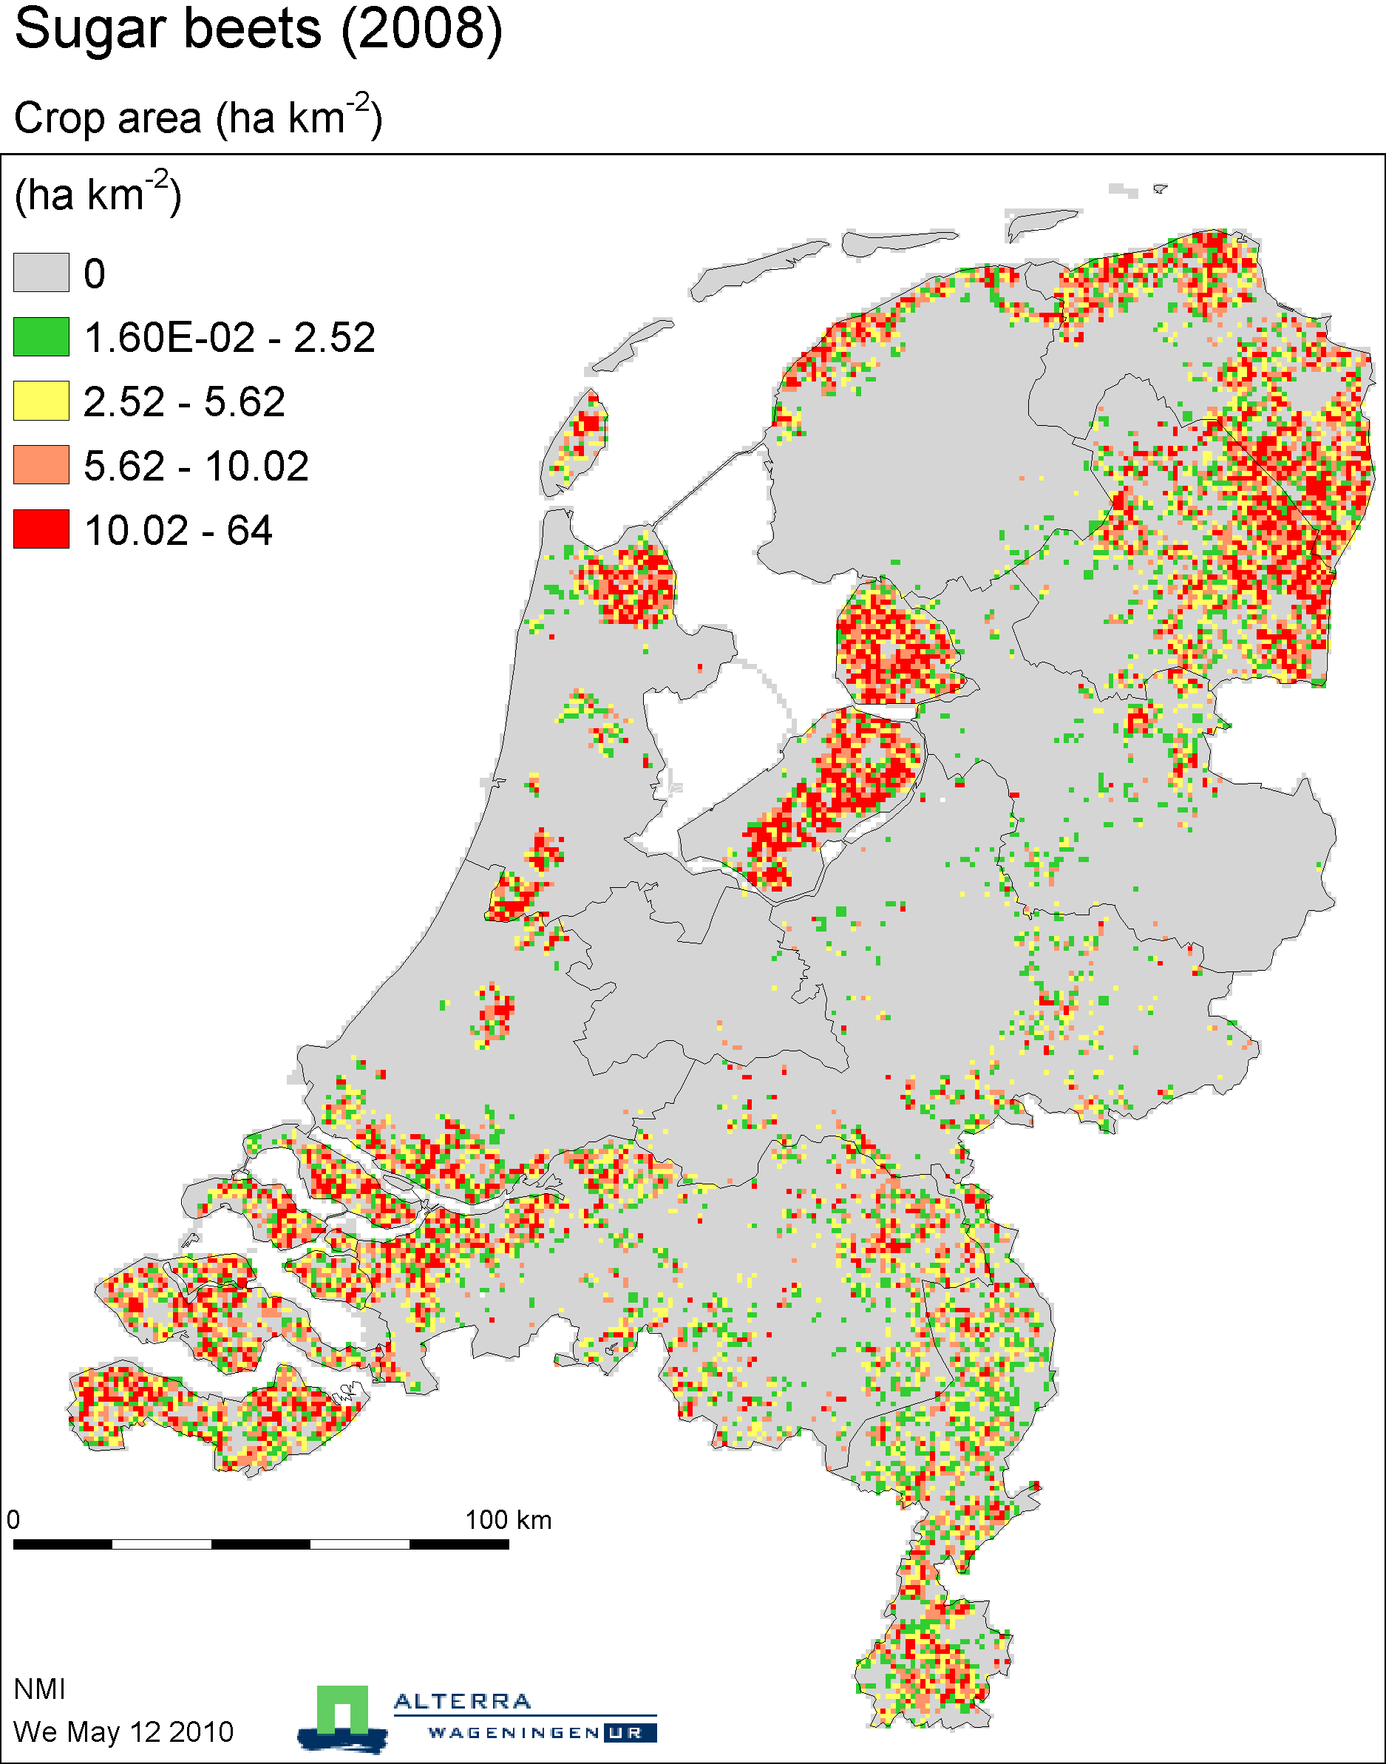

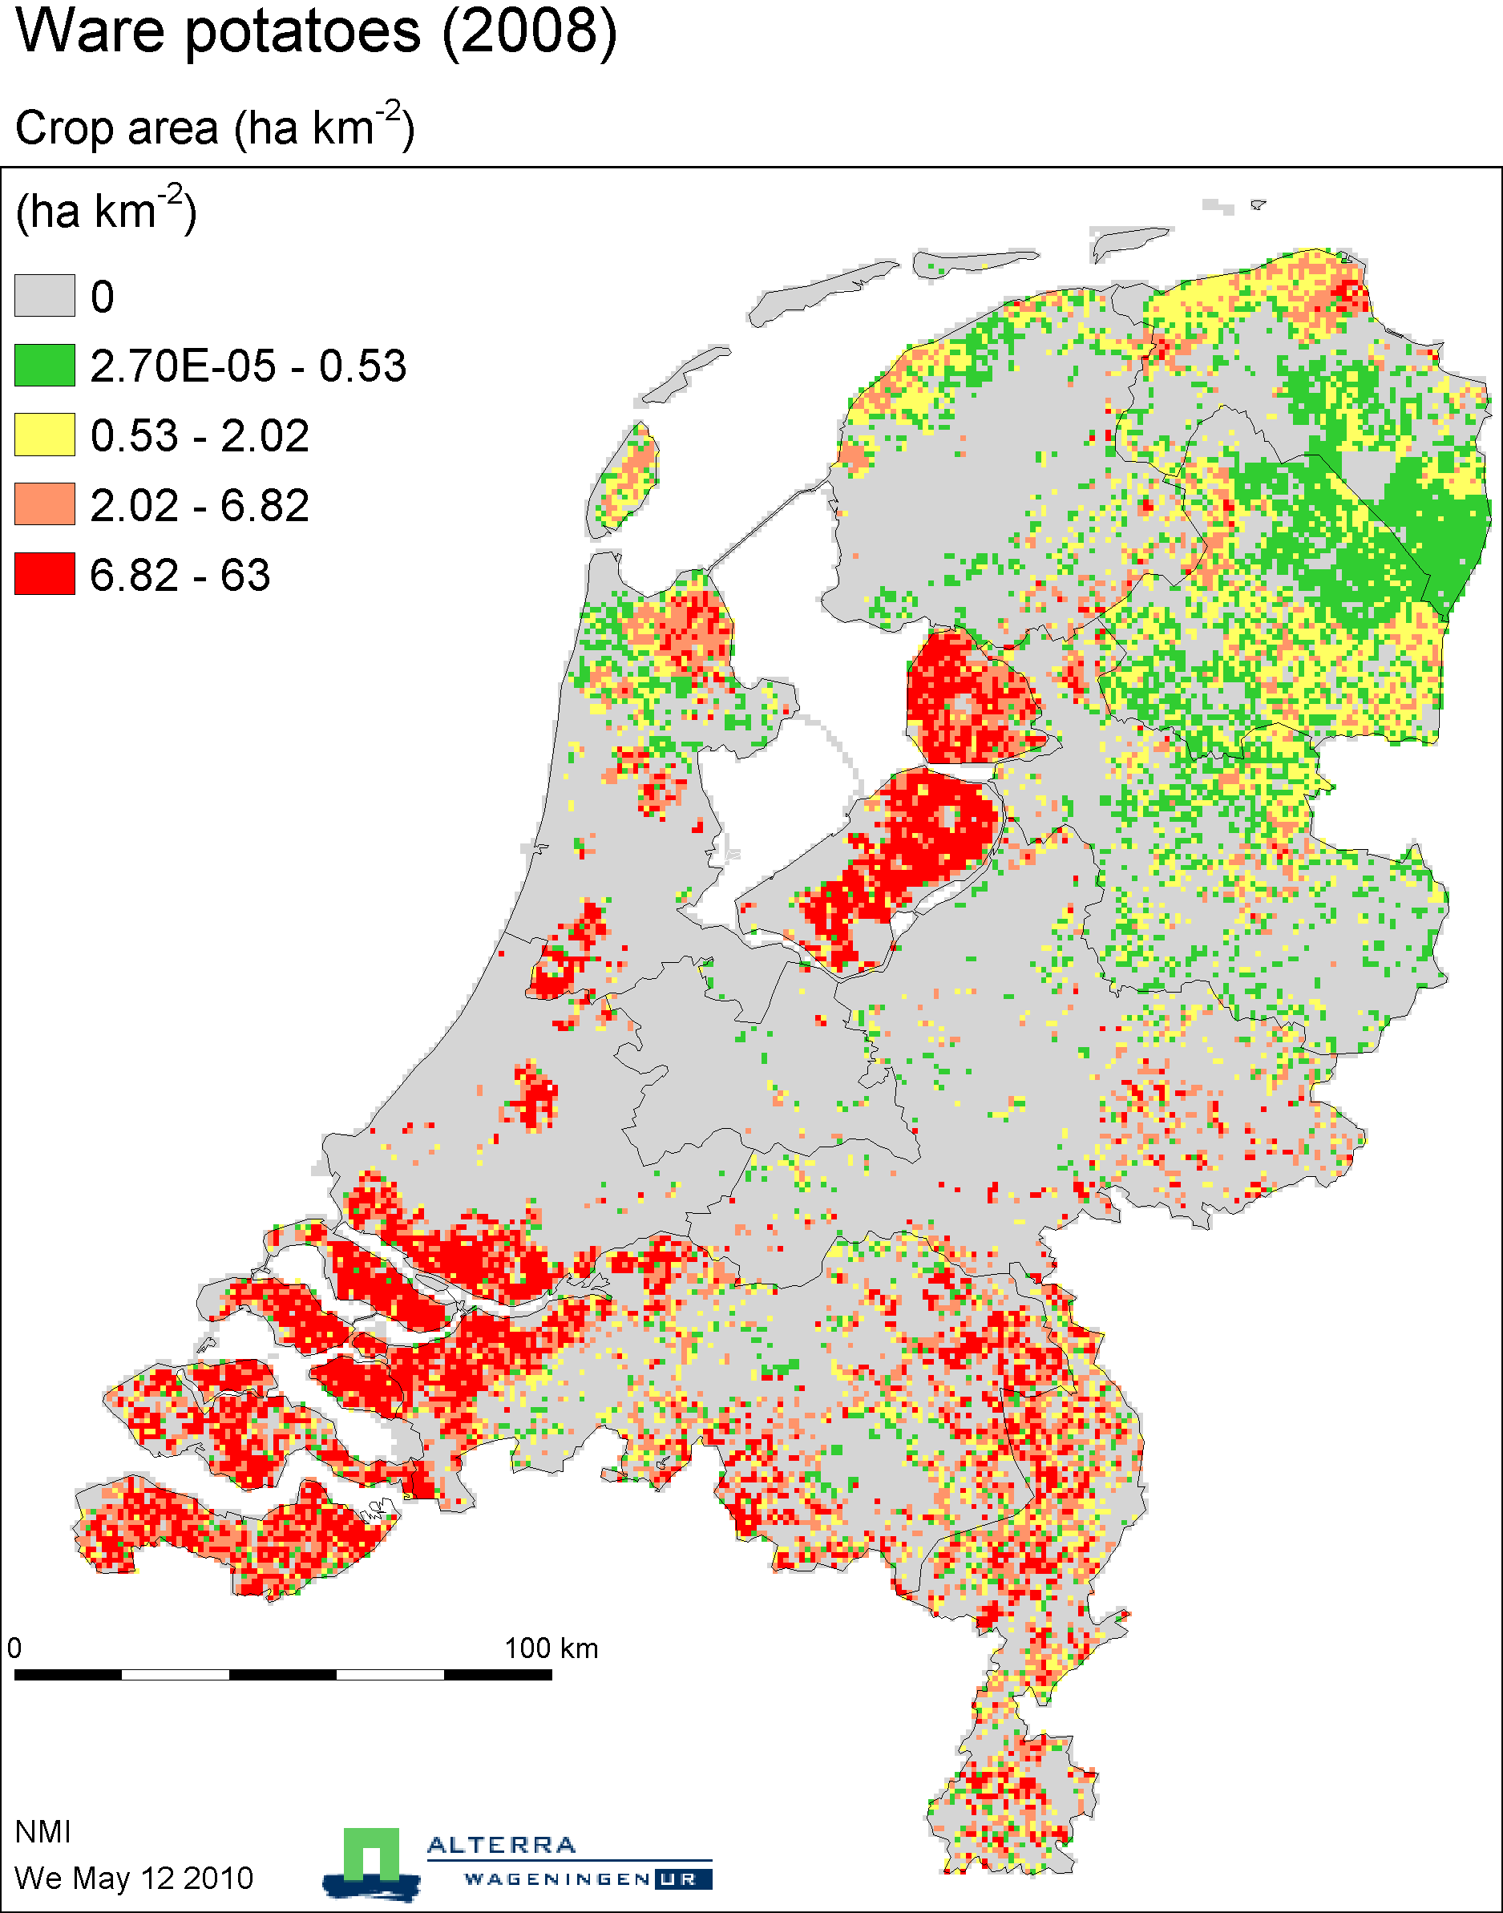

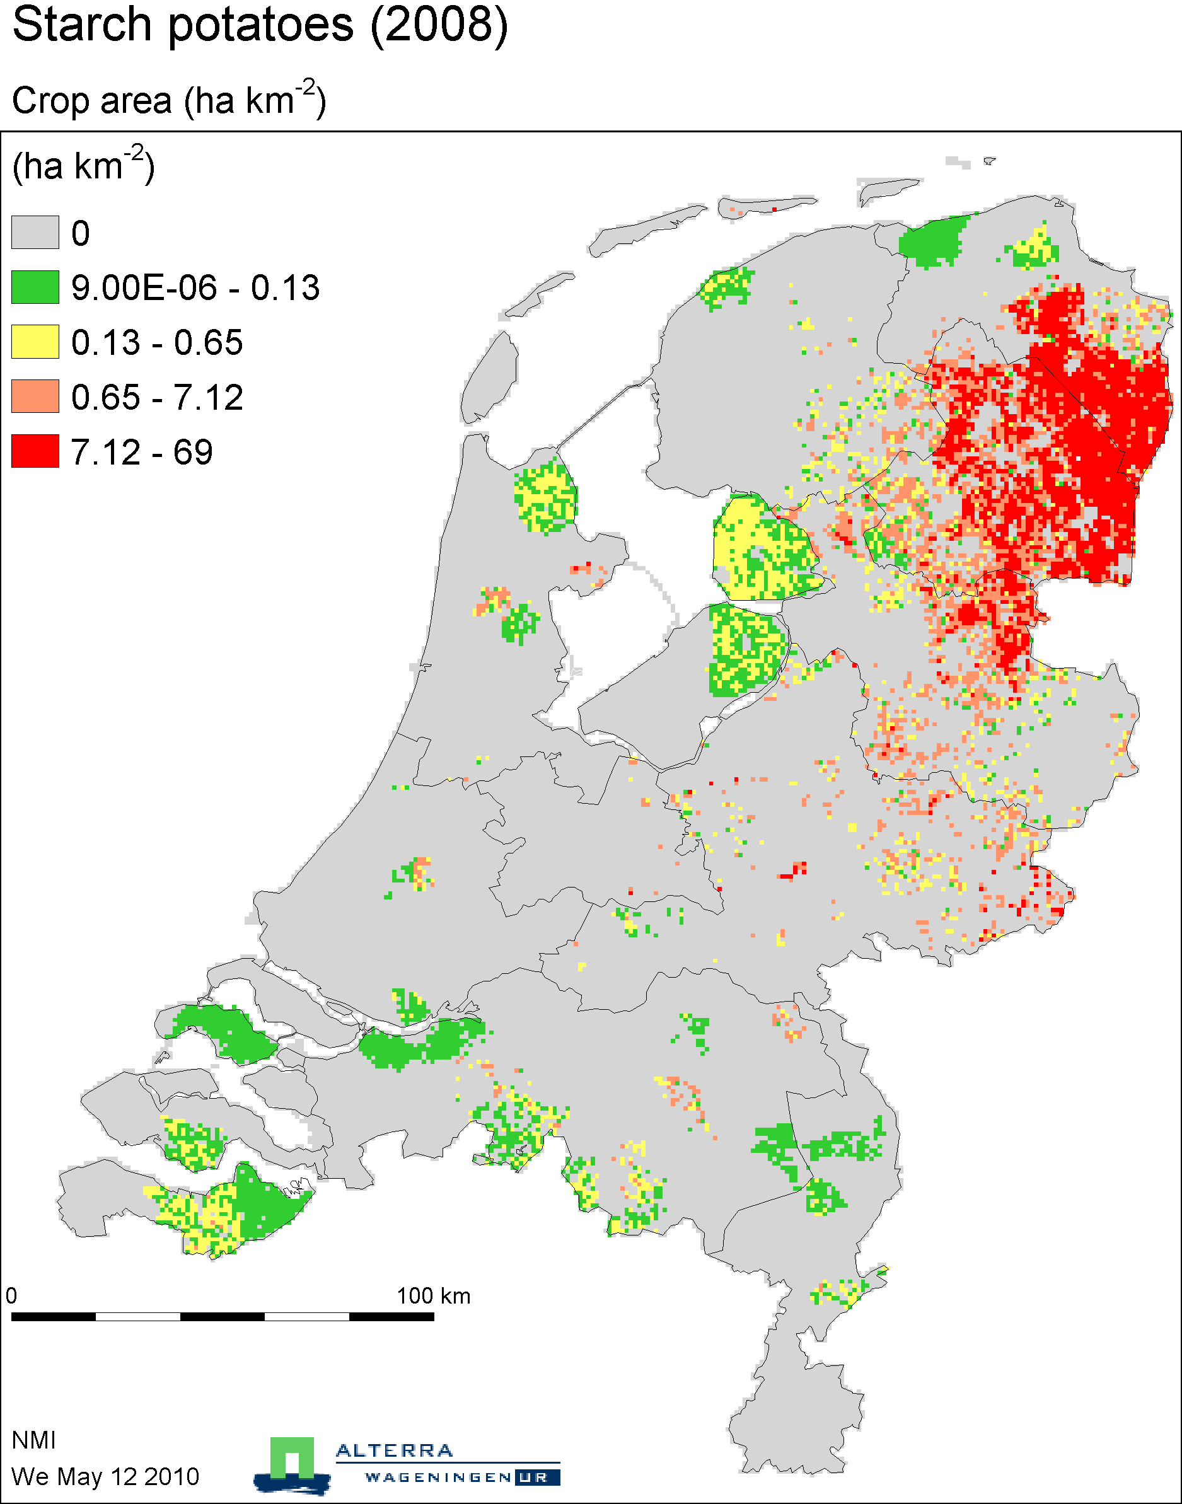

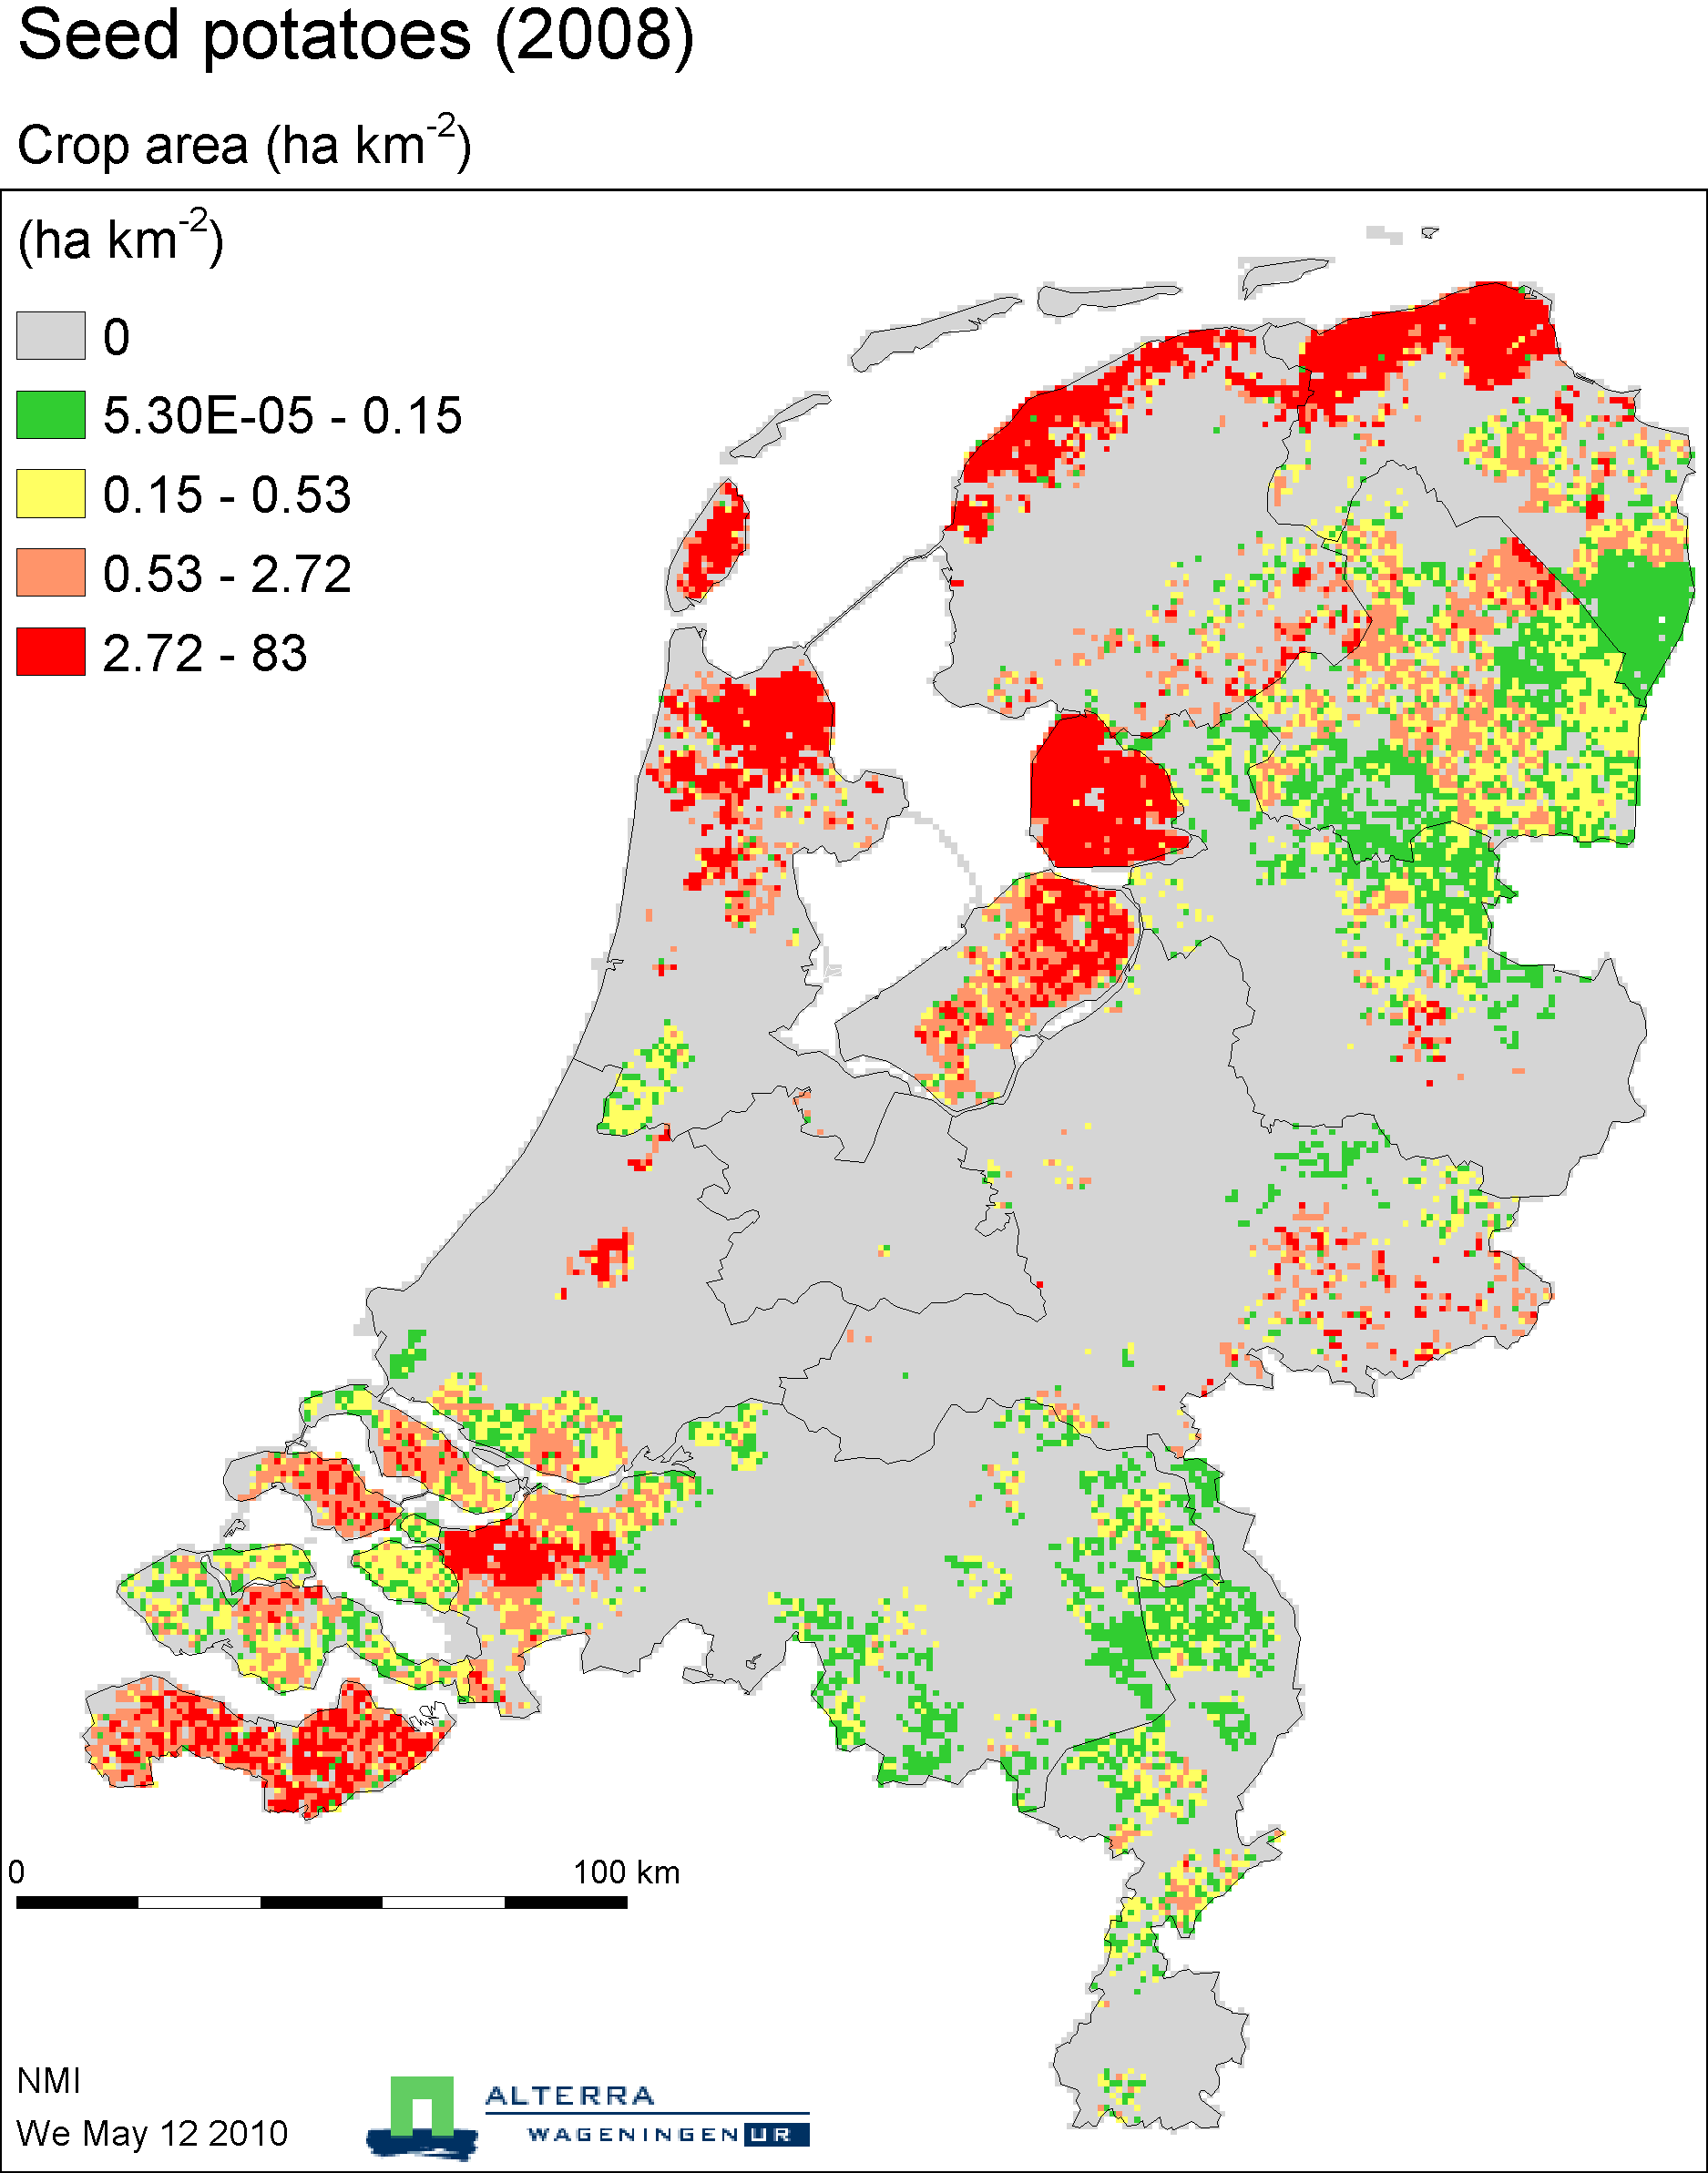

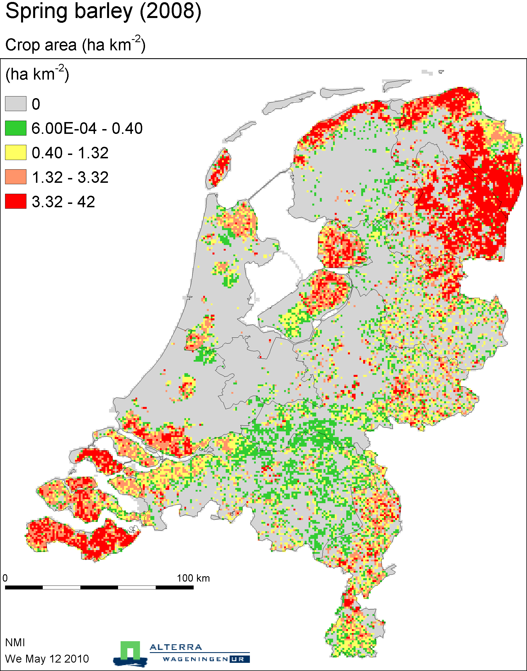

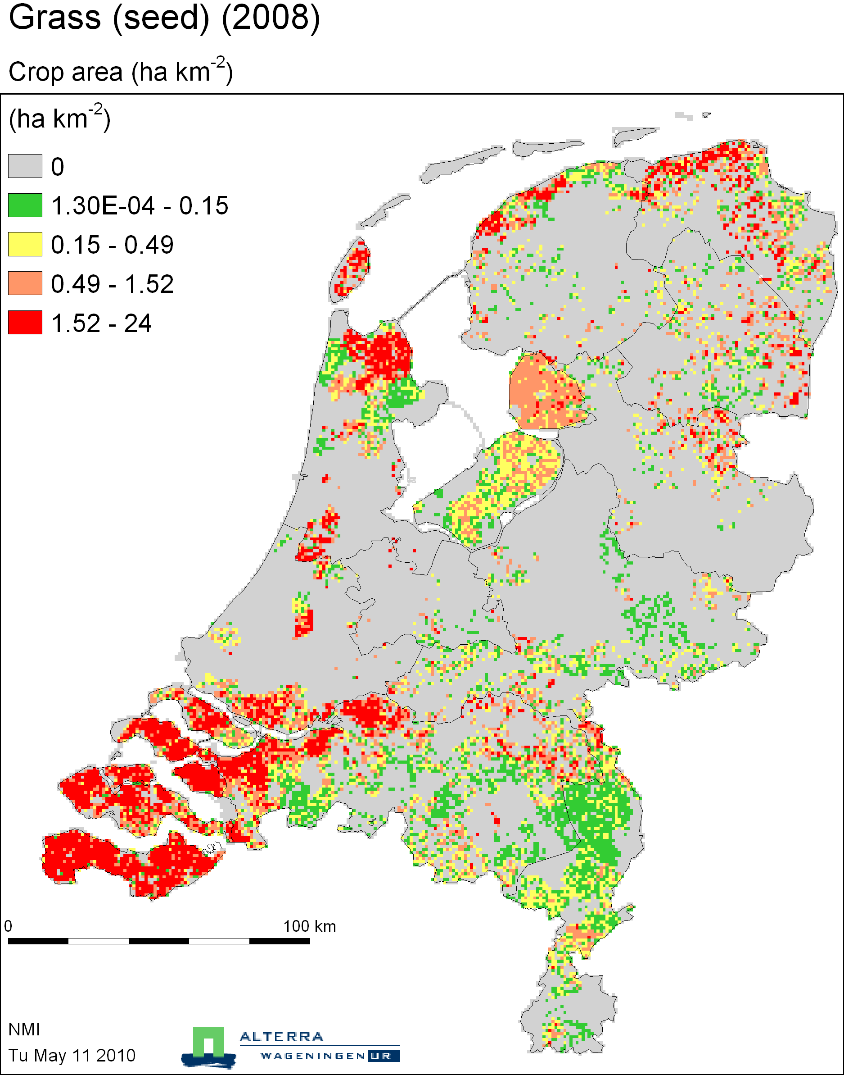

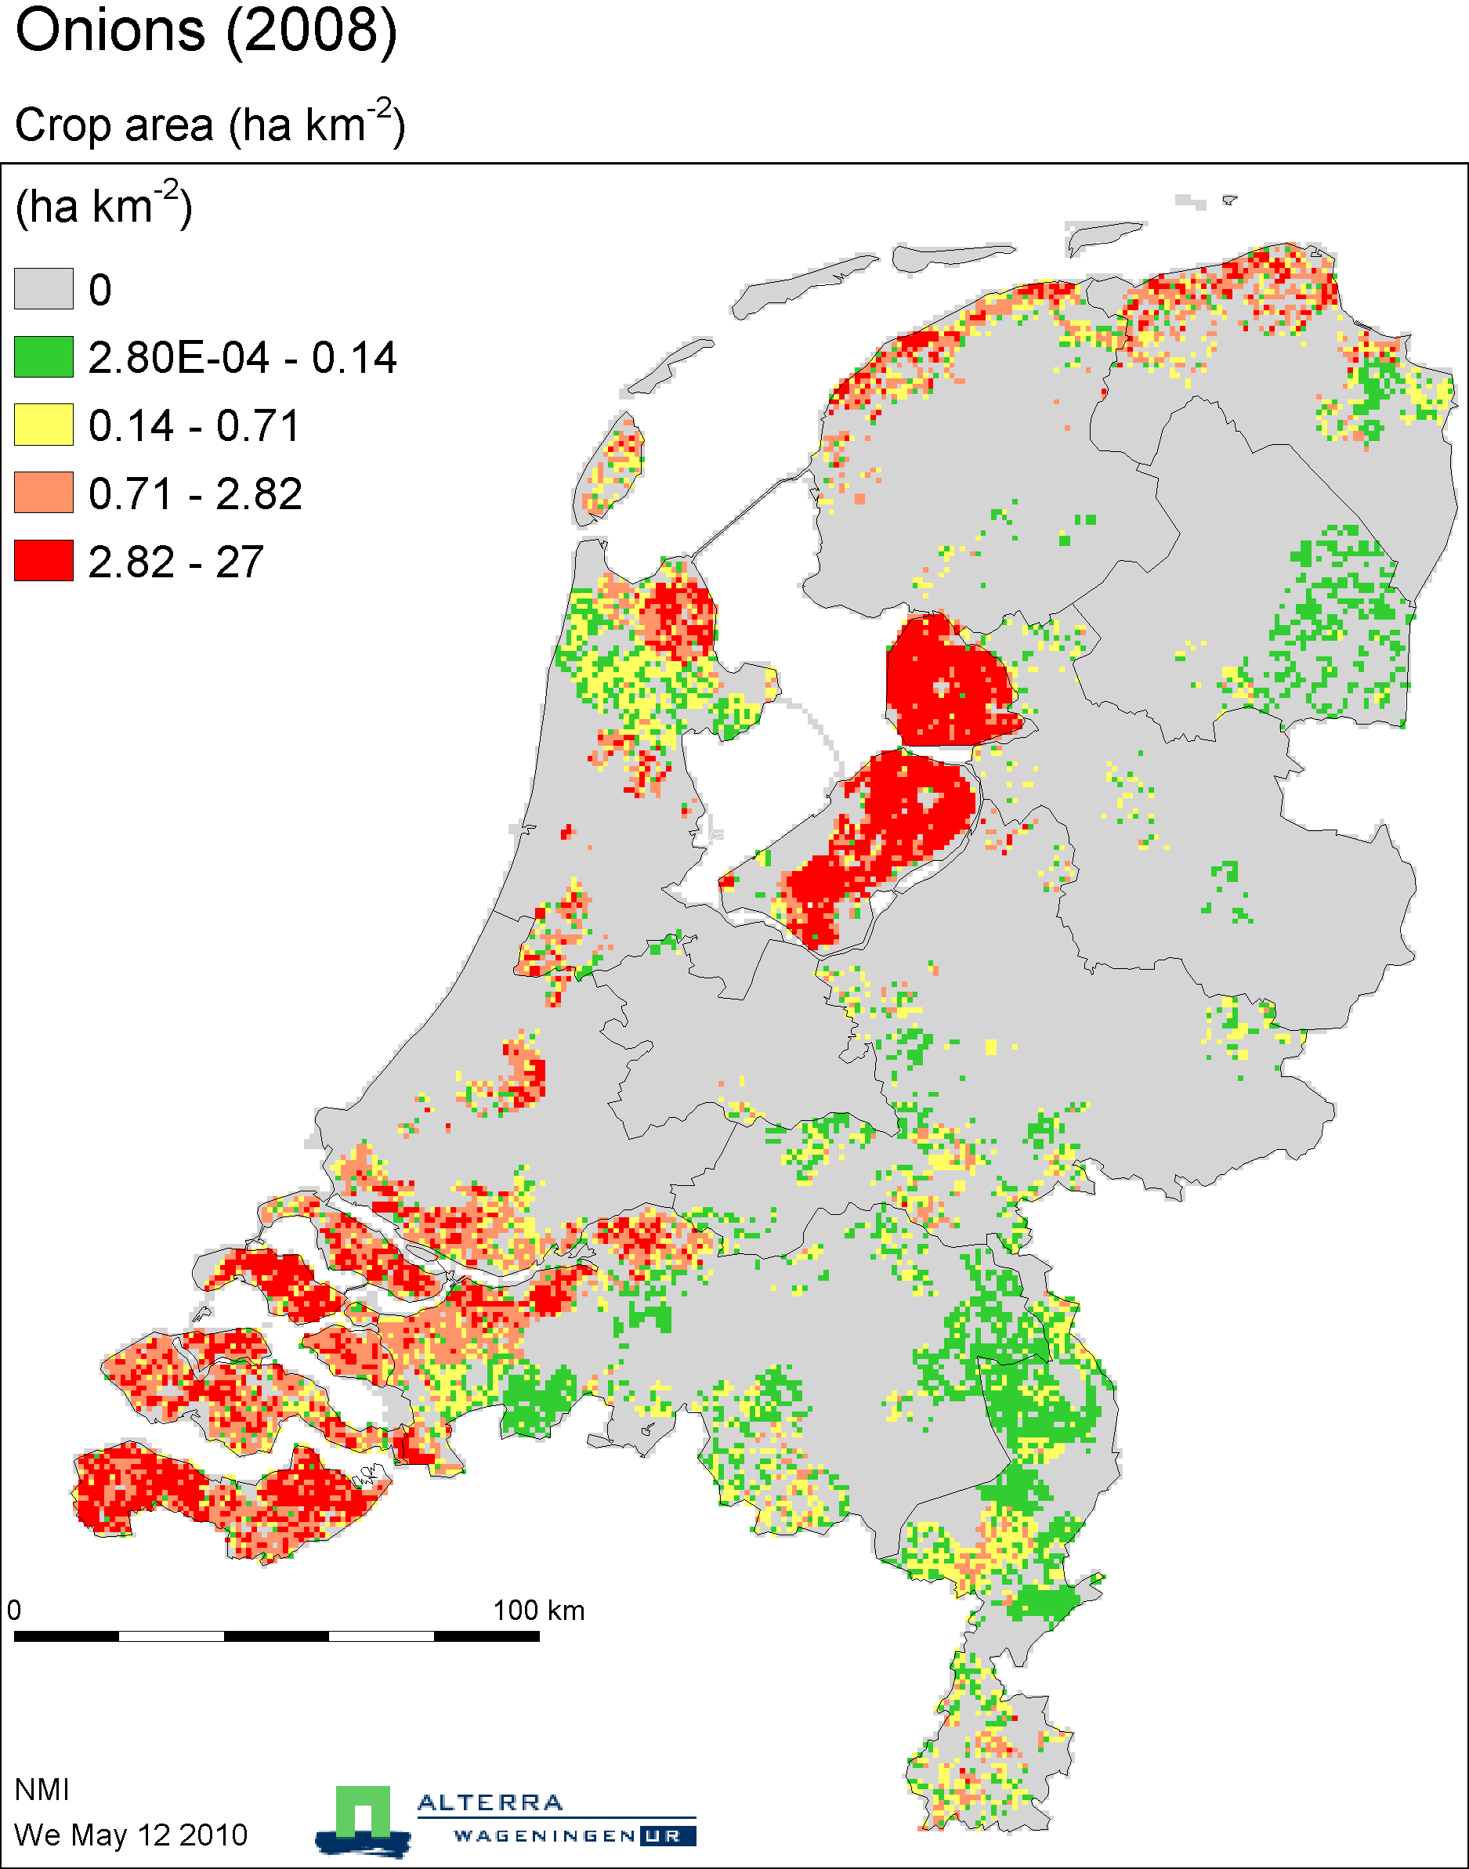

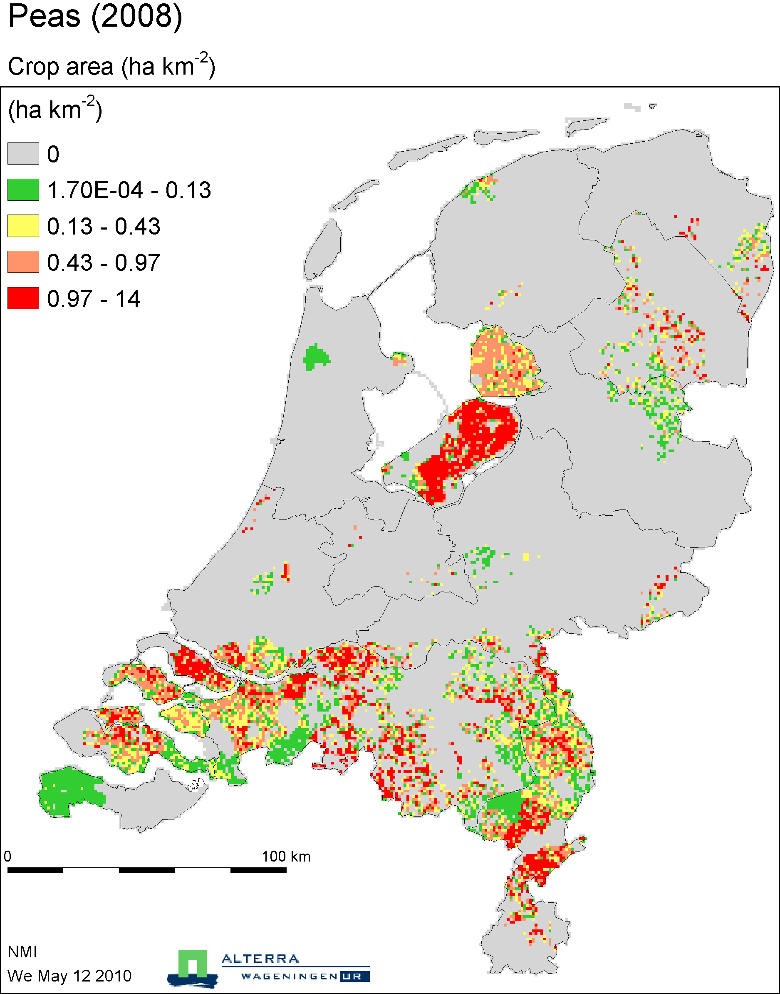

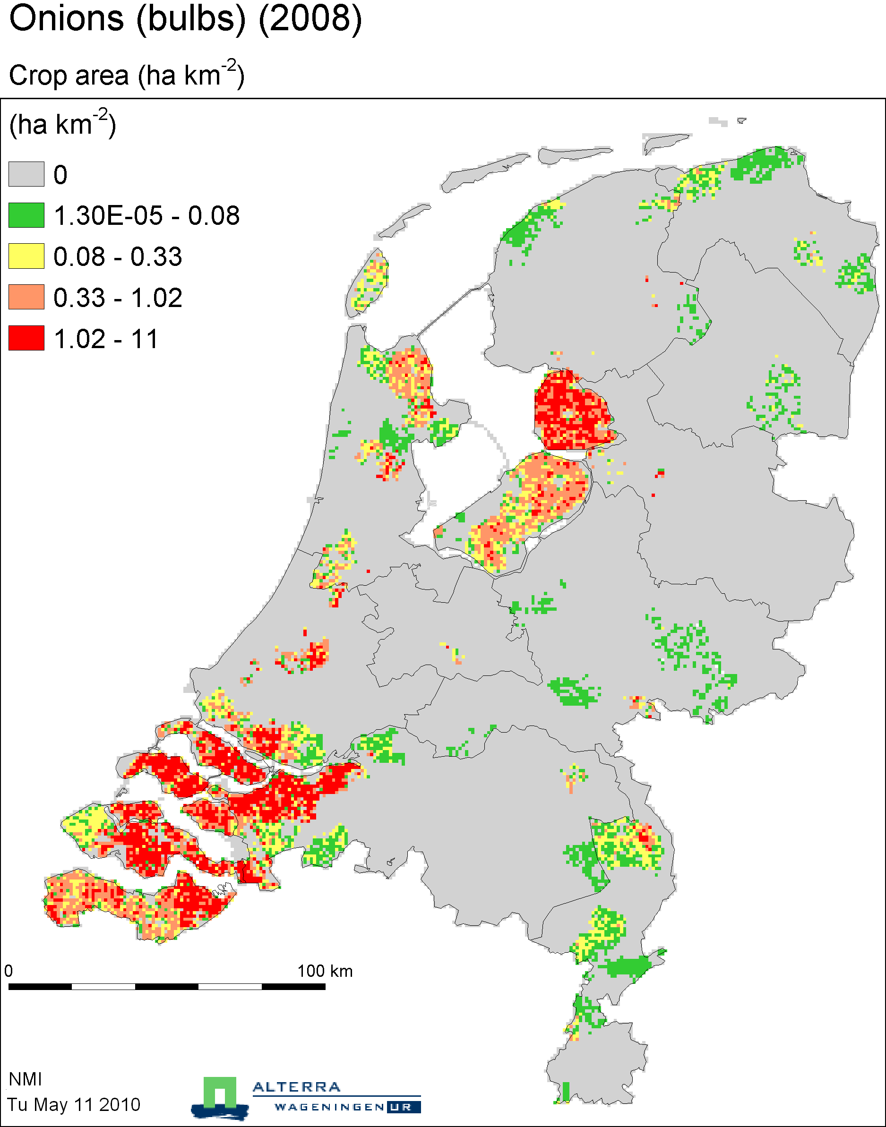

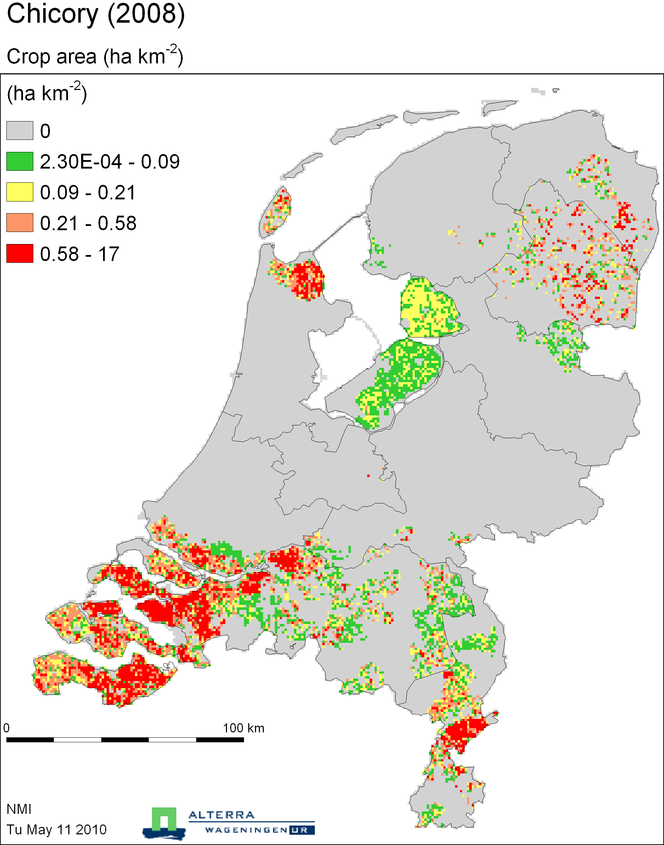

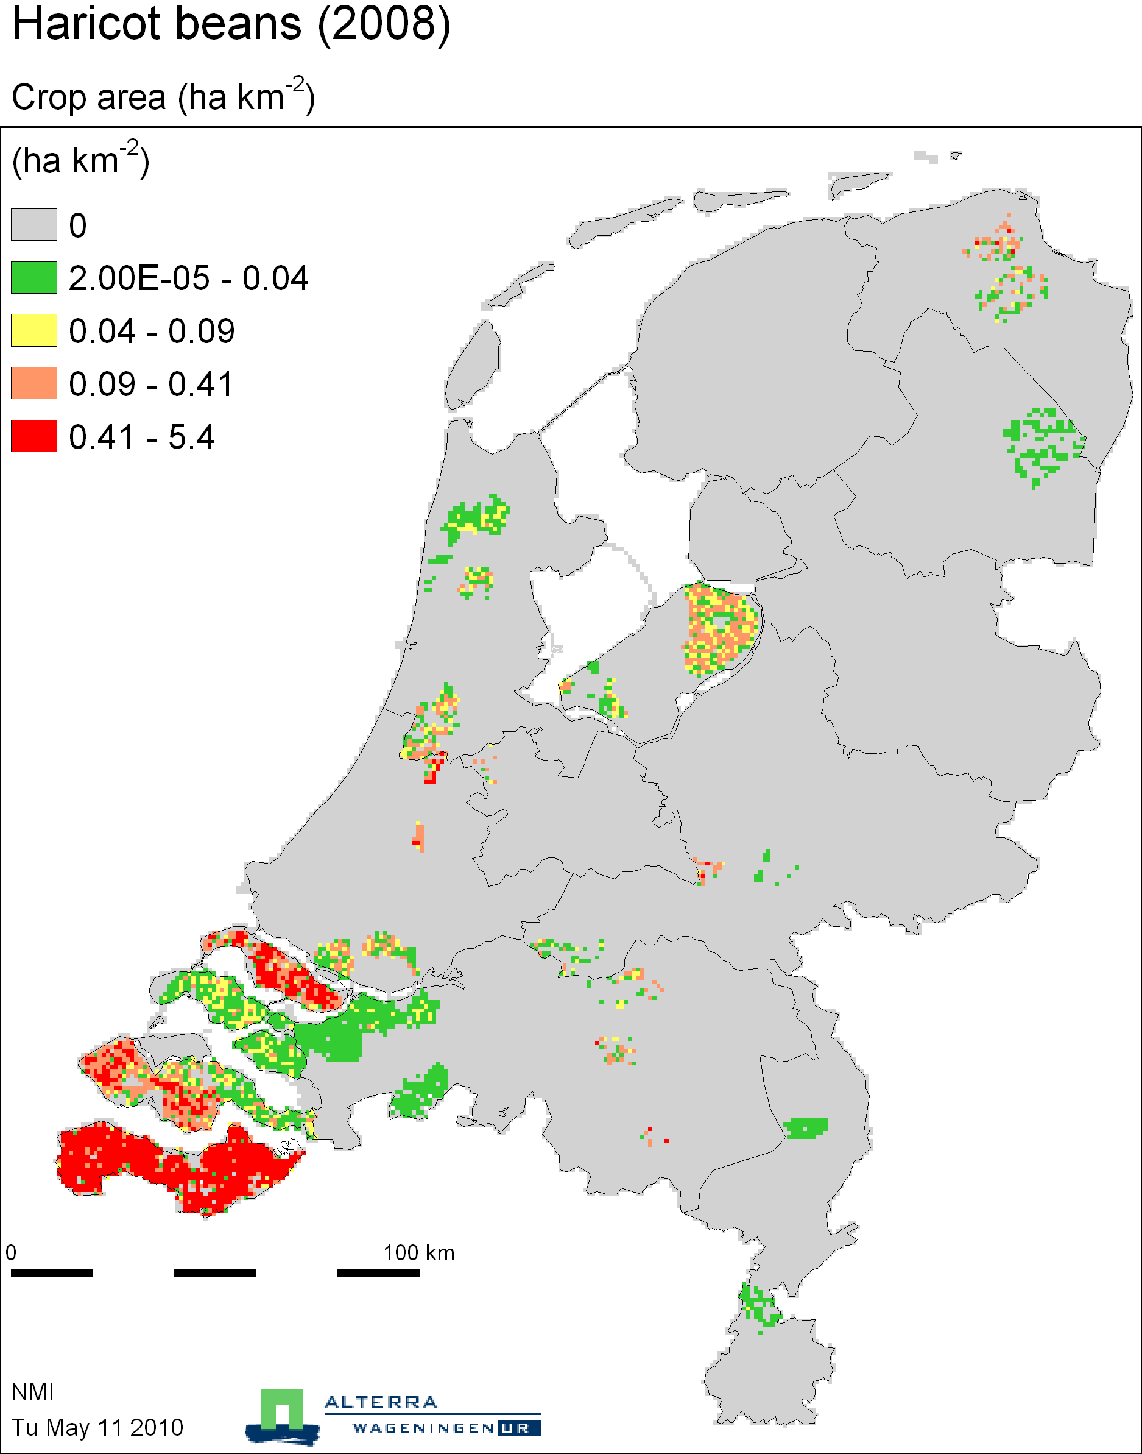

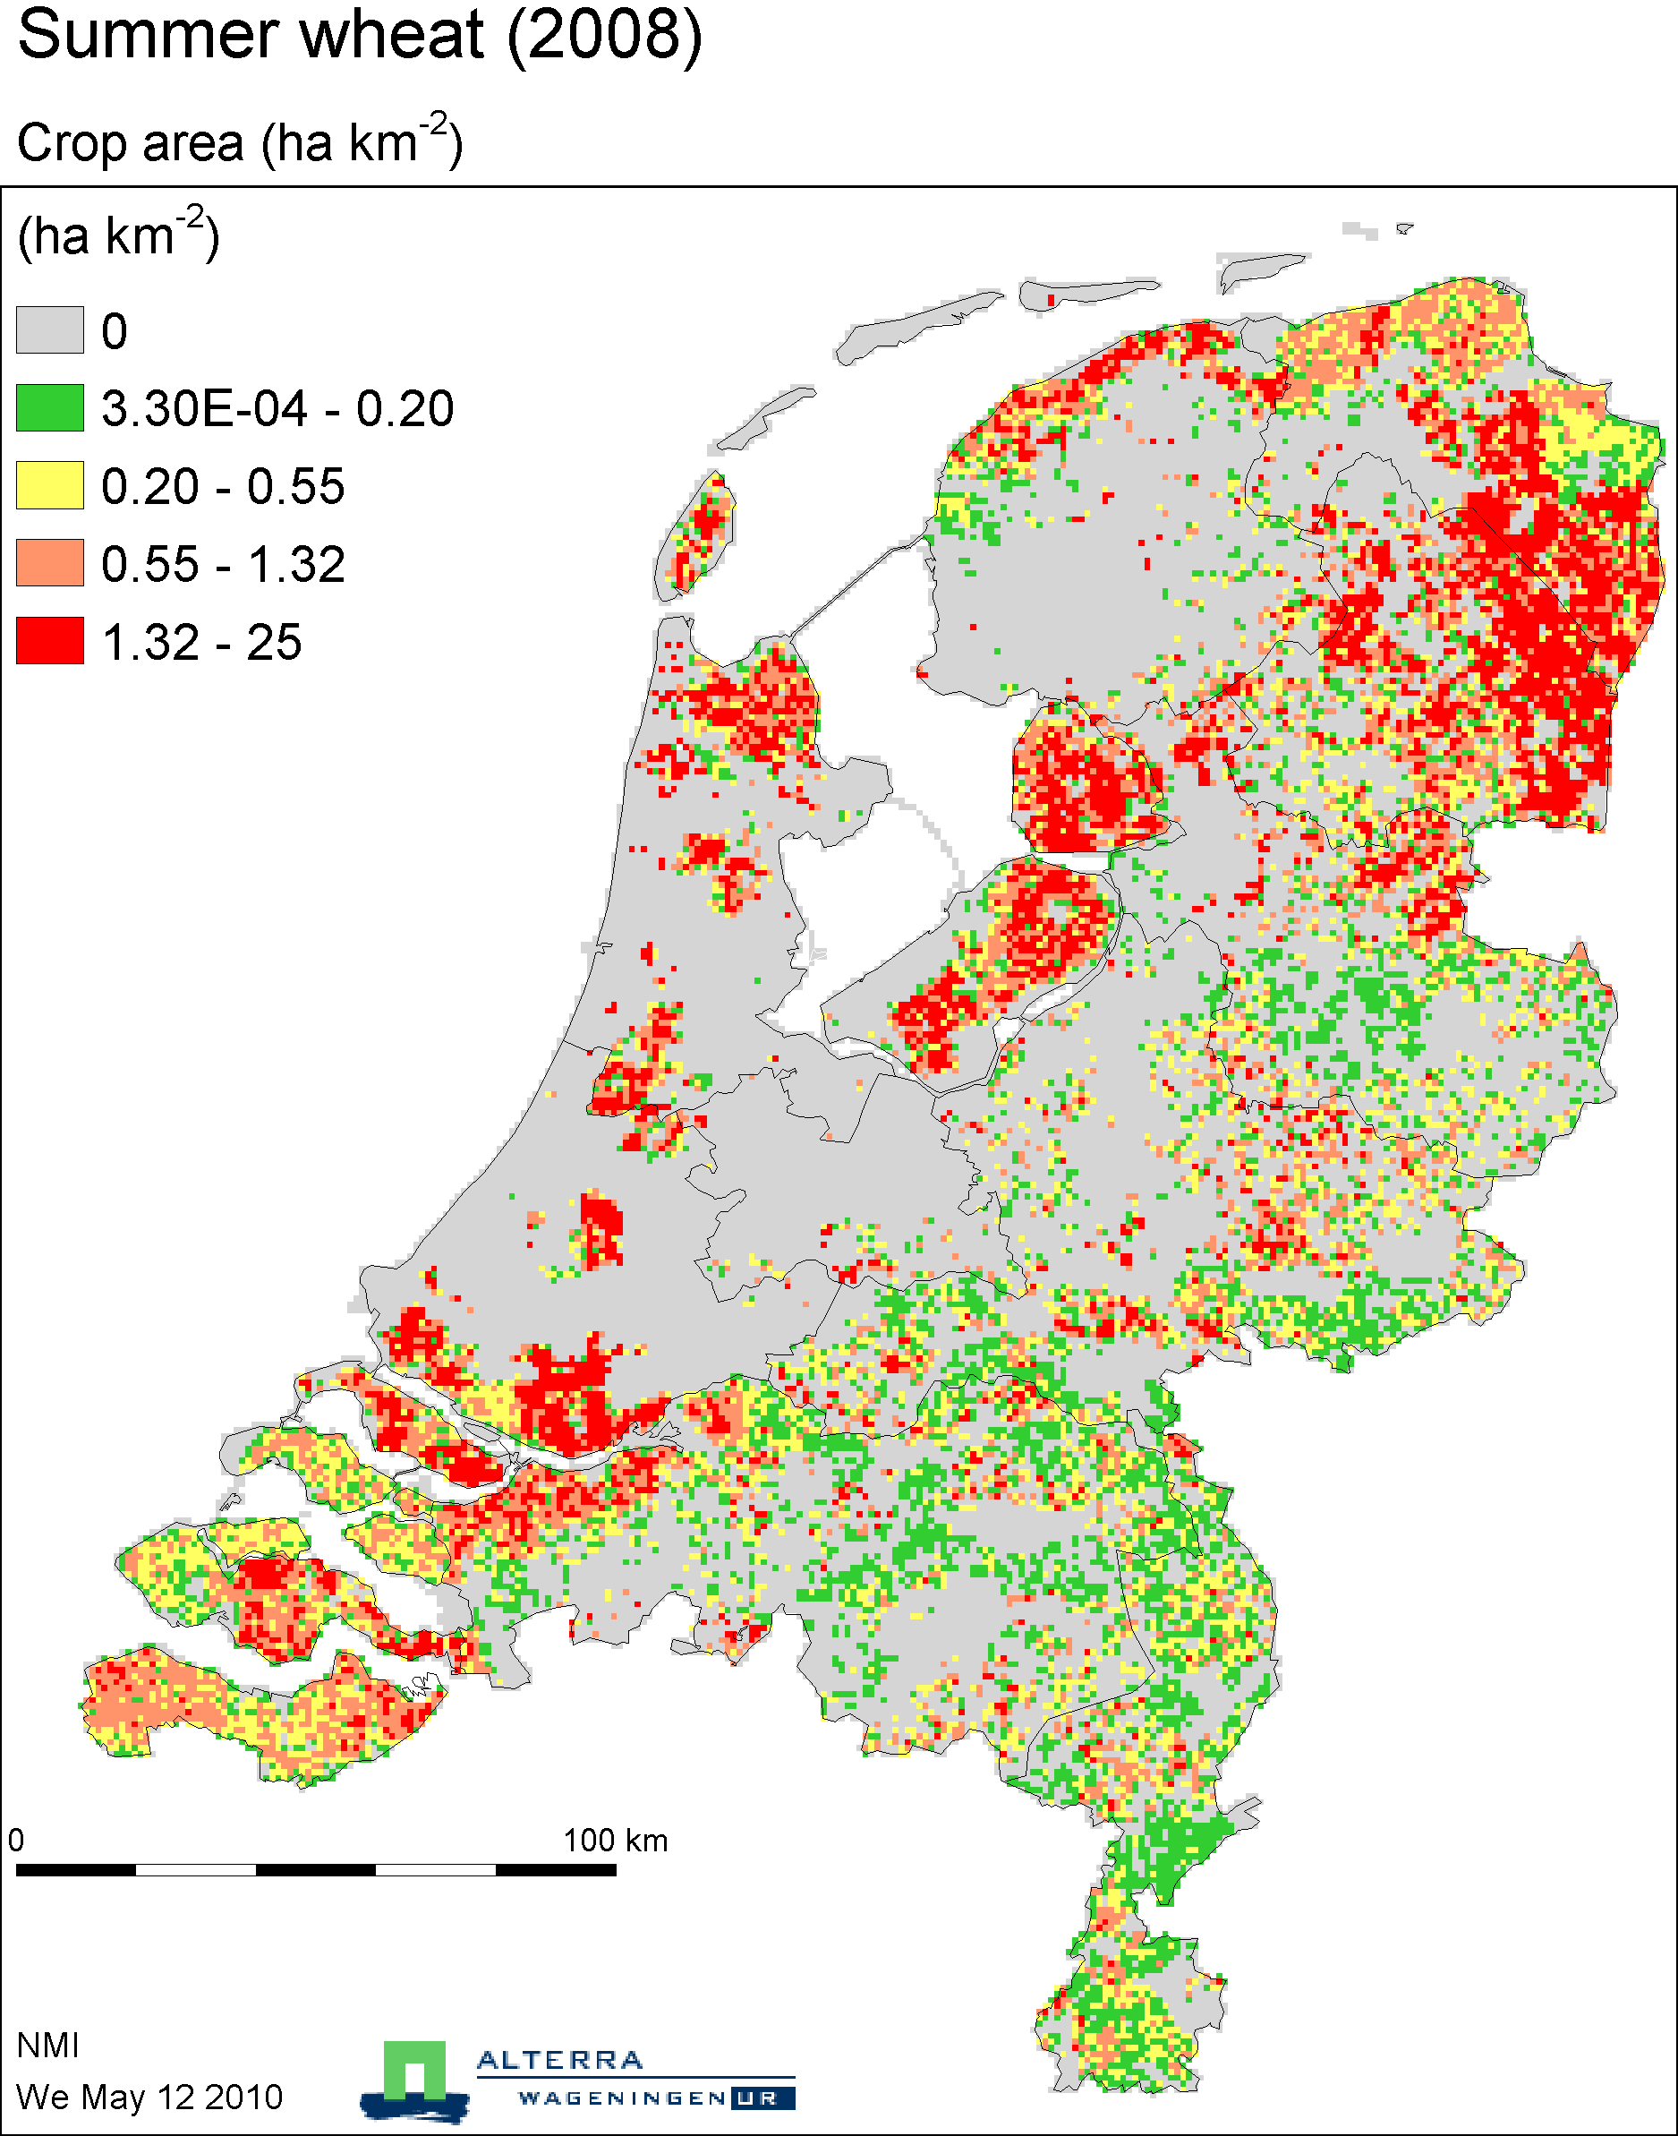

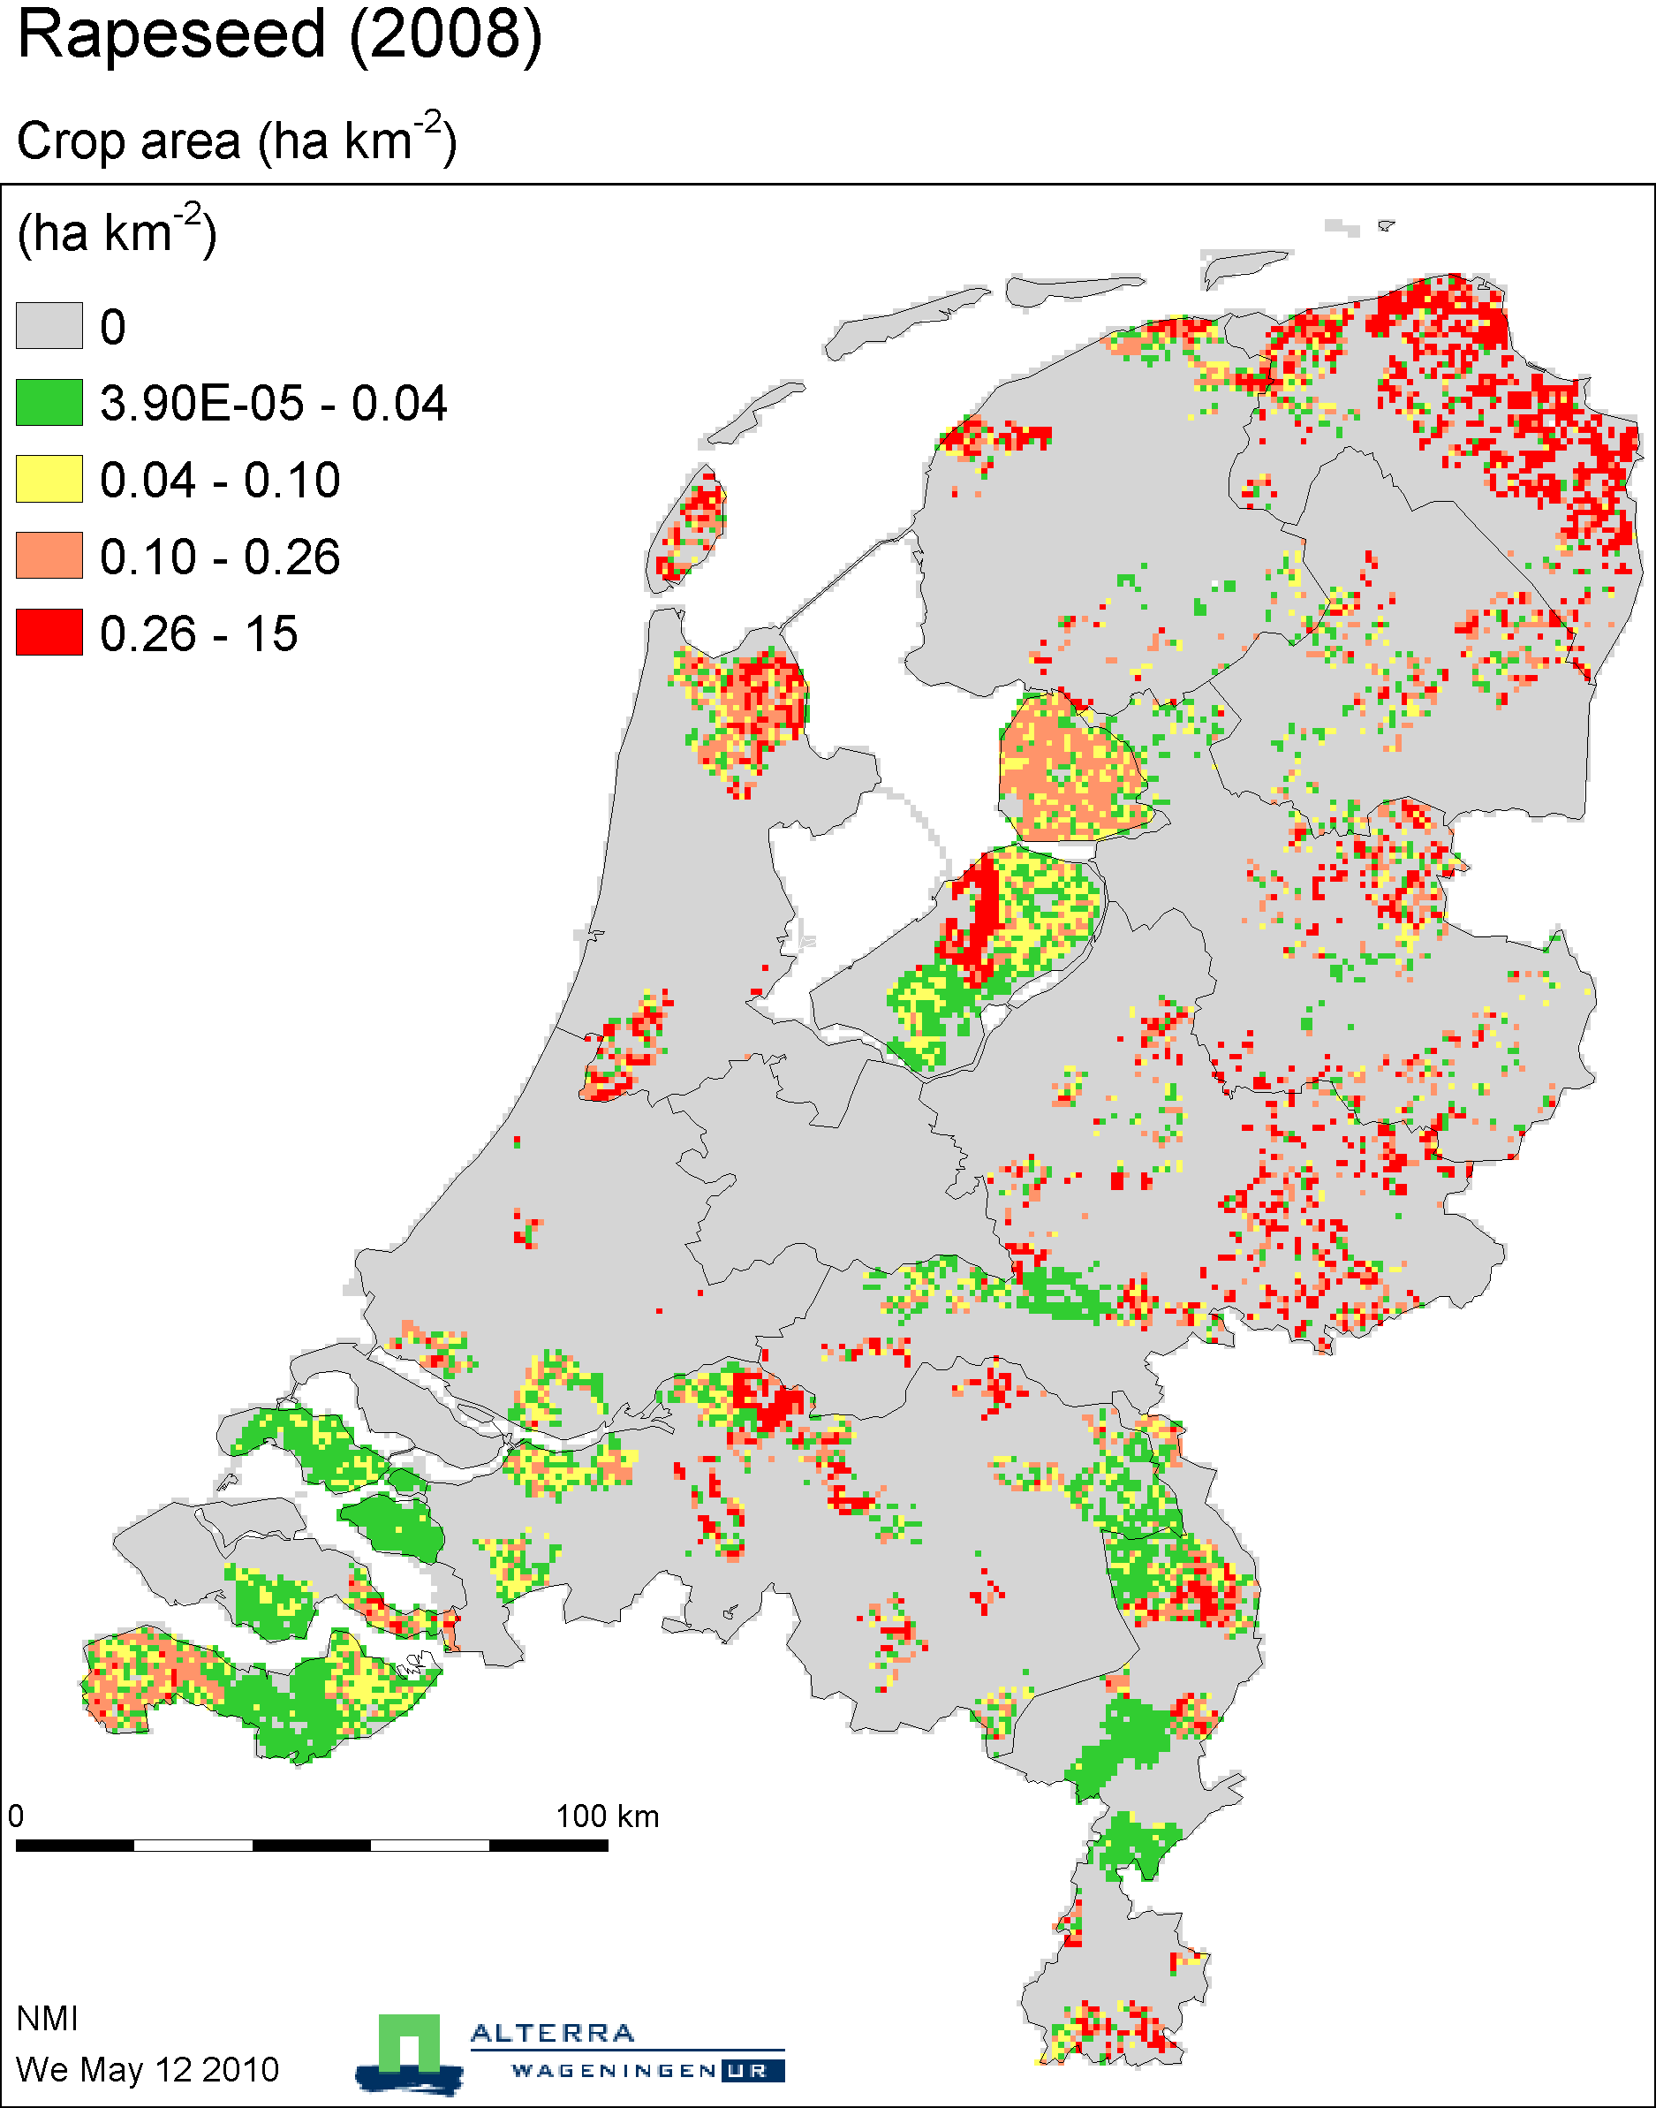

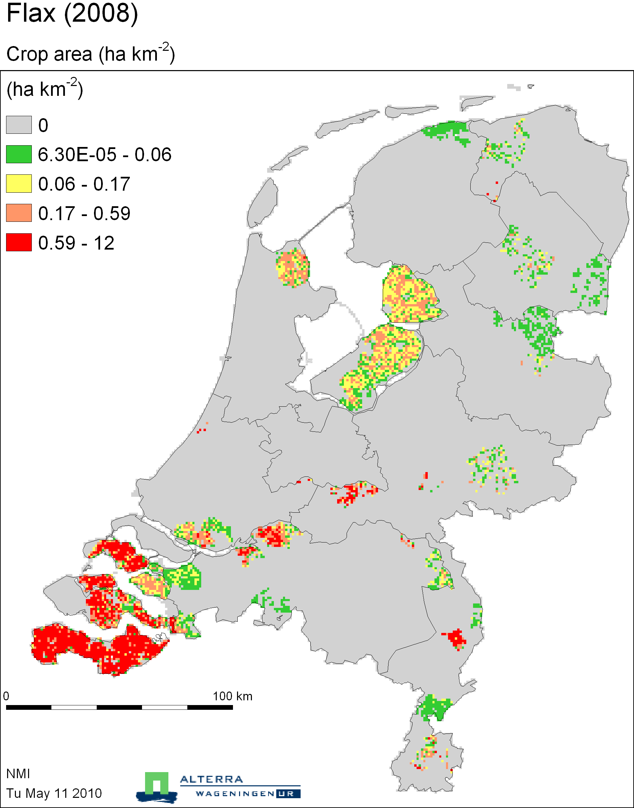

Flowerbulb cultivation

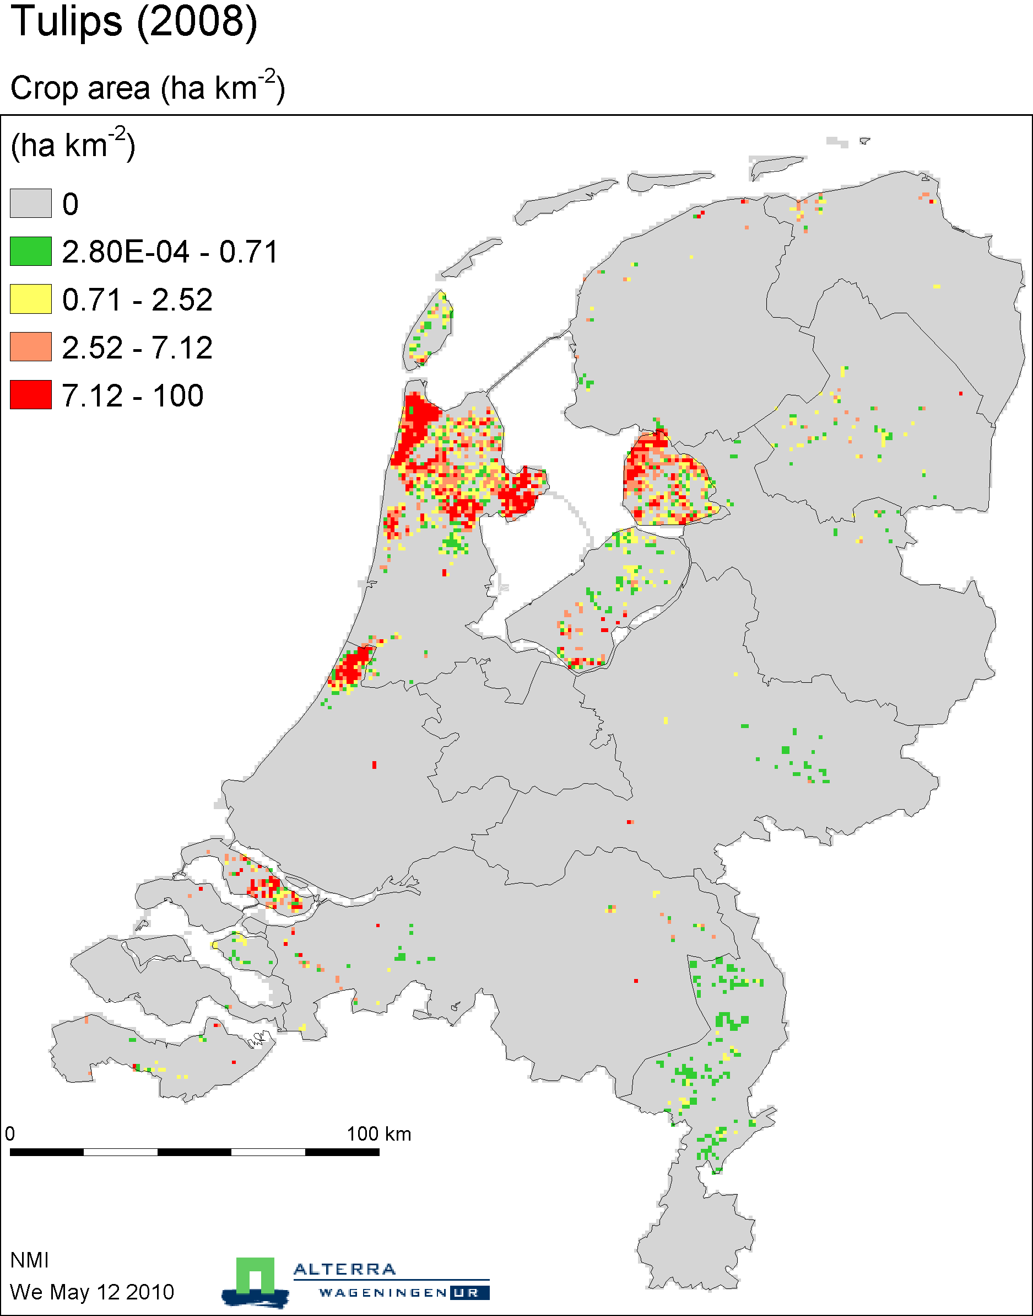

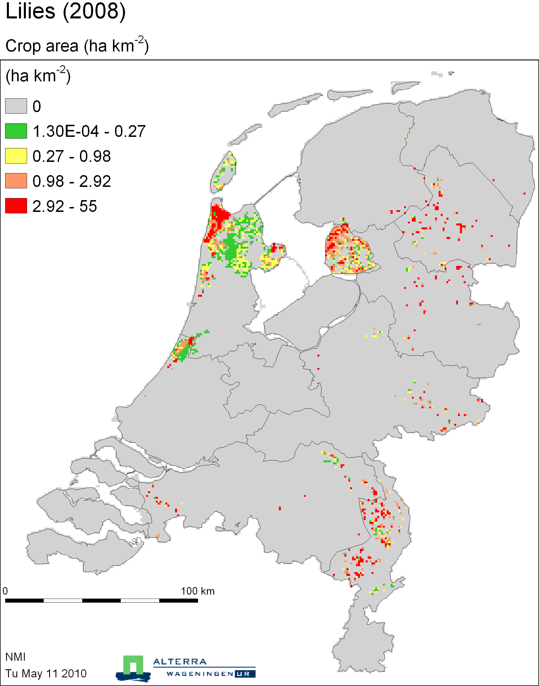

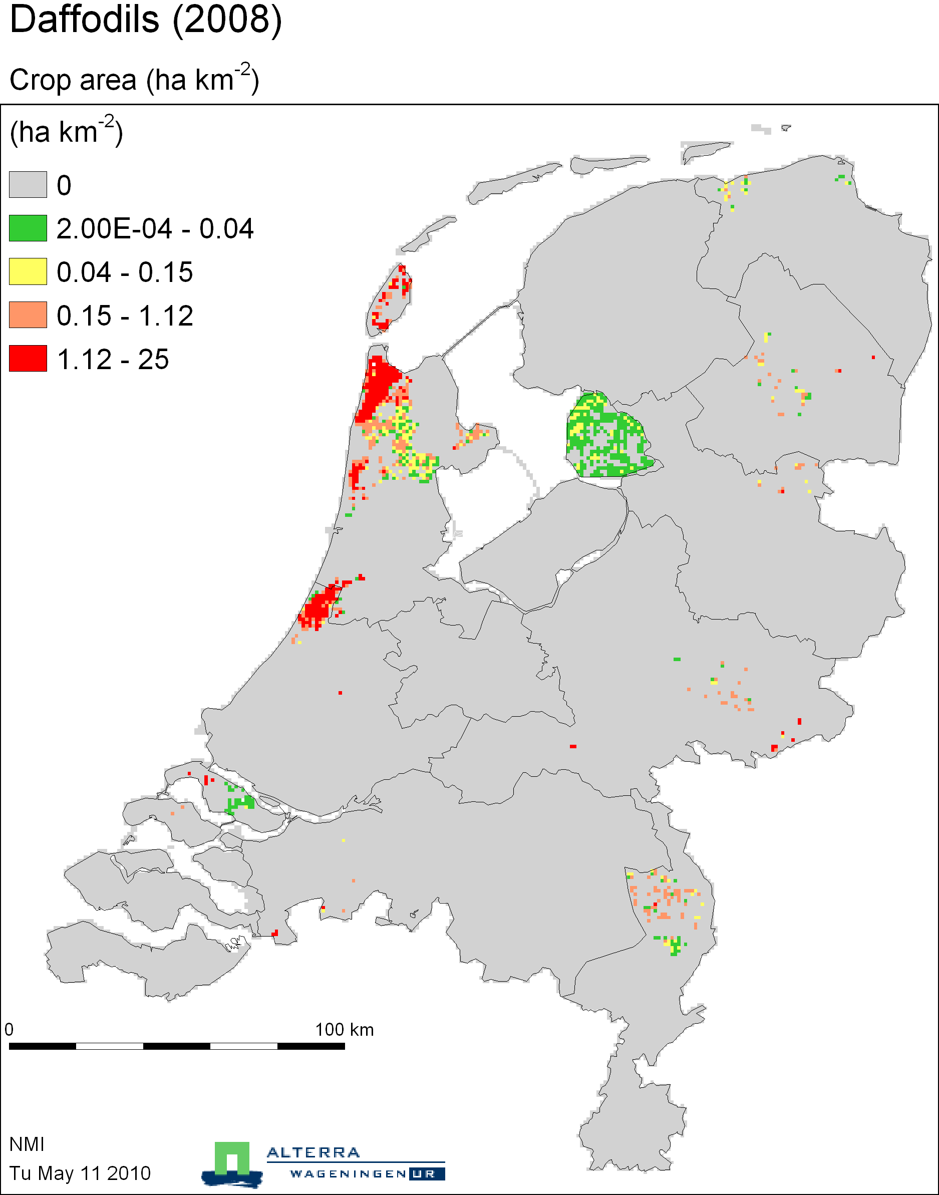

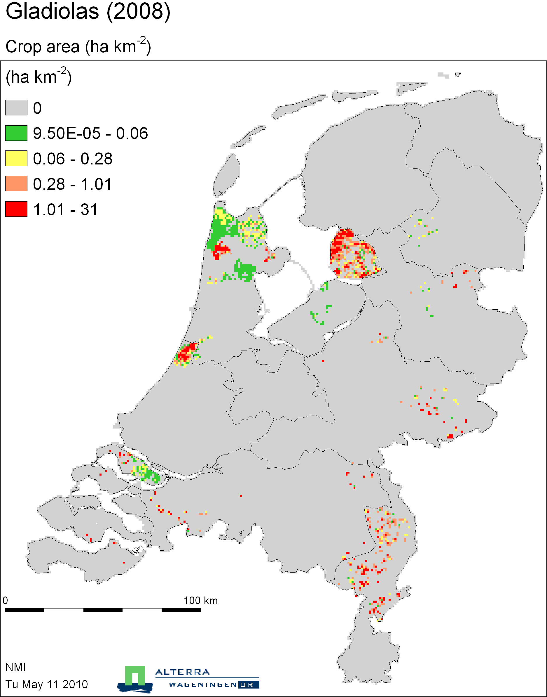

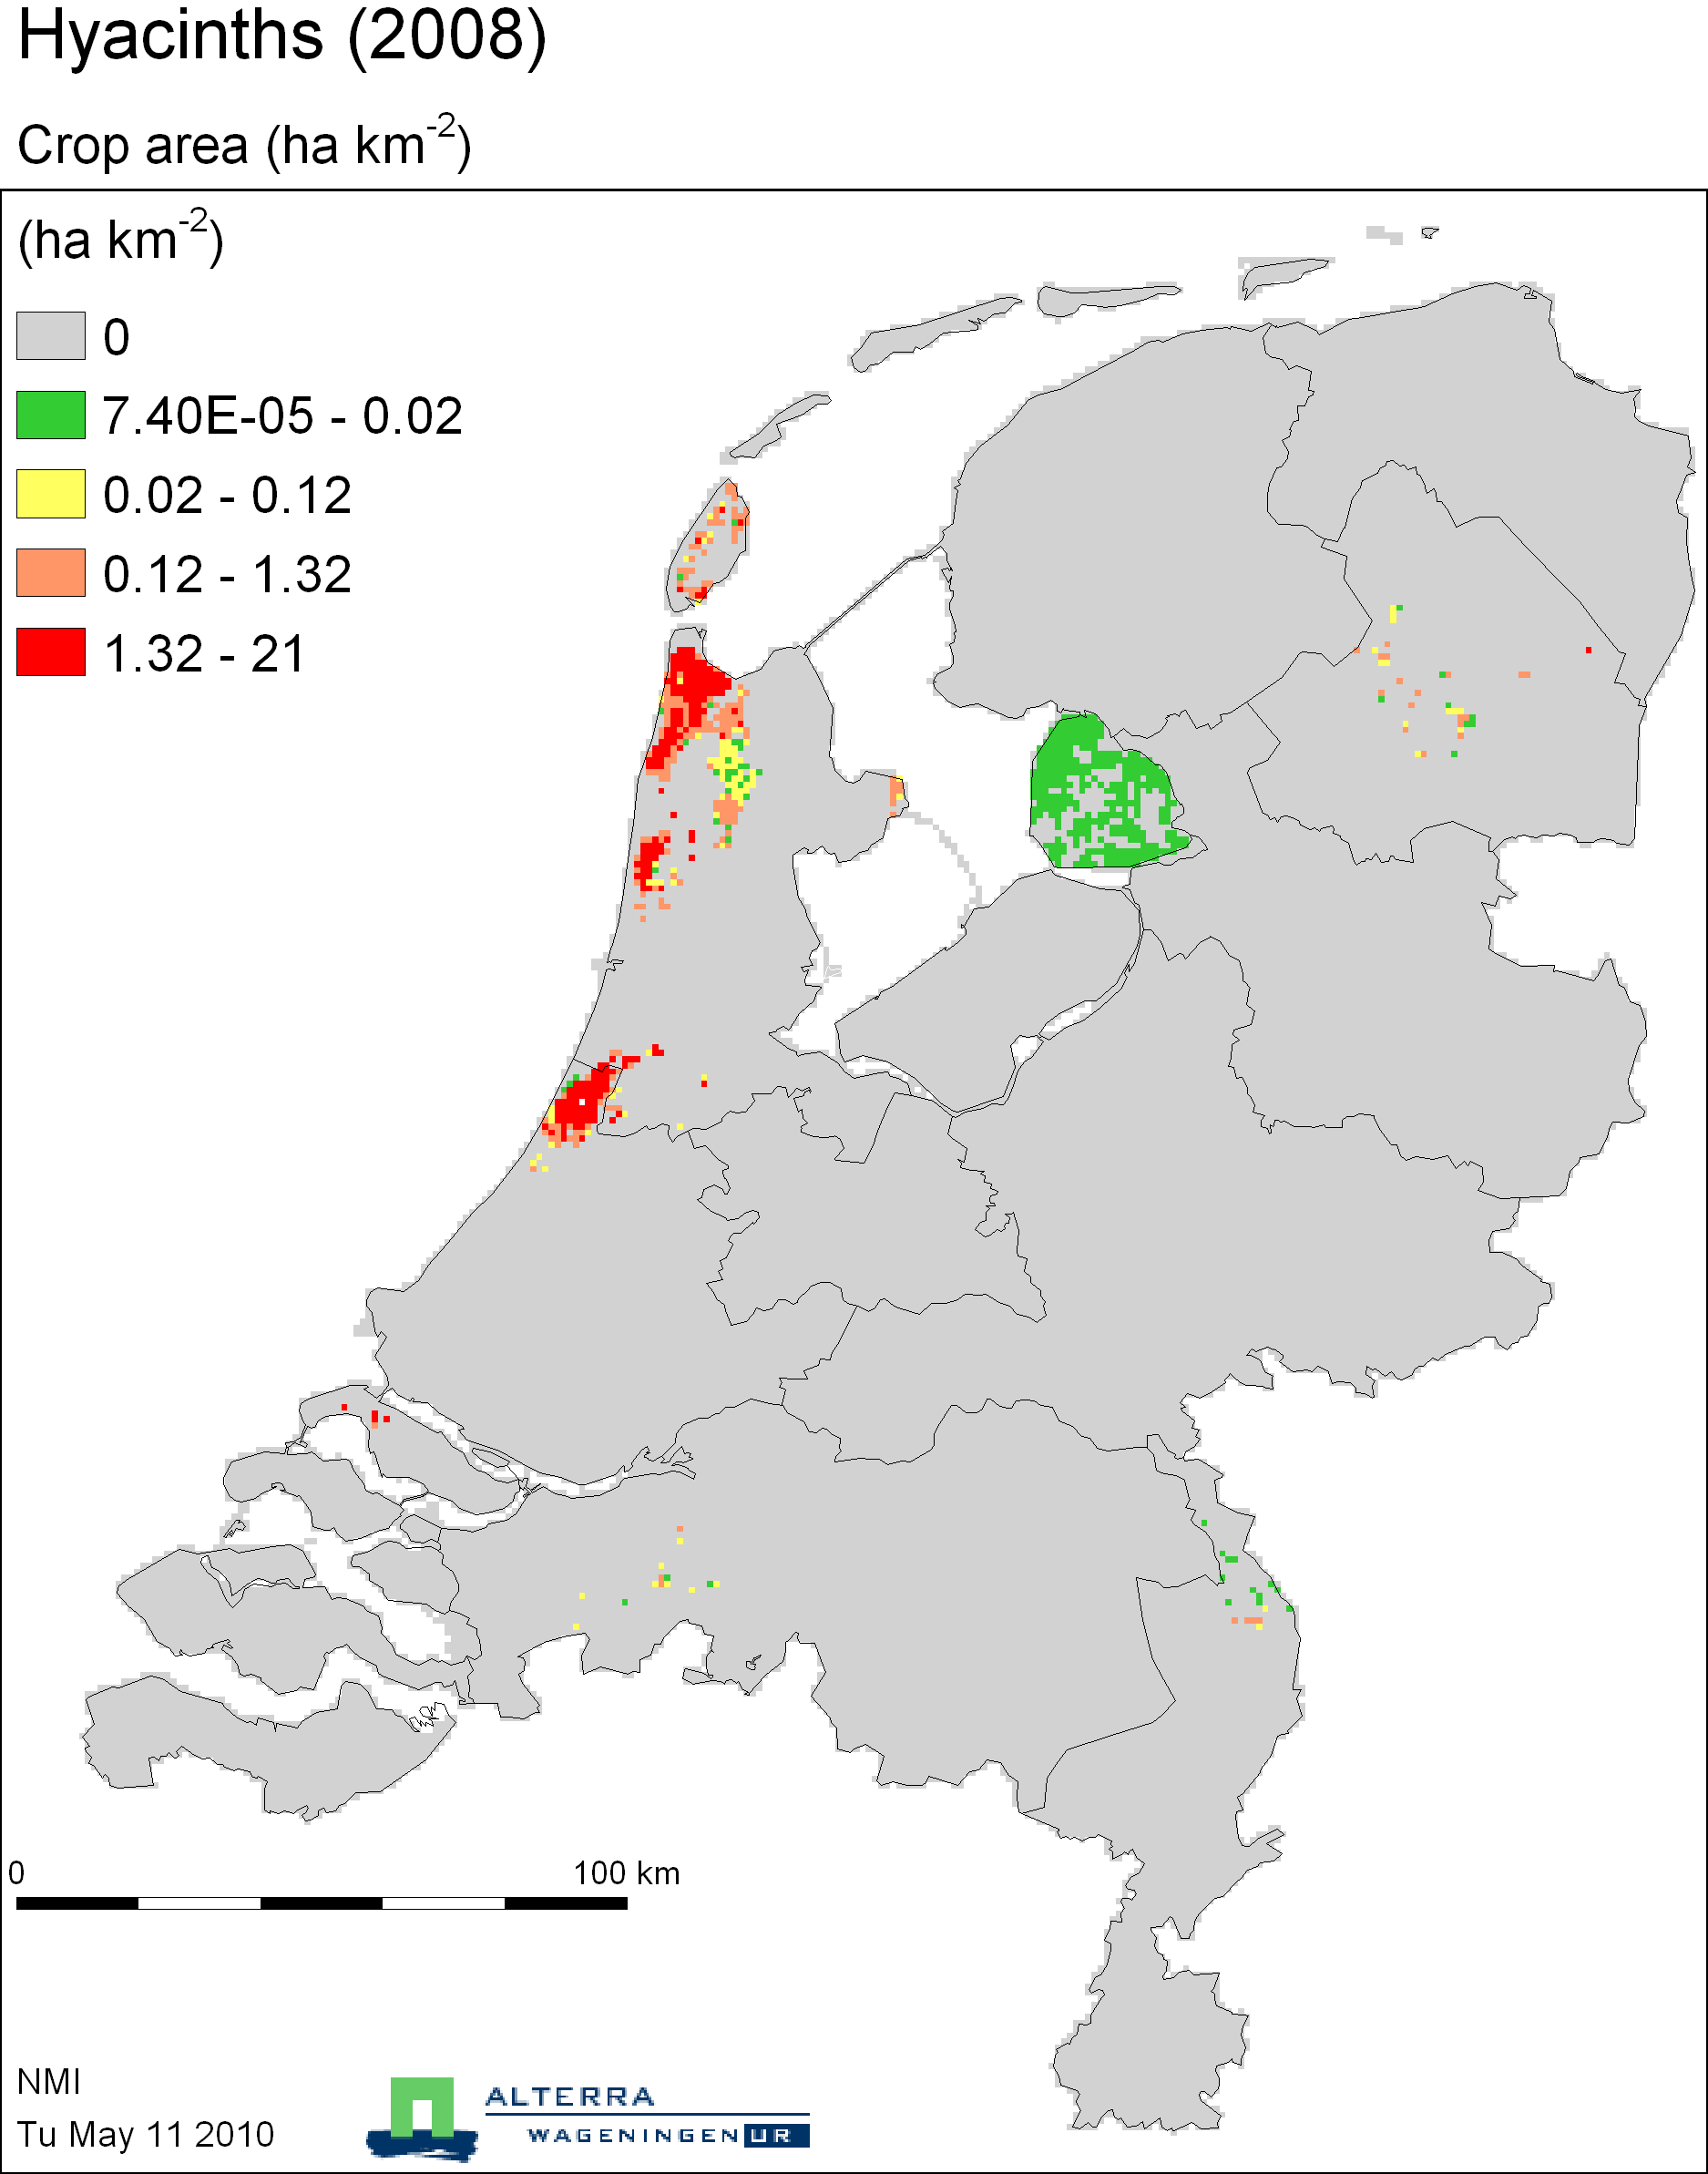

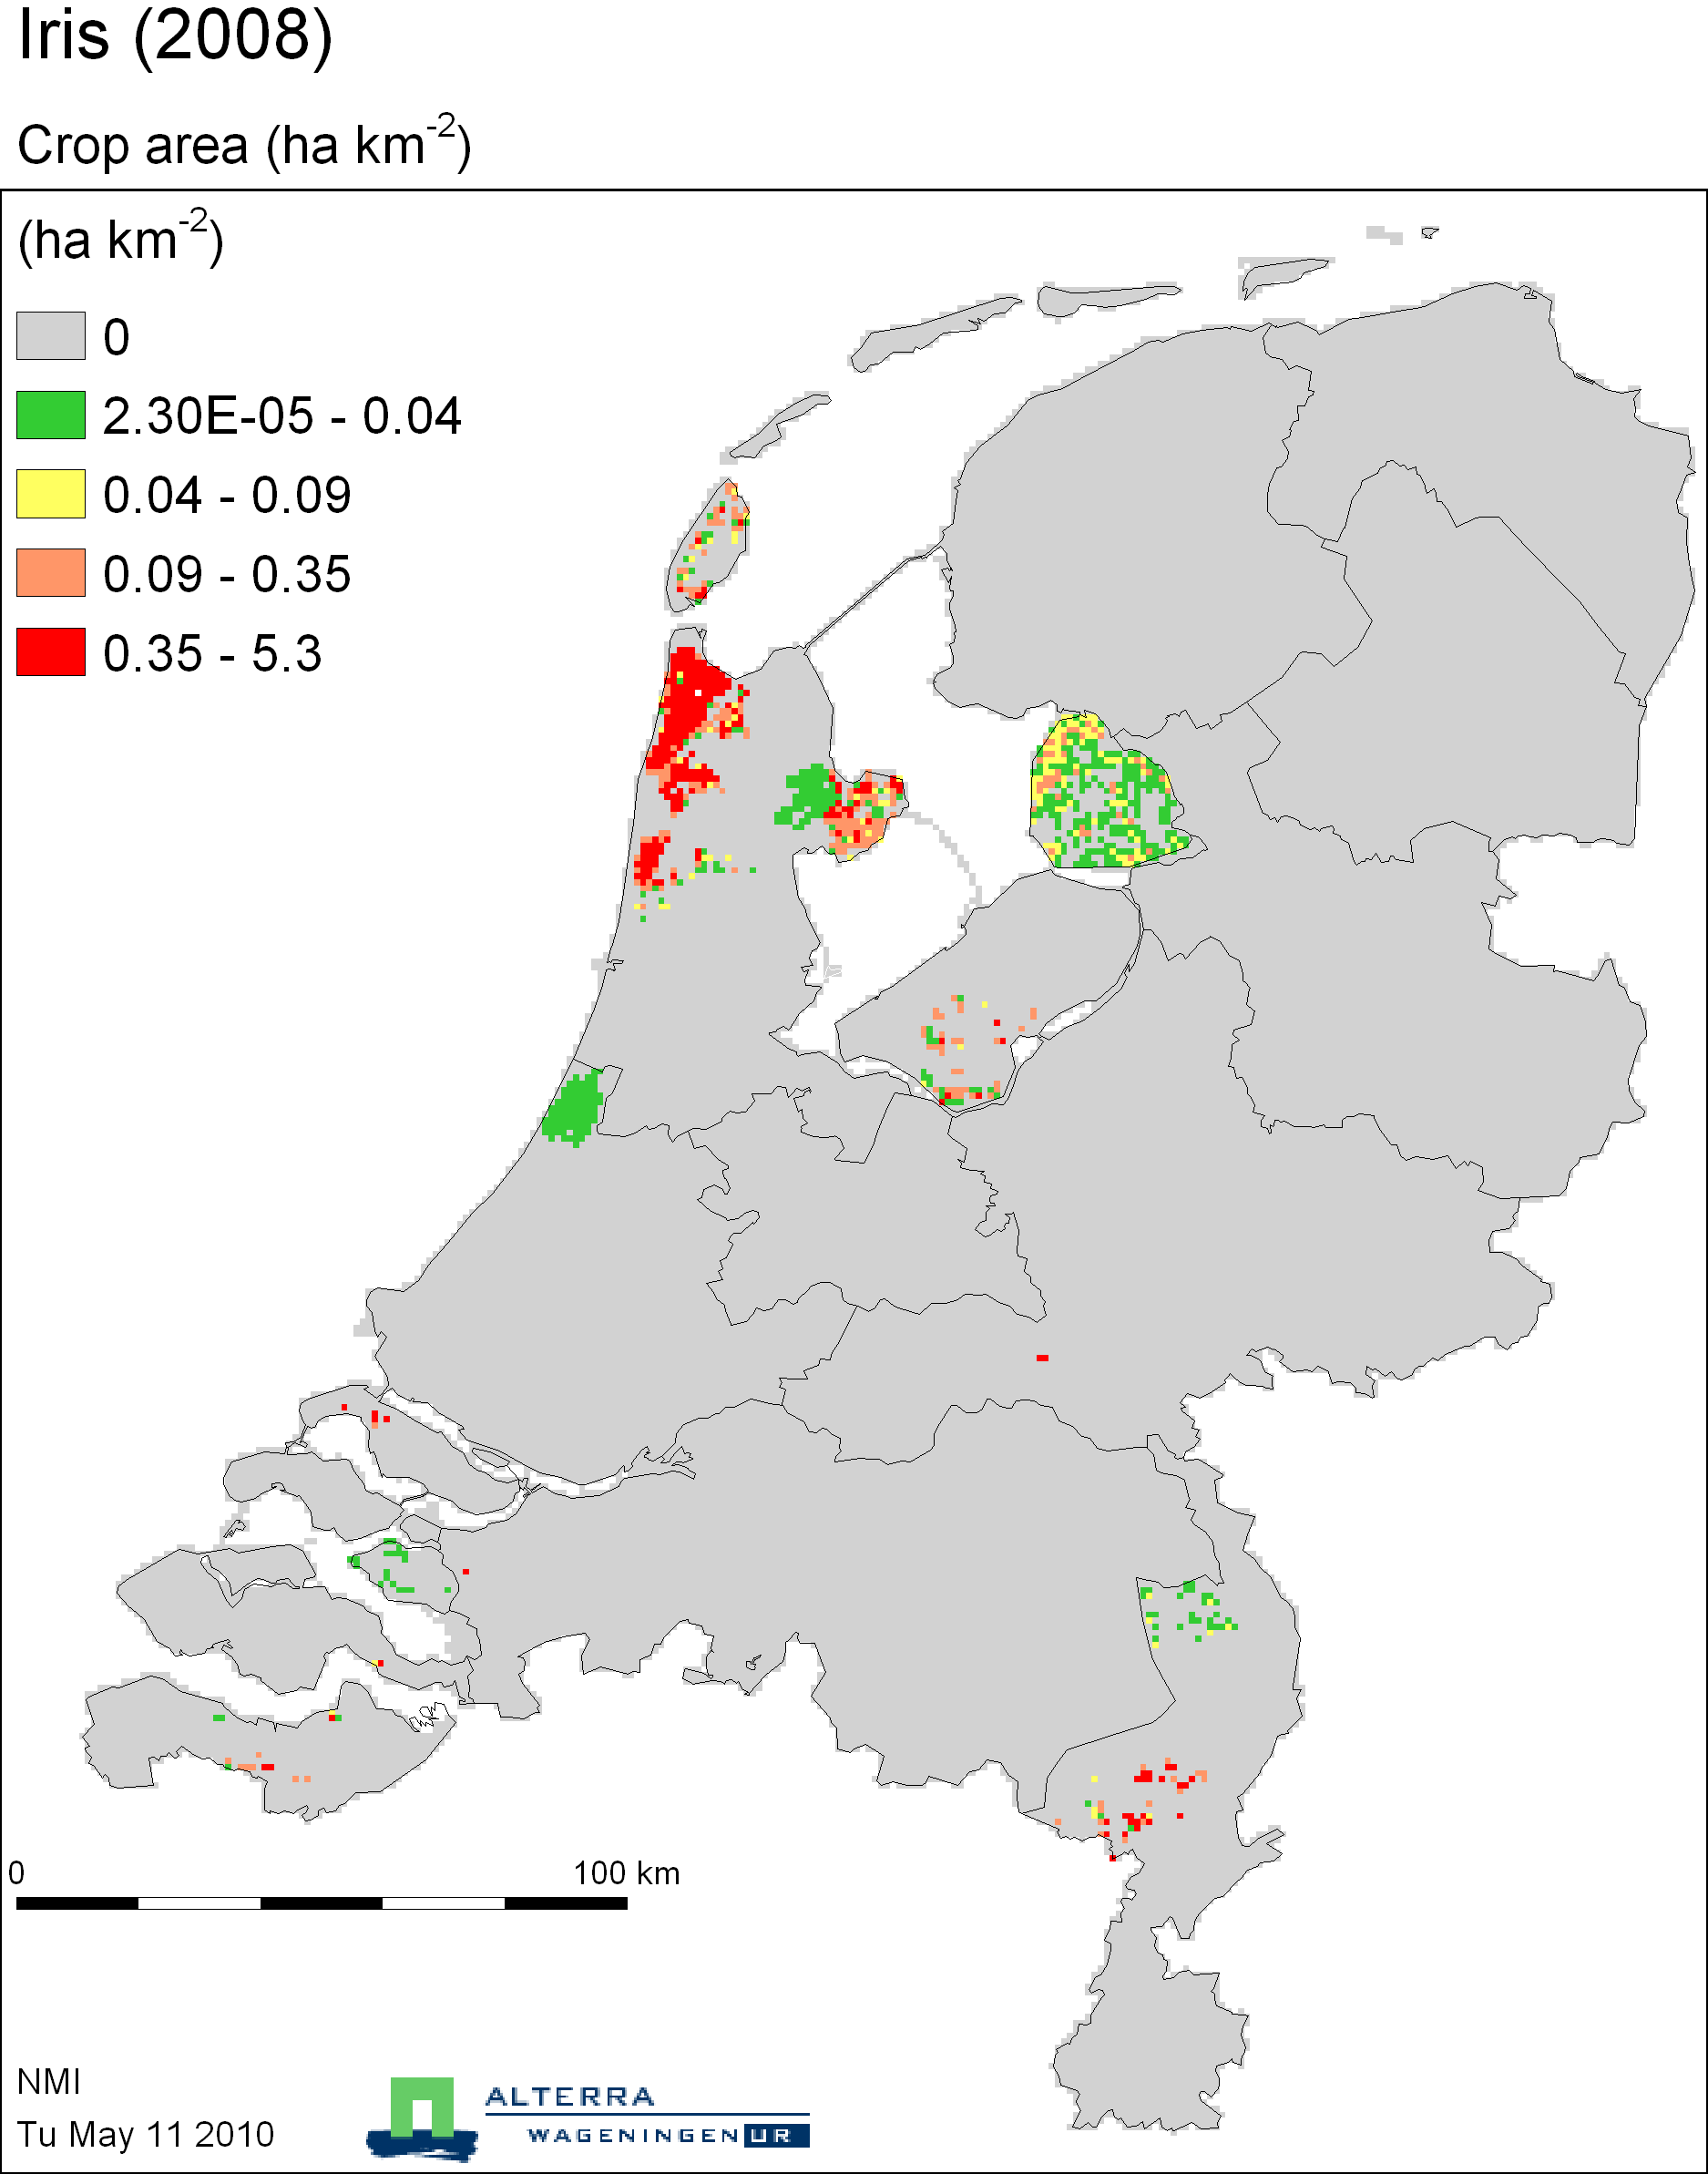

Glasshouse floristry

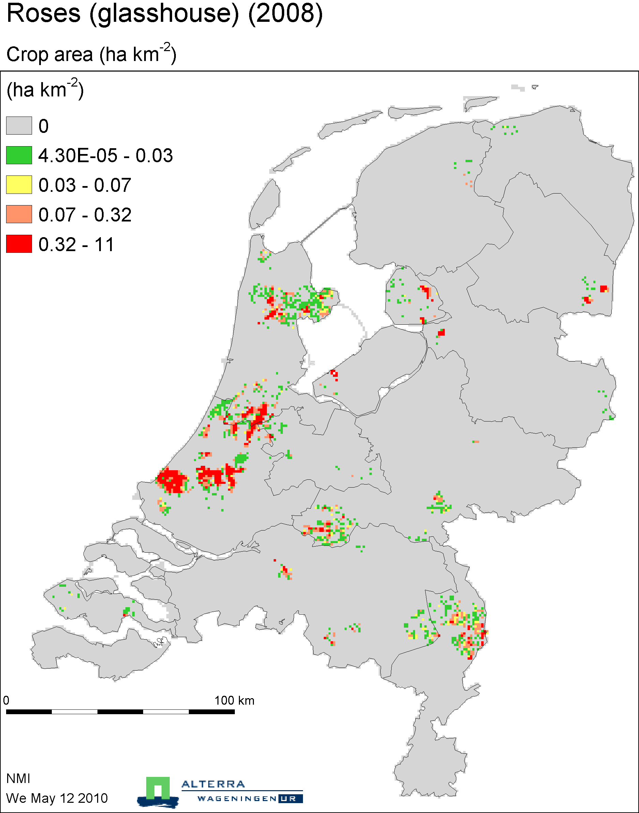

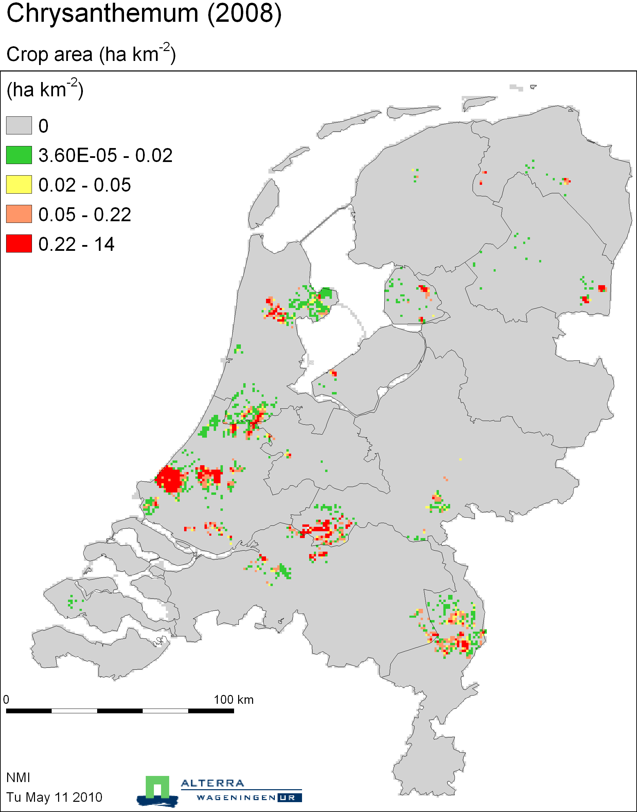

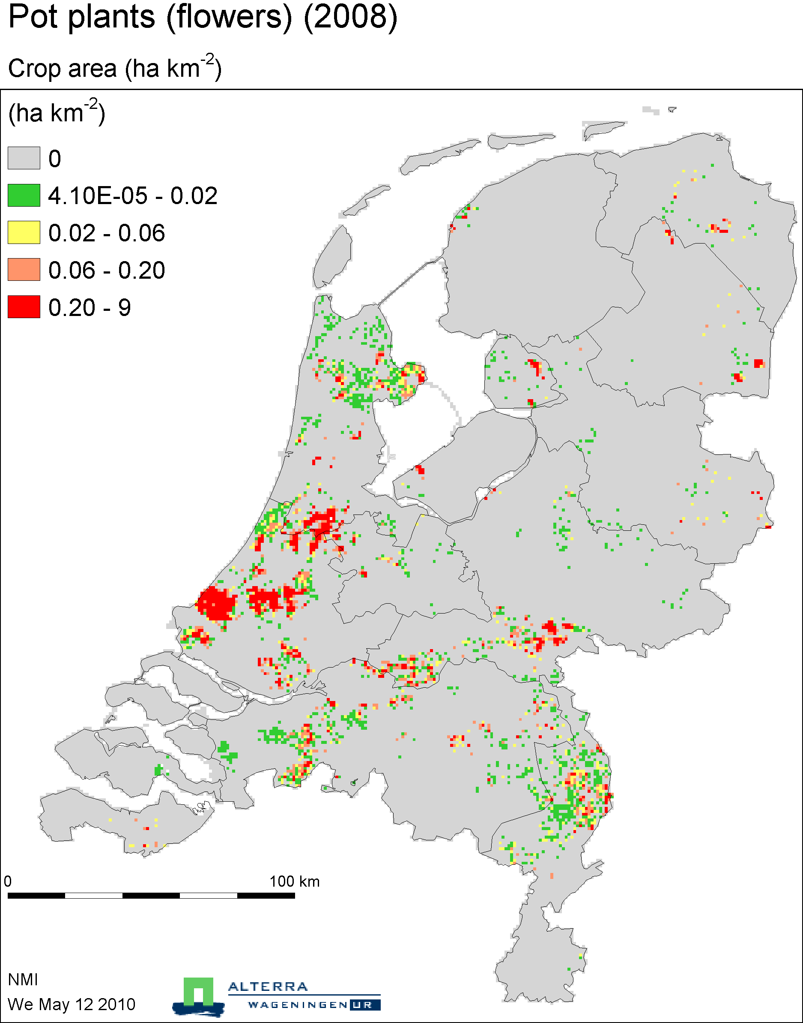

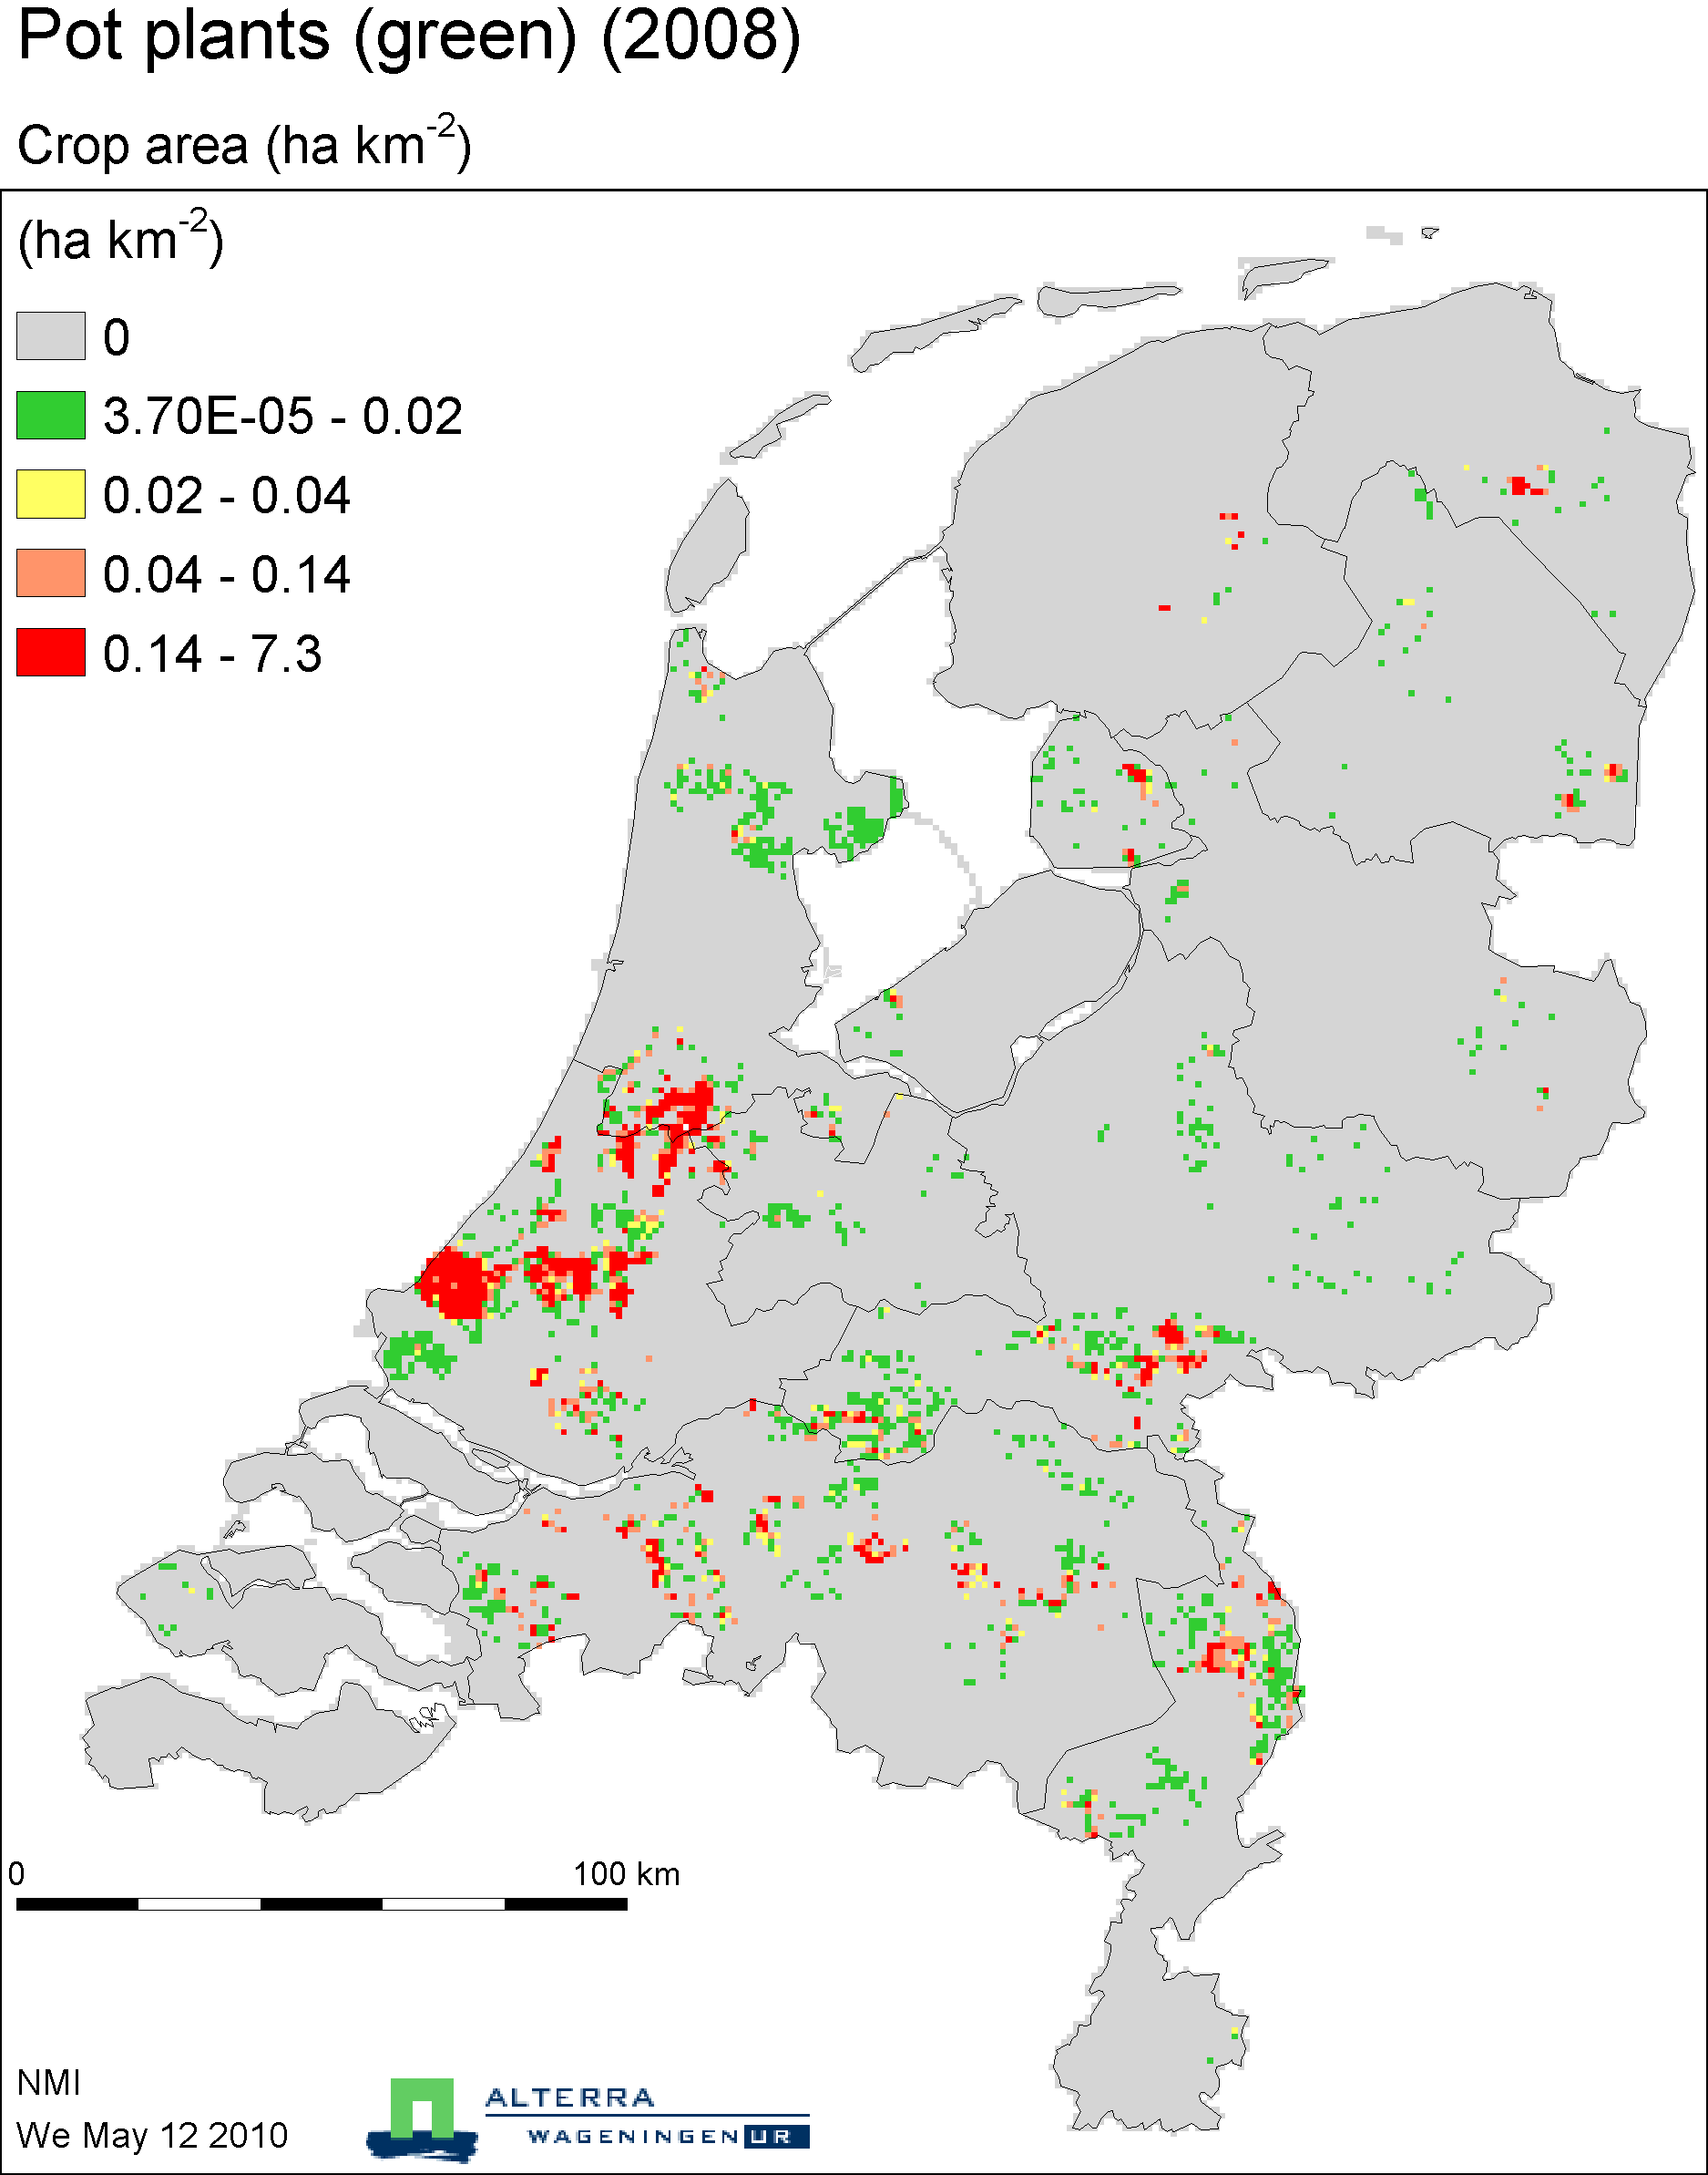

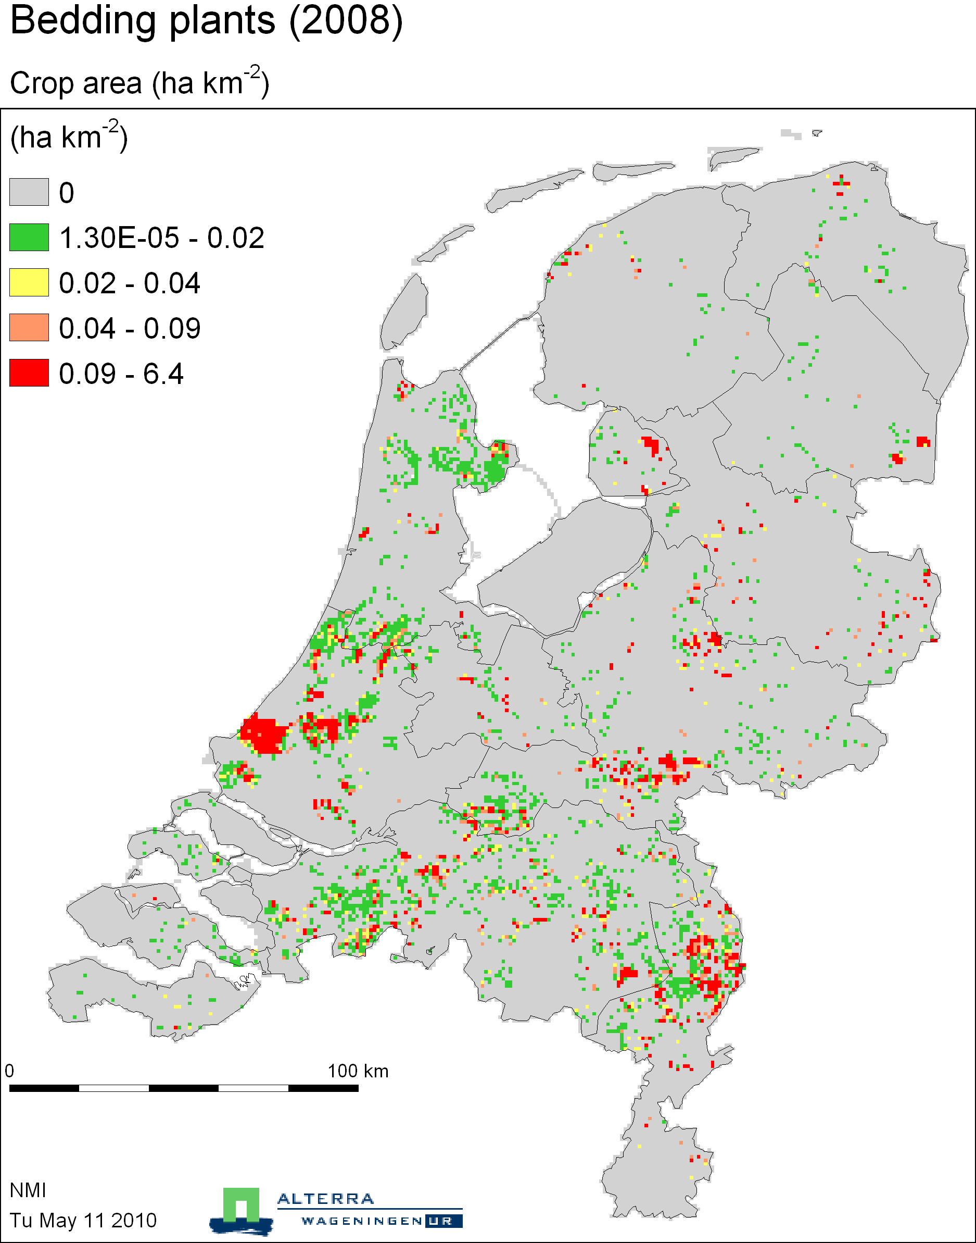

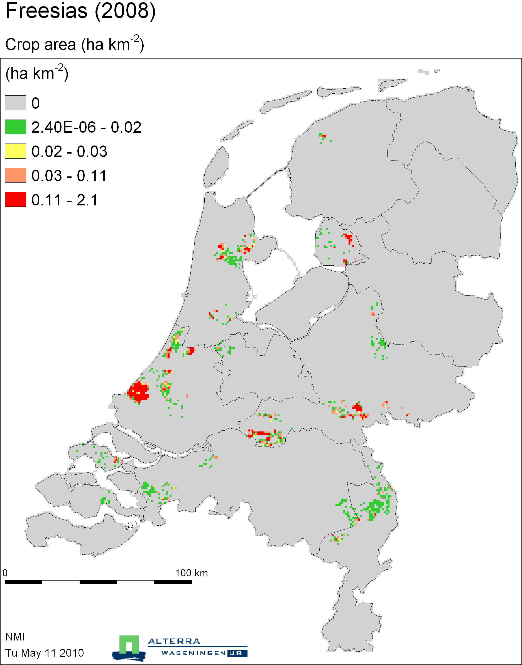

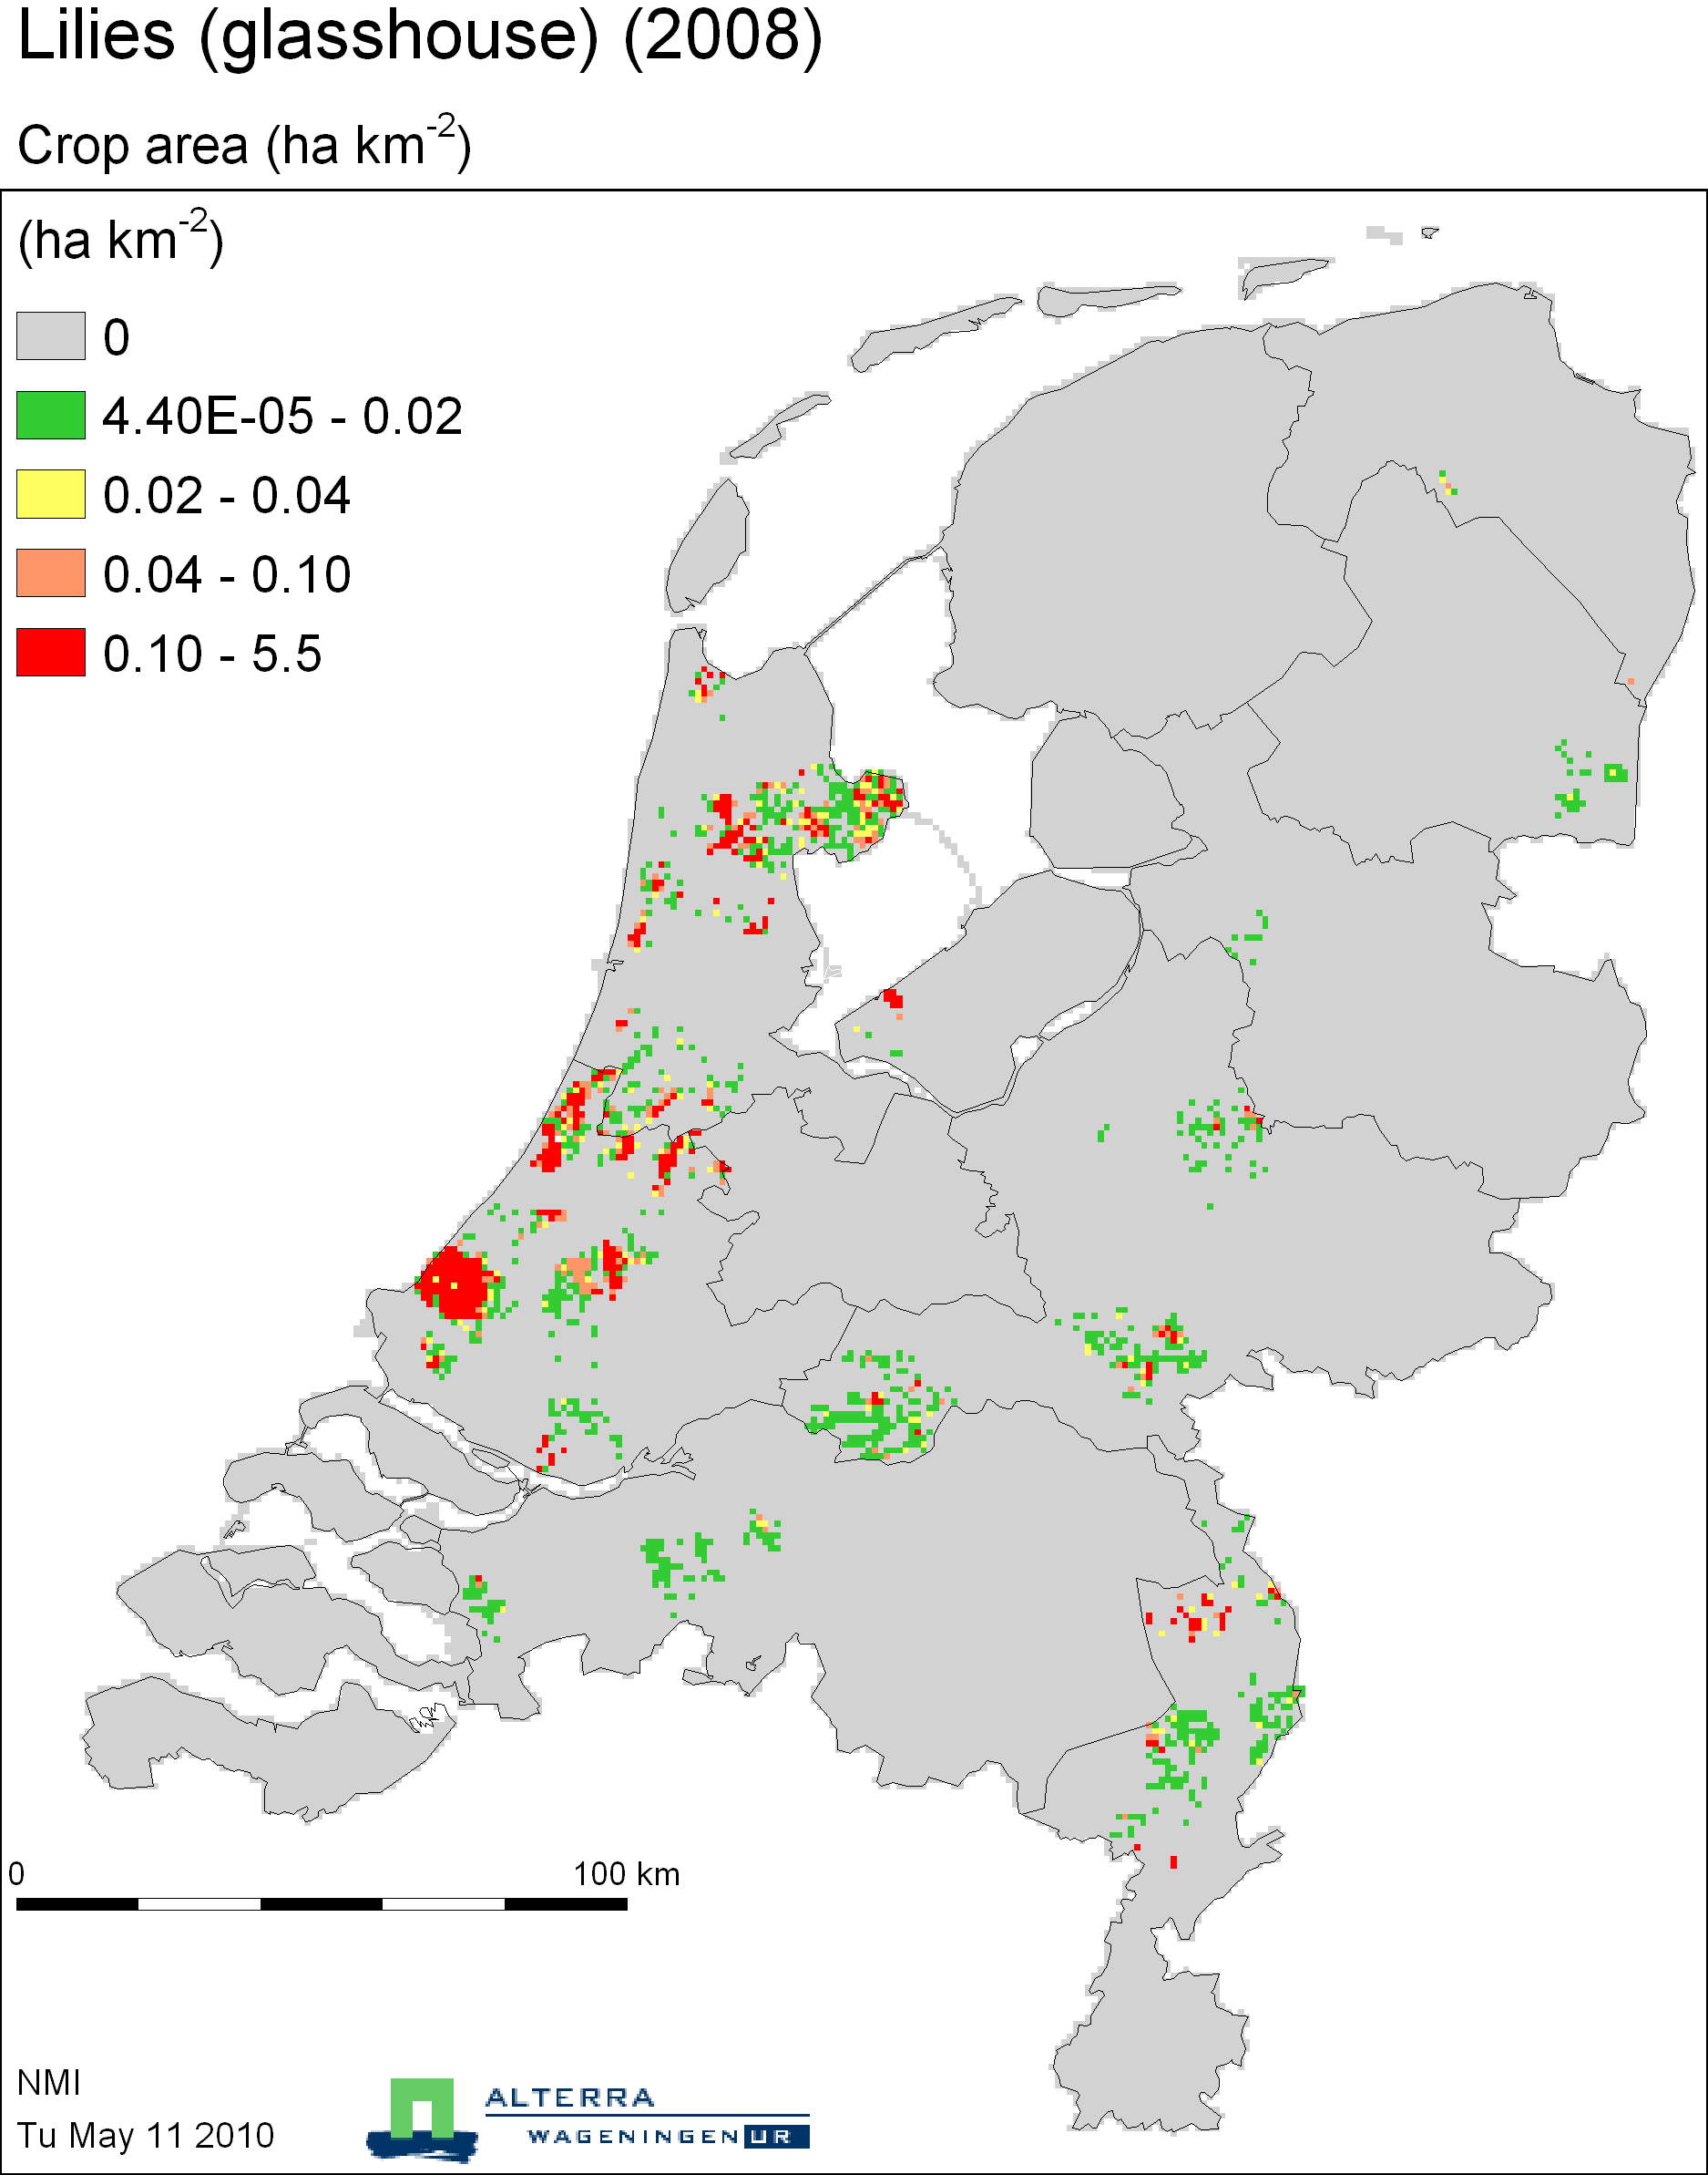

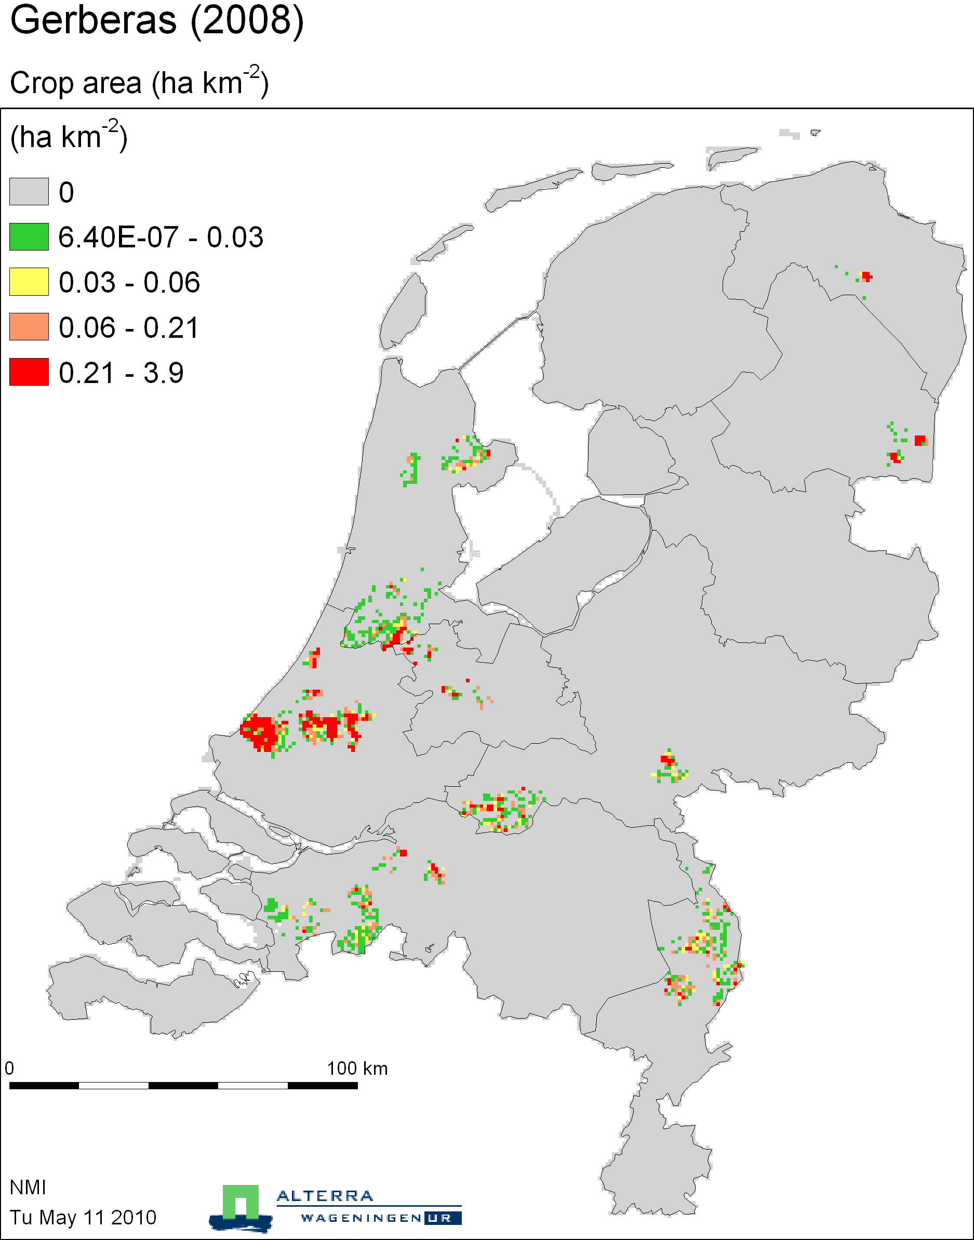

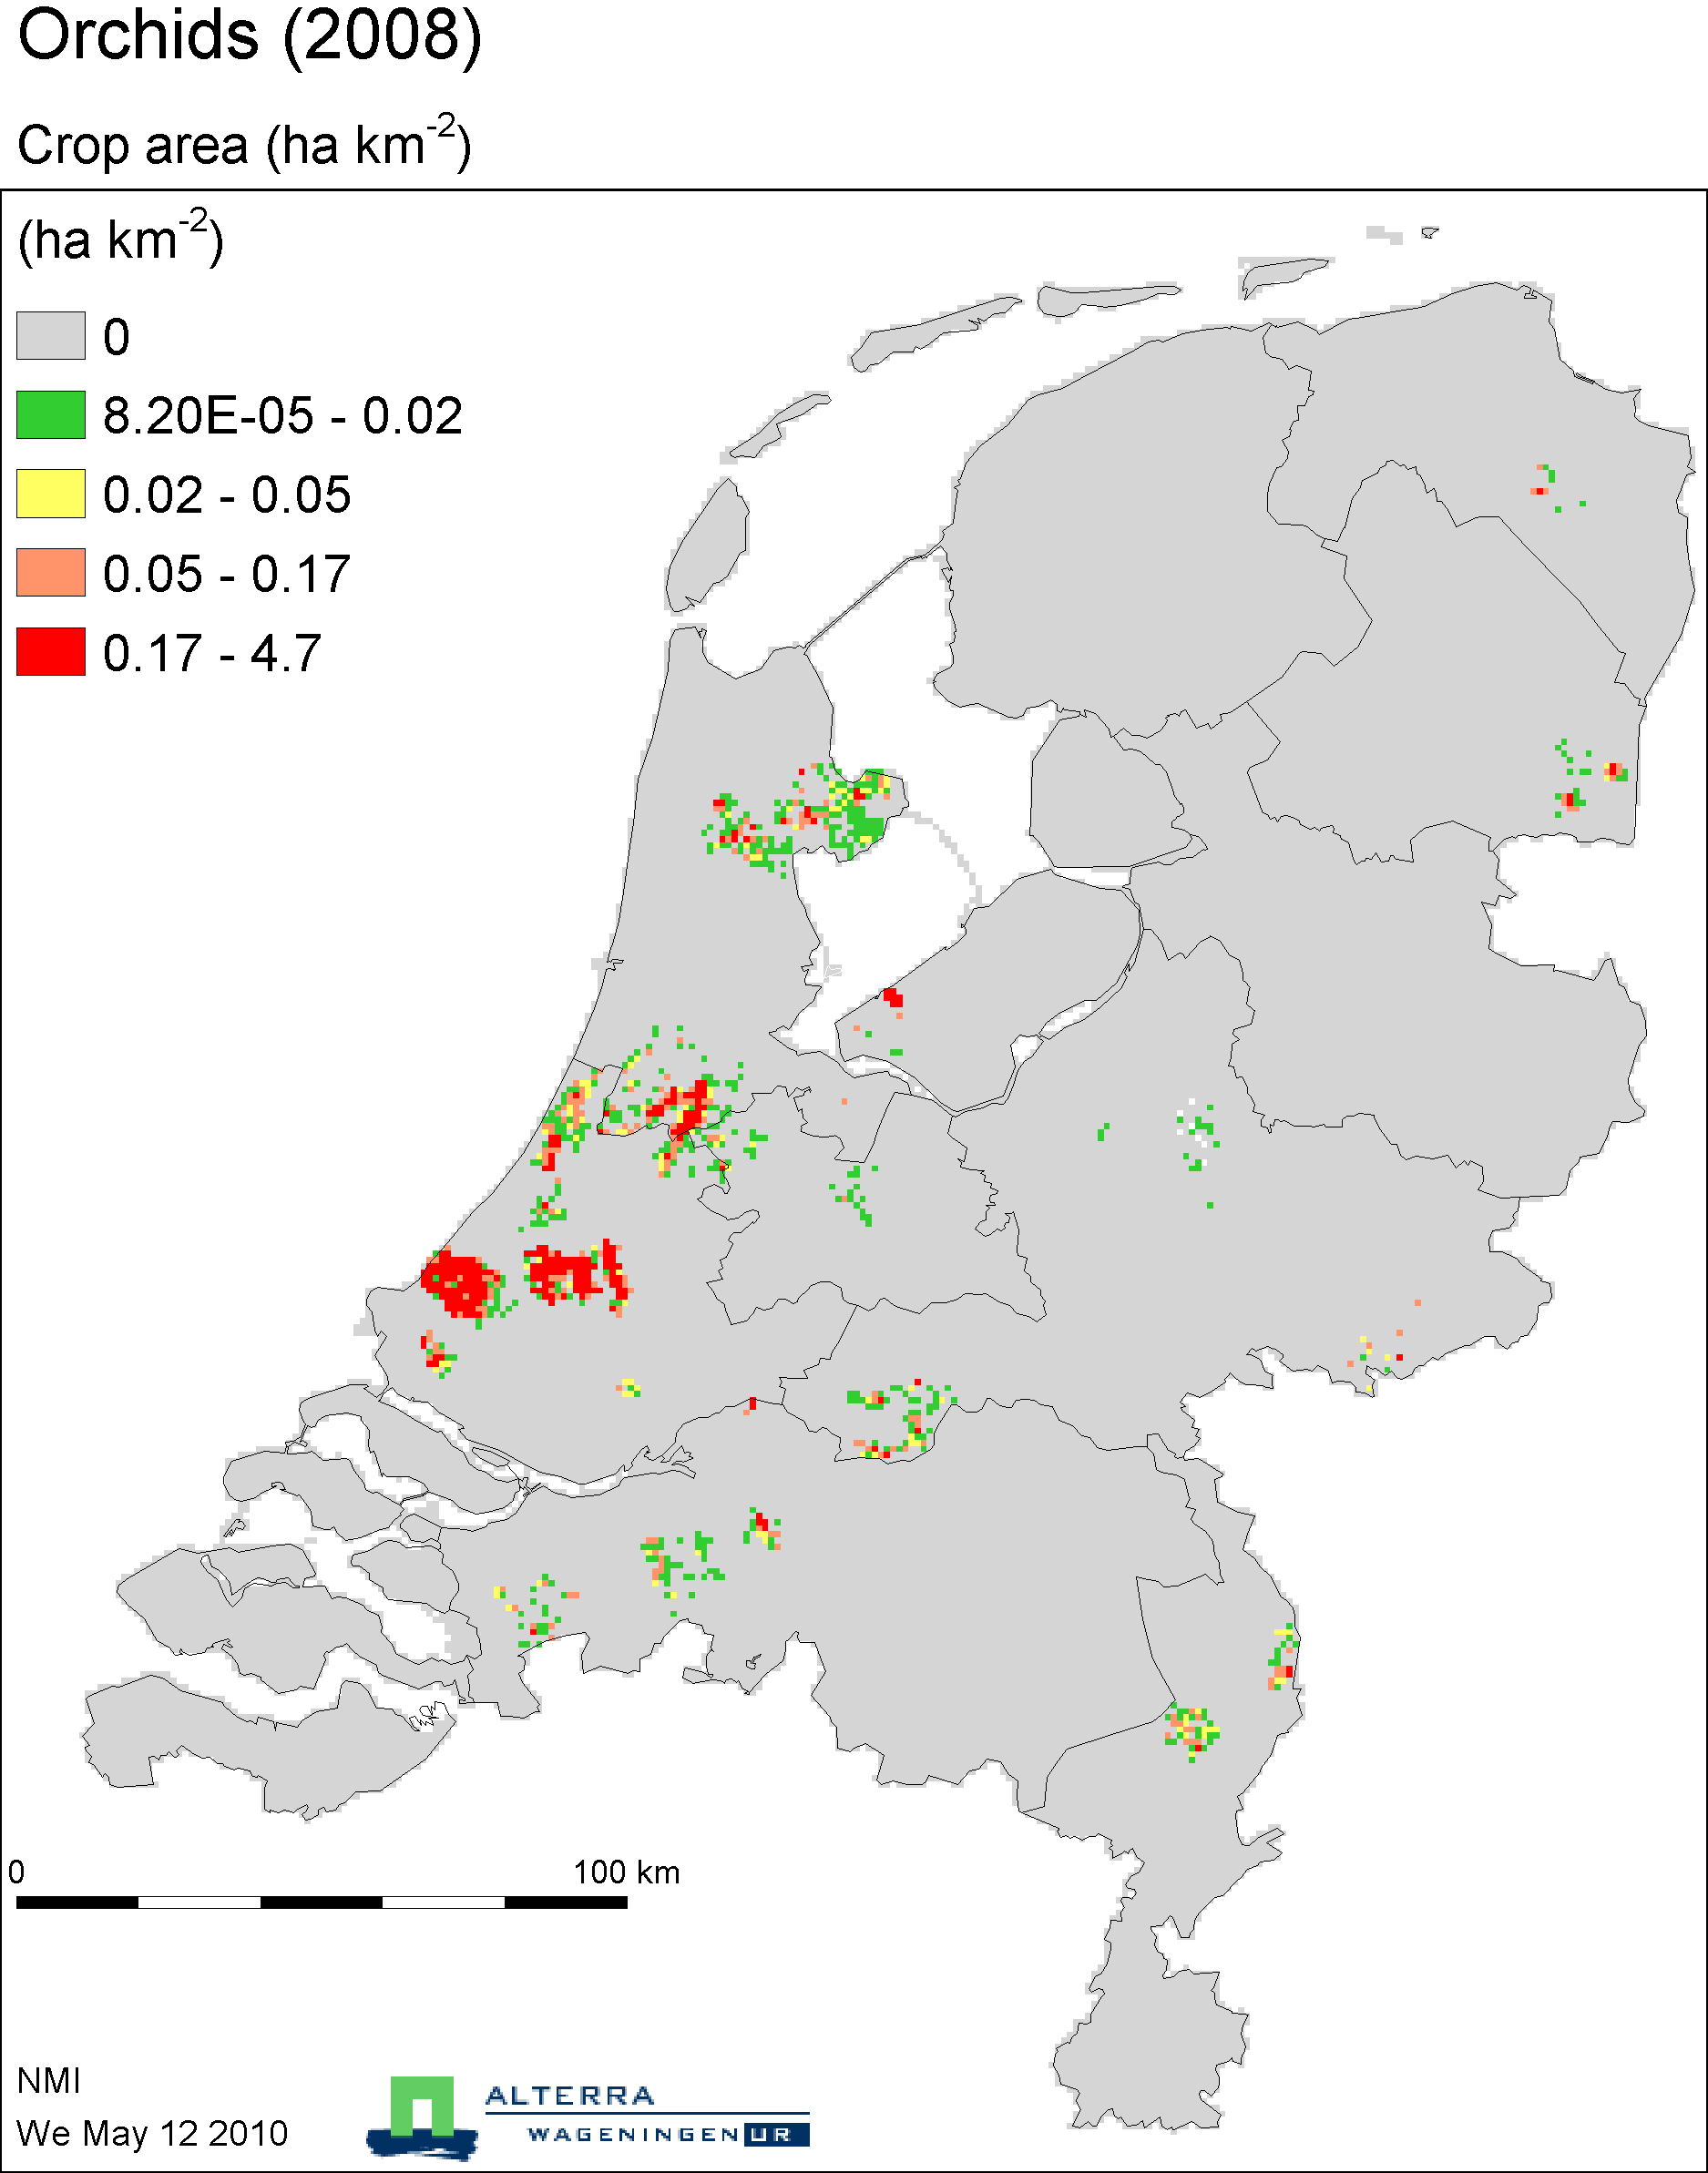

Tree cultivation

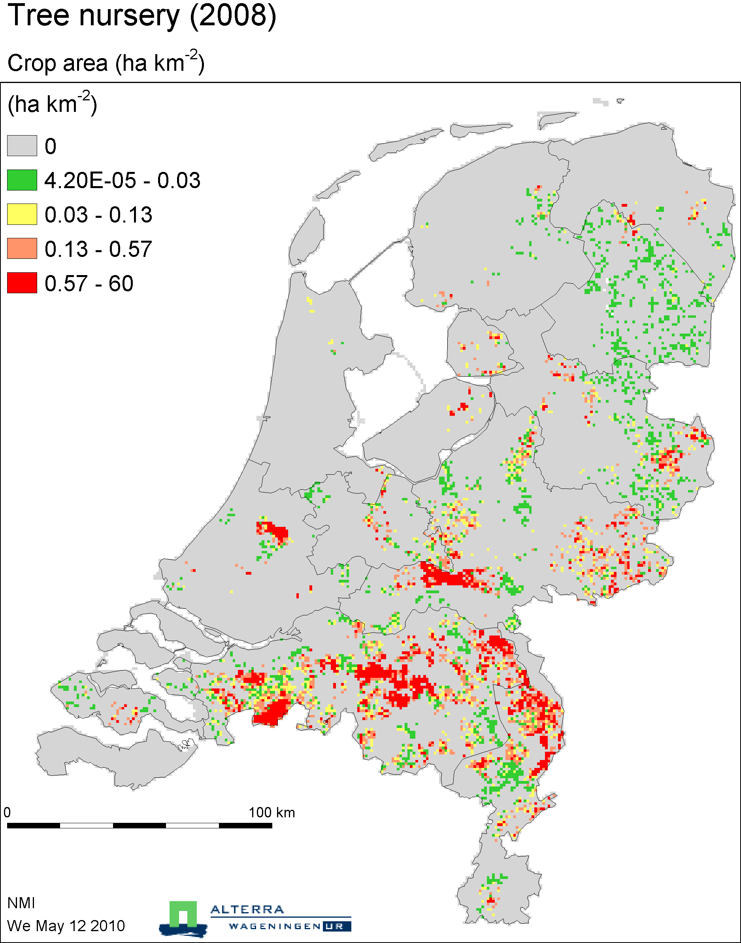

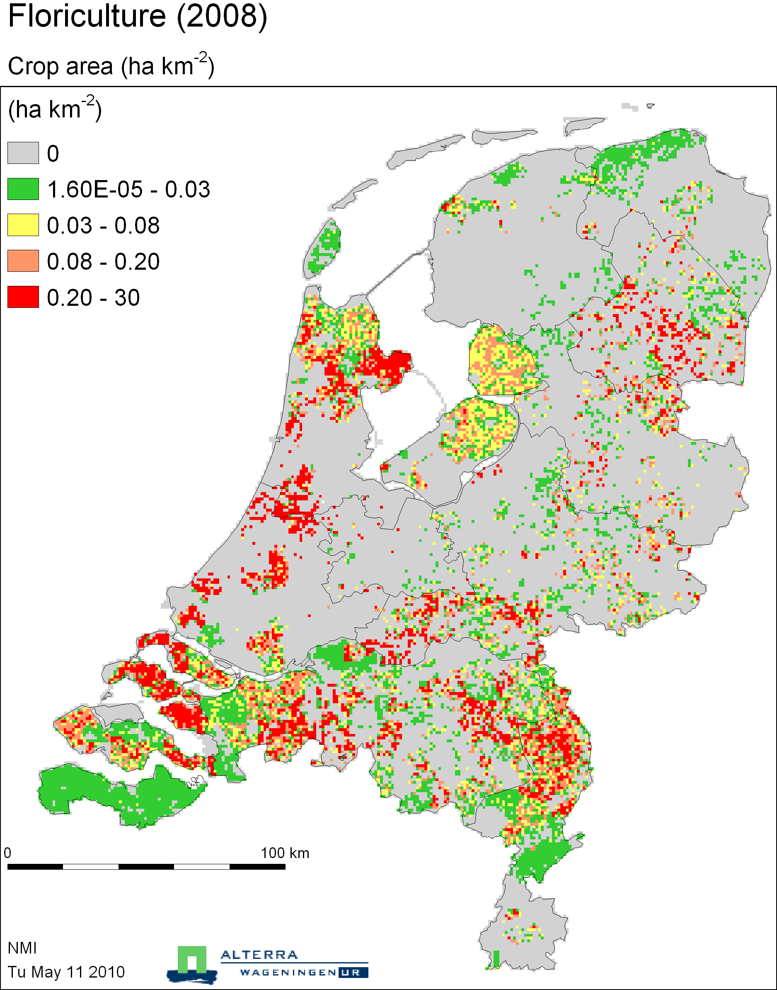

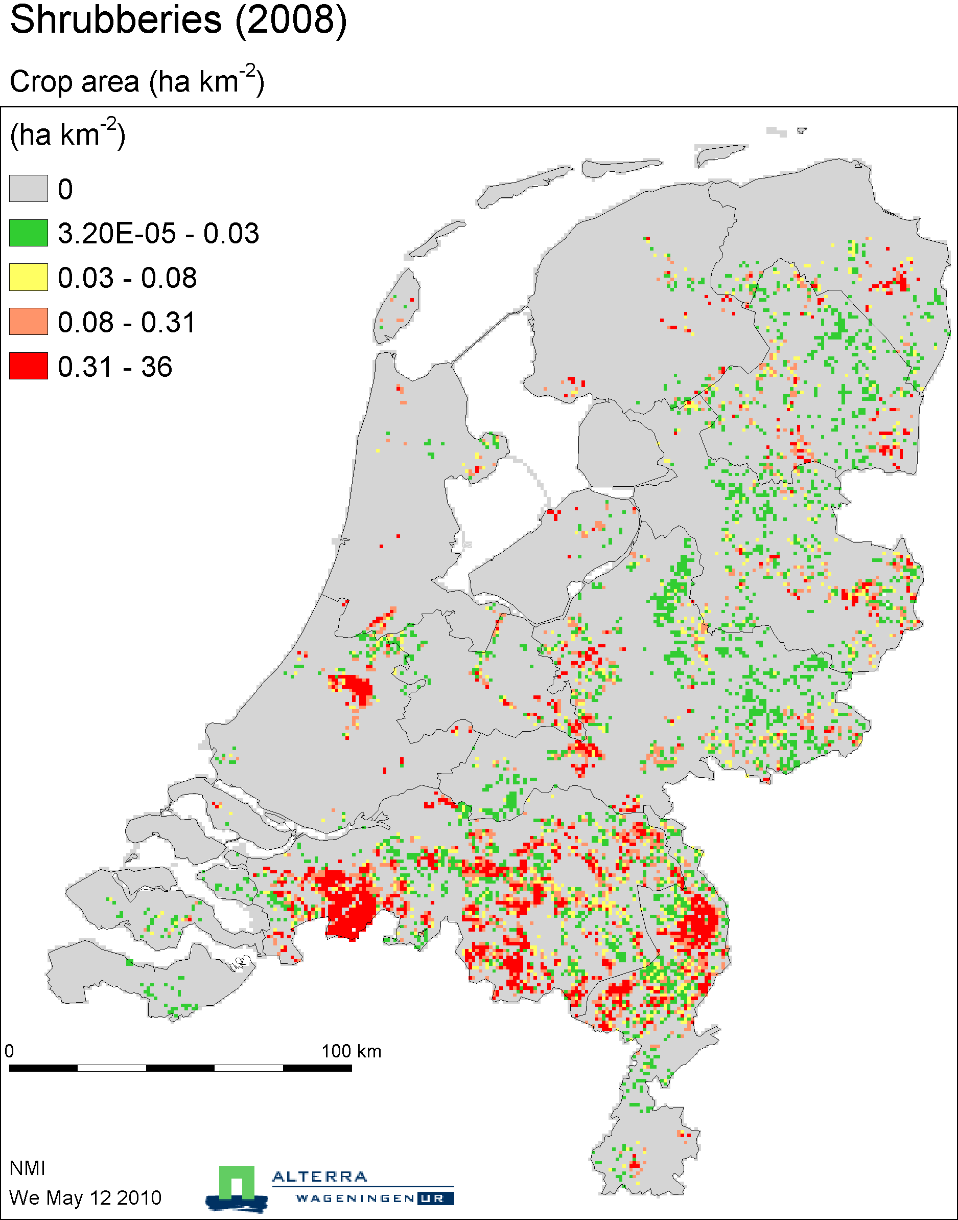

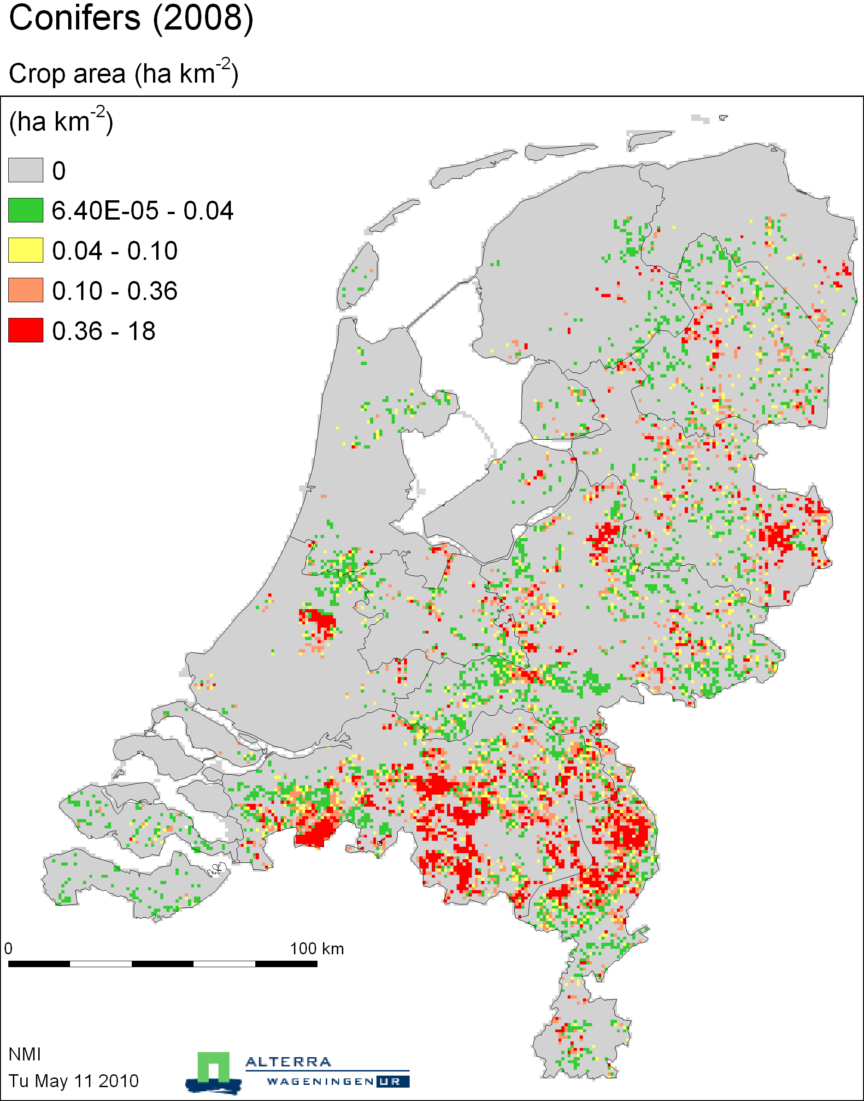

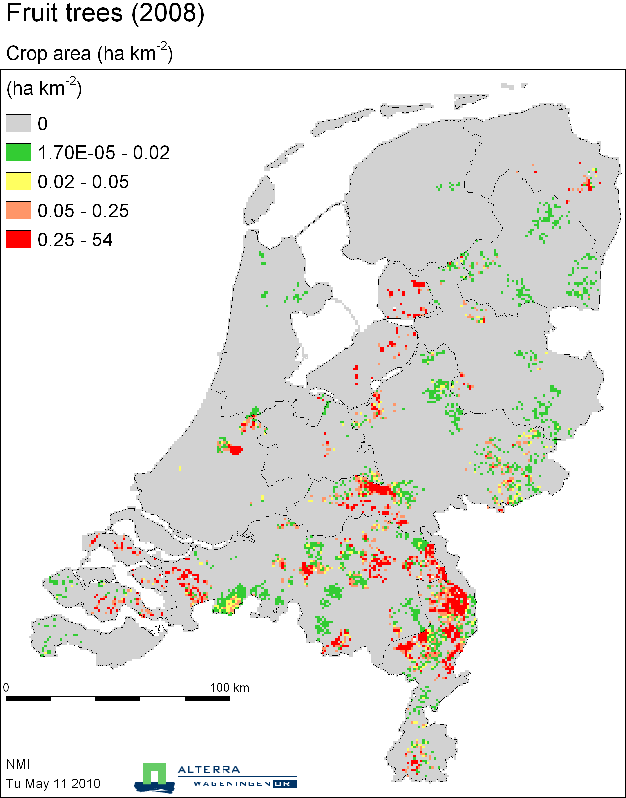

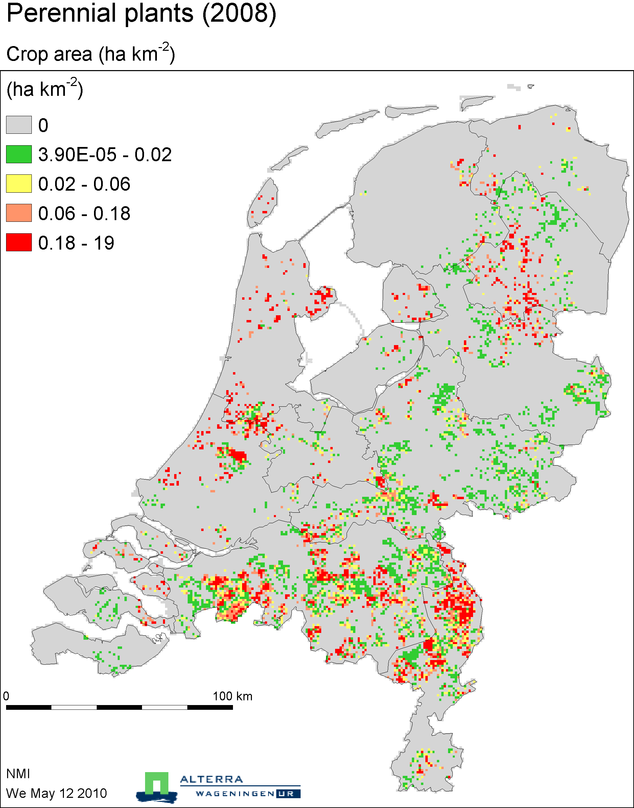

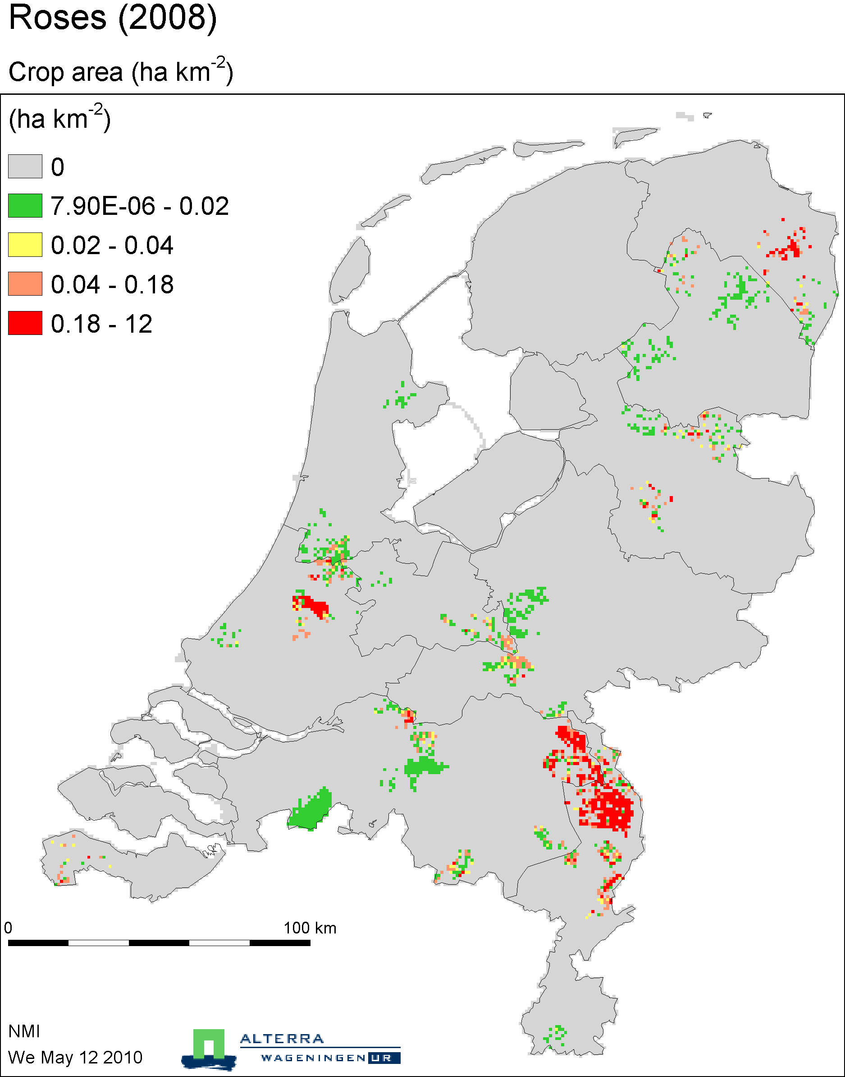

Fruit cultivation

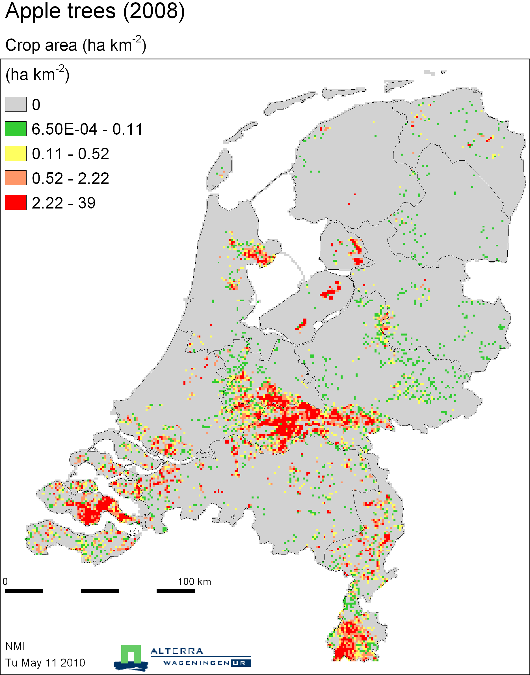

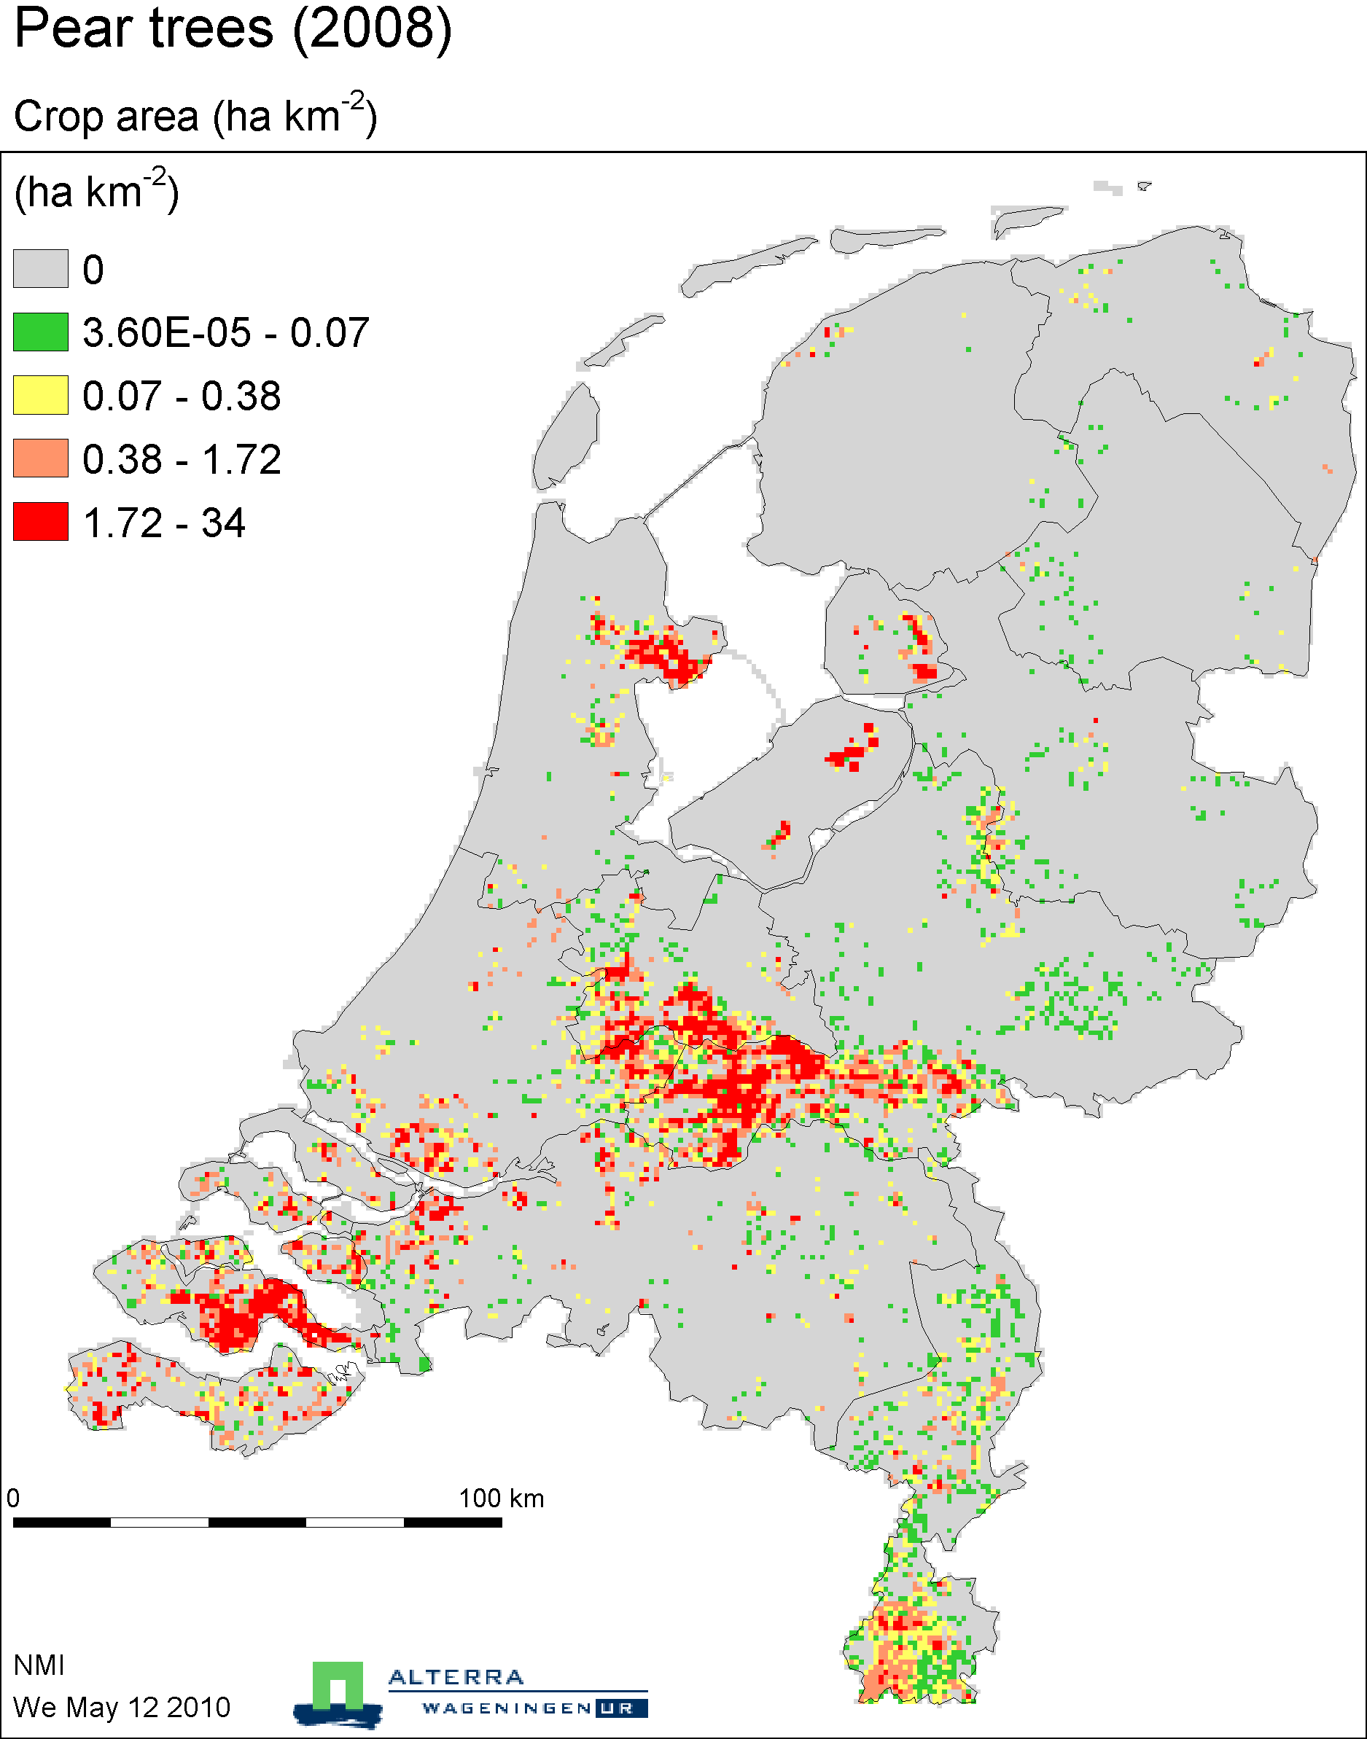

Greenhouse vegetables

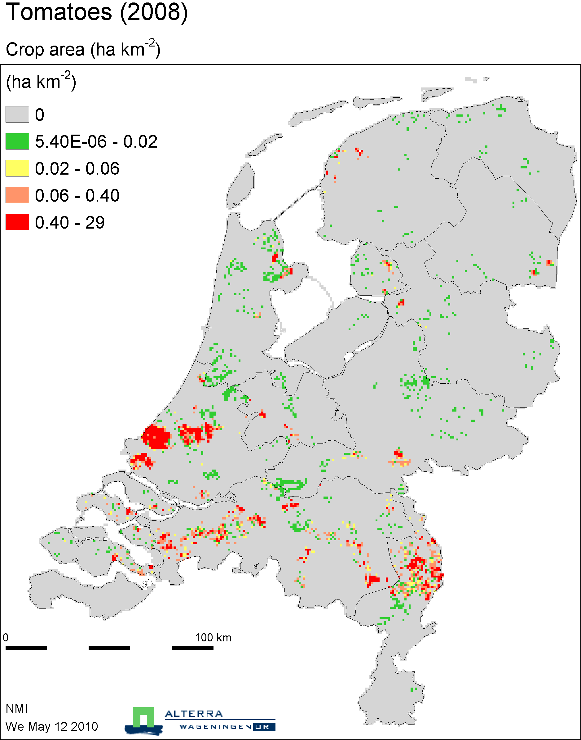

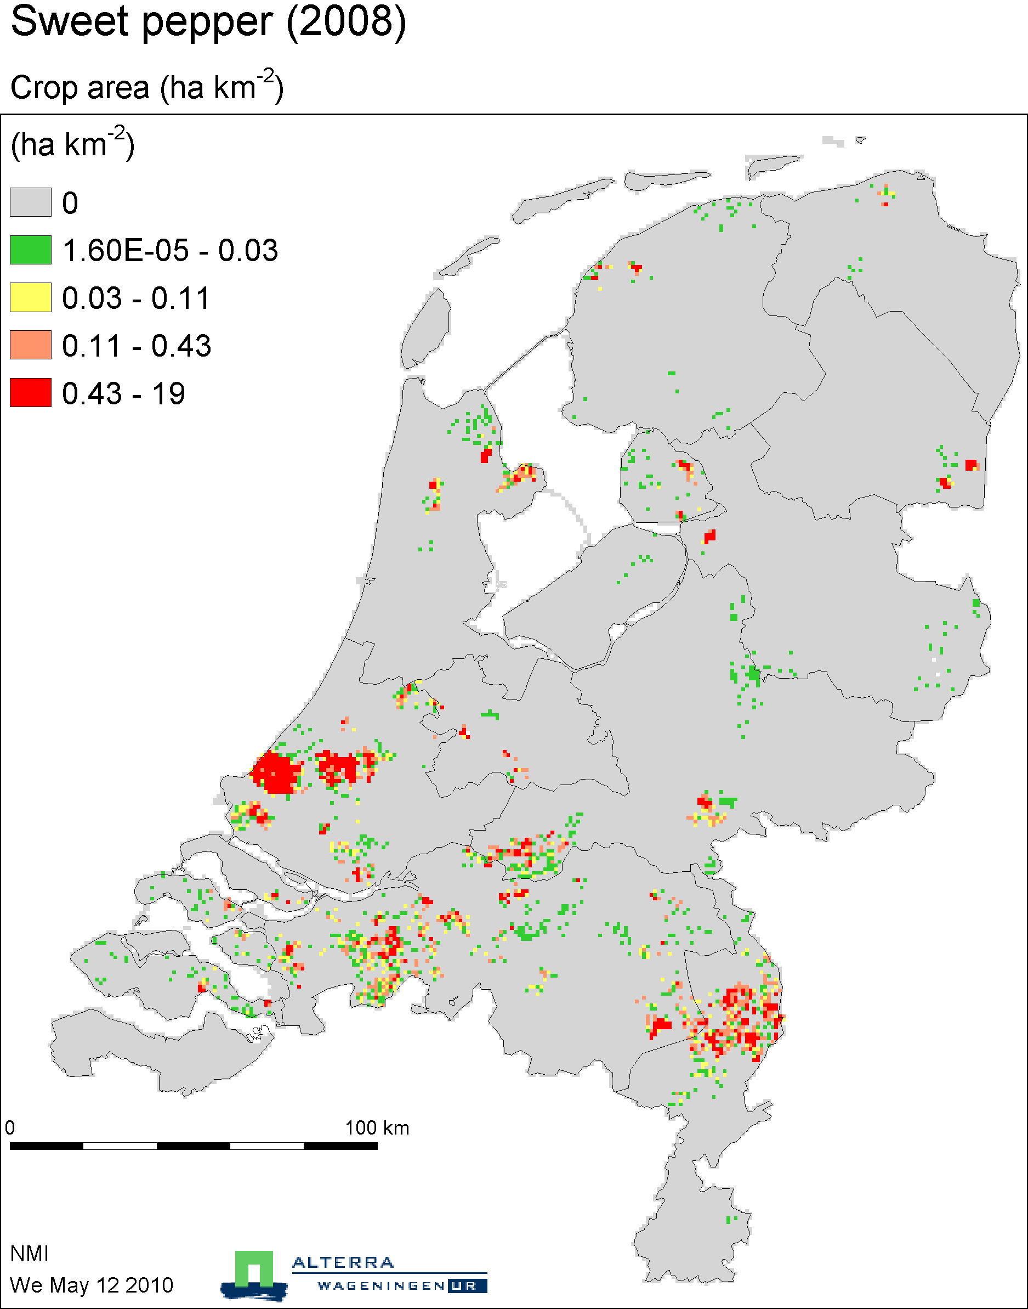

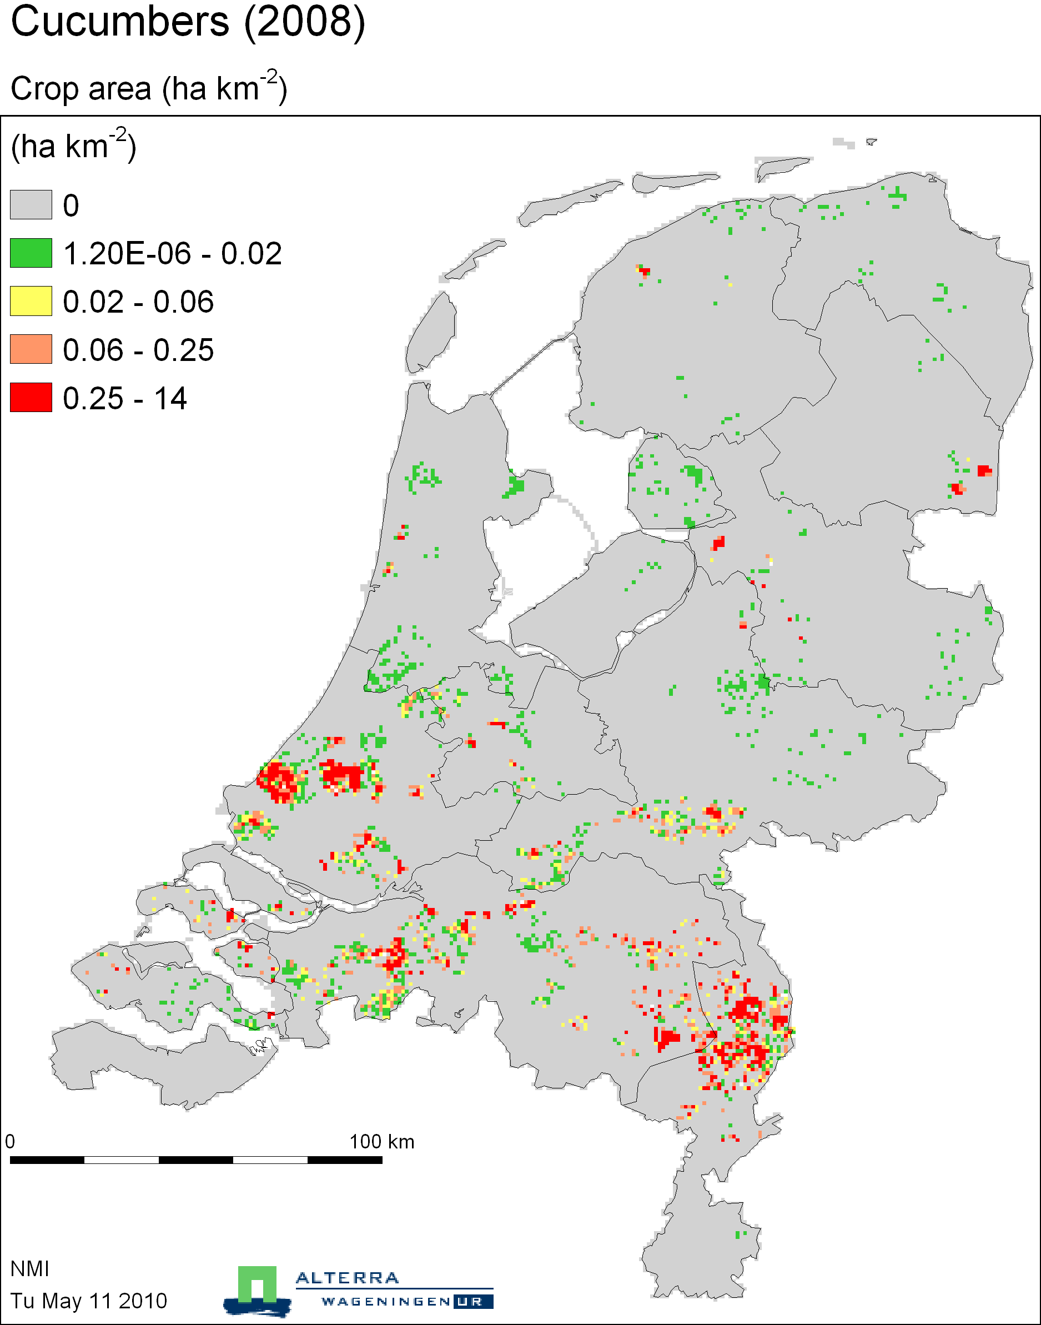

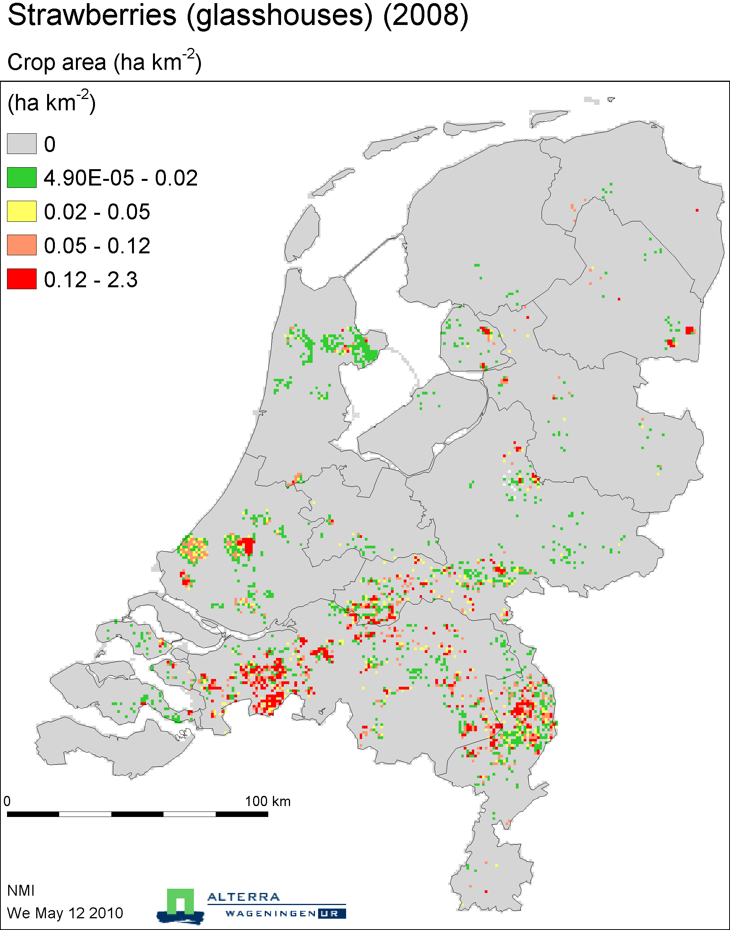

Open air vegetables

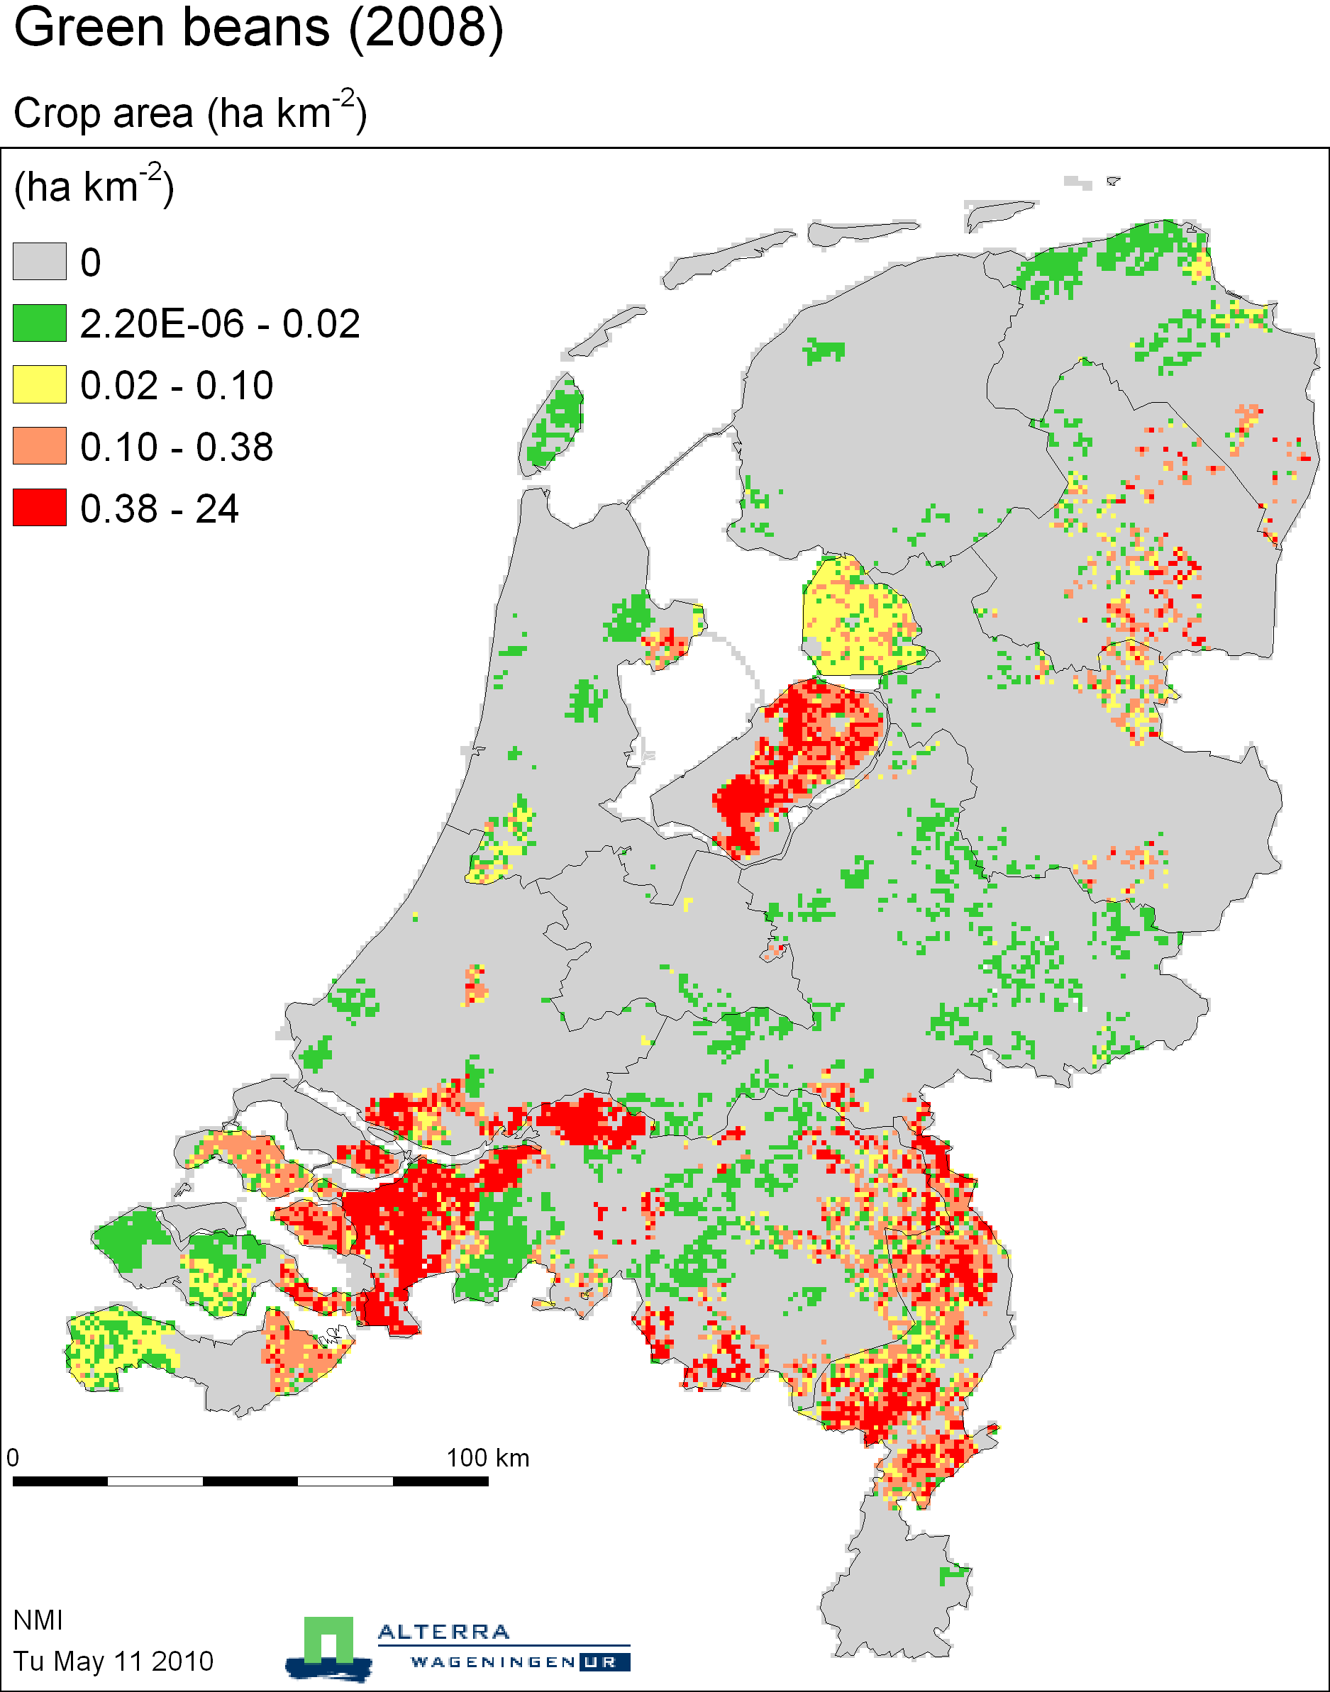

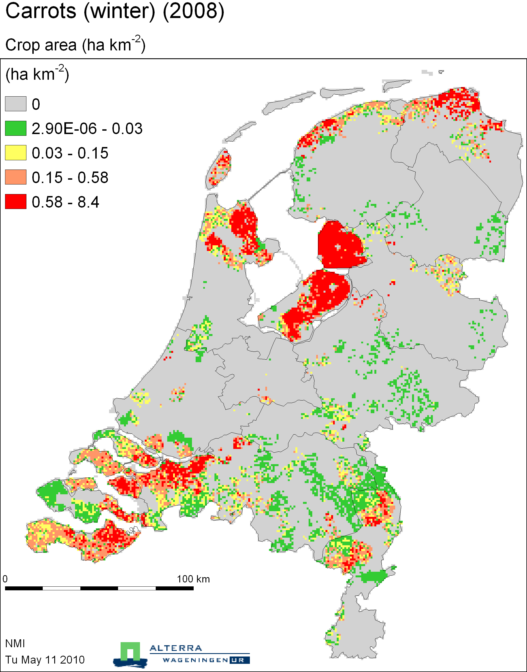

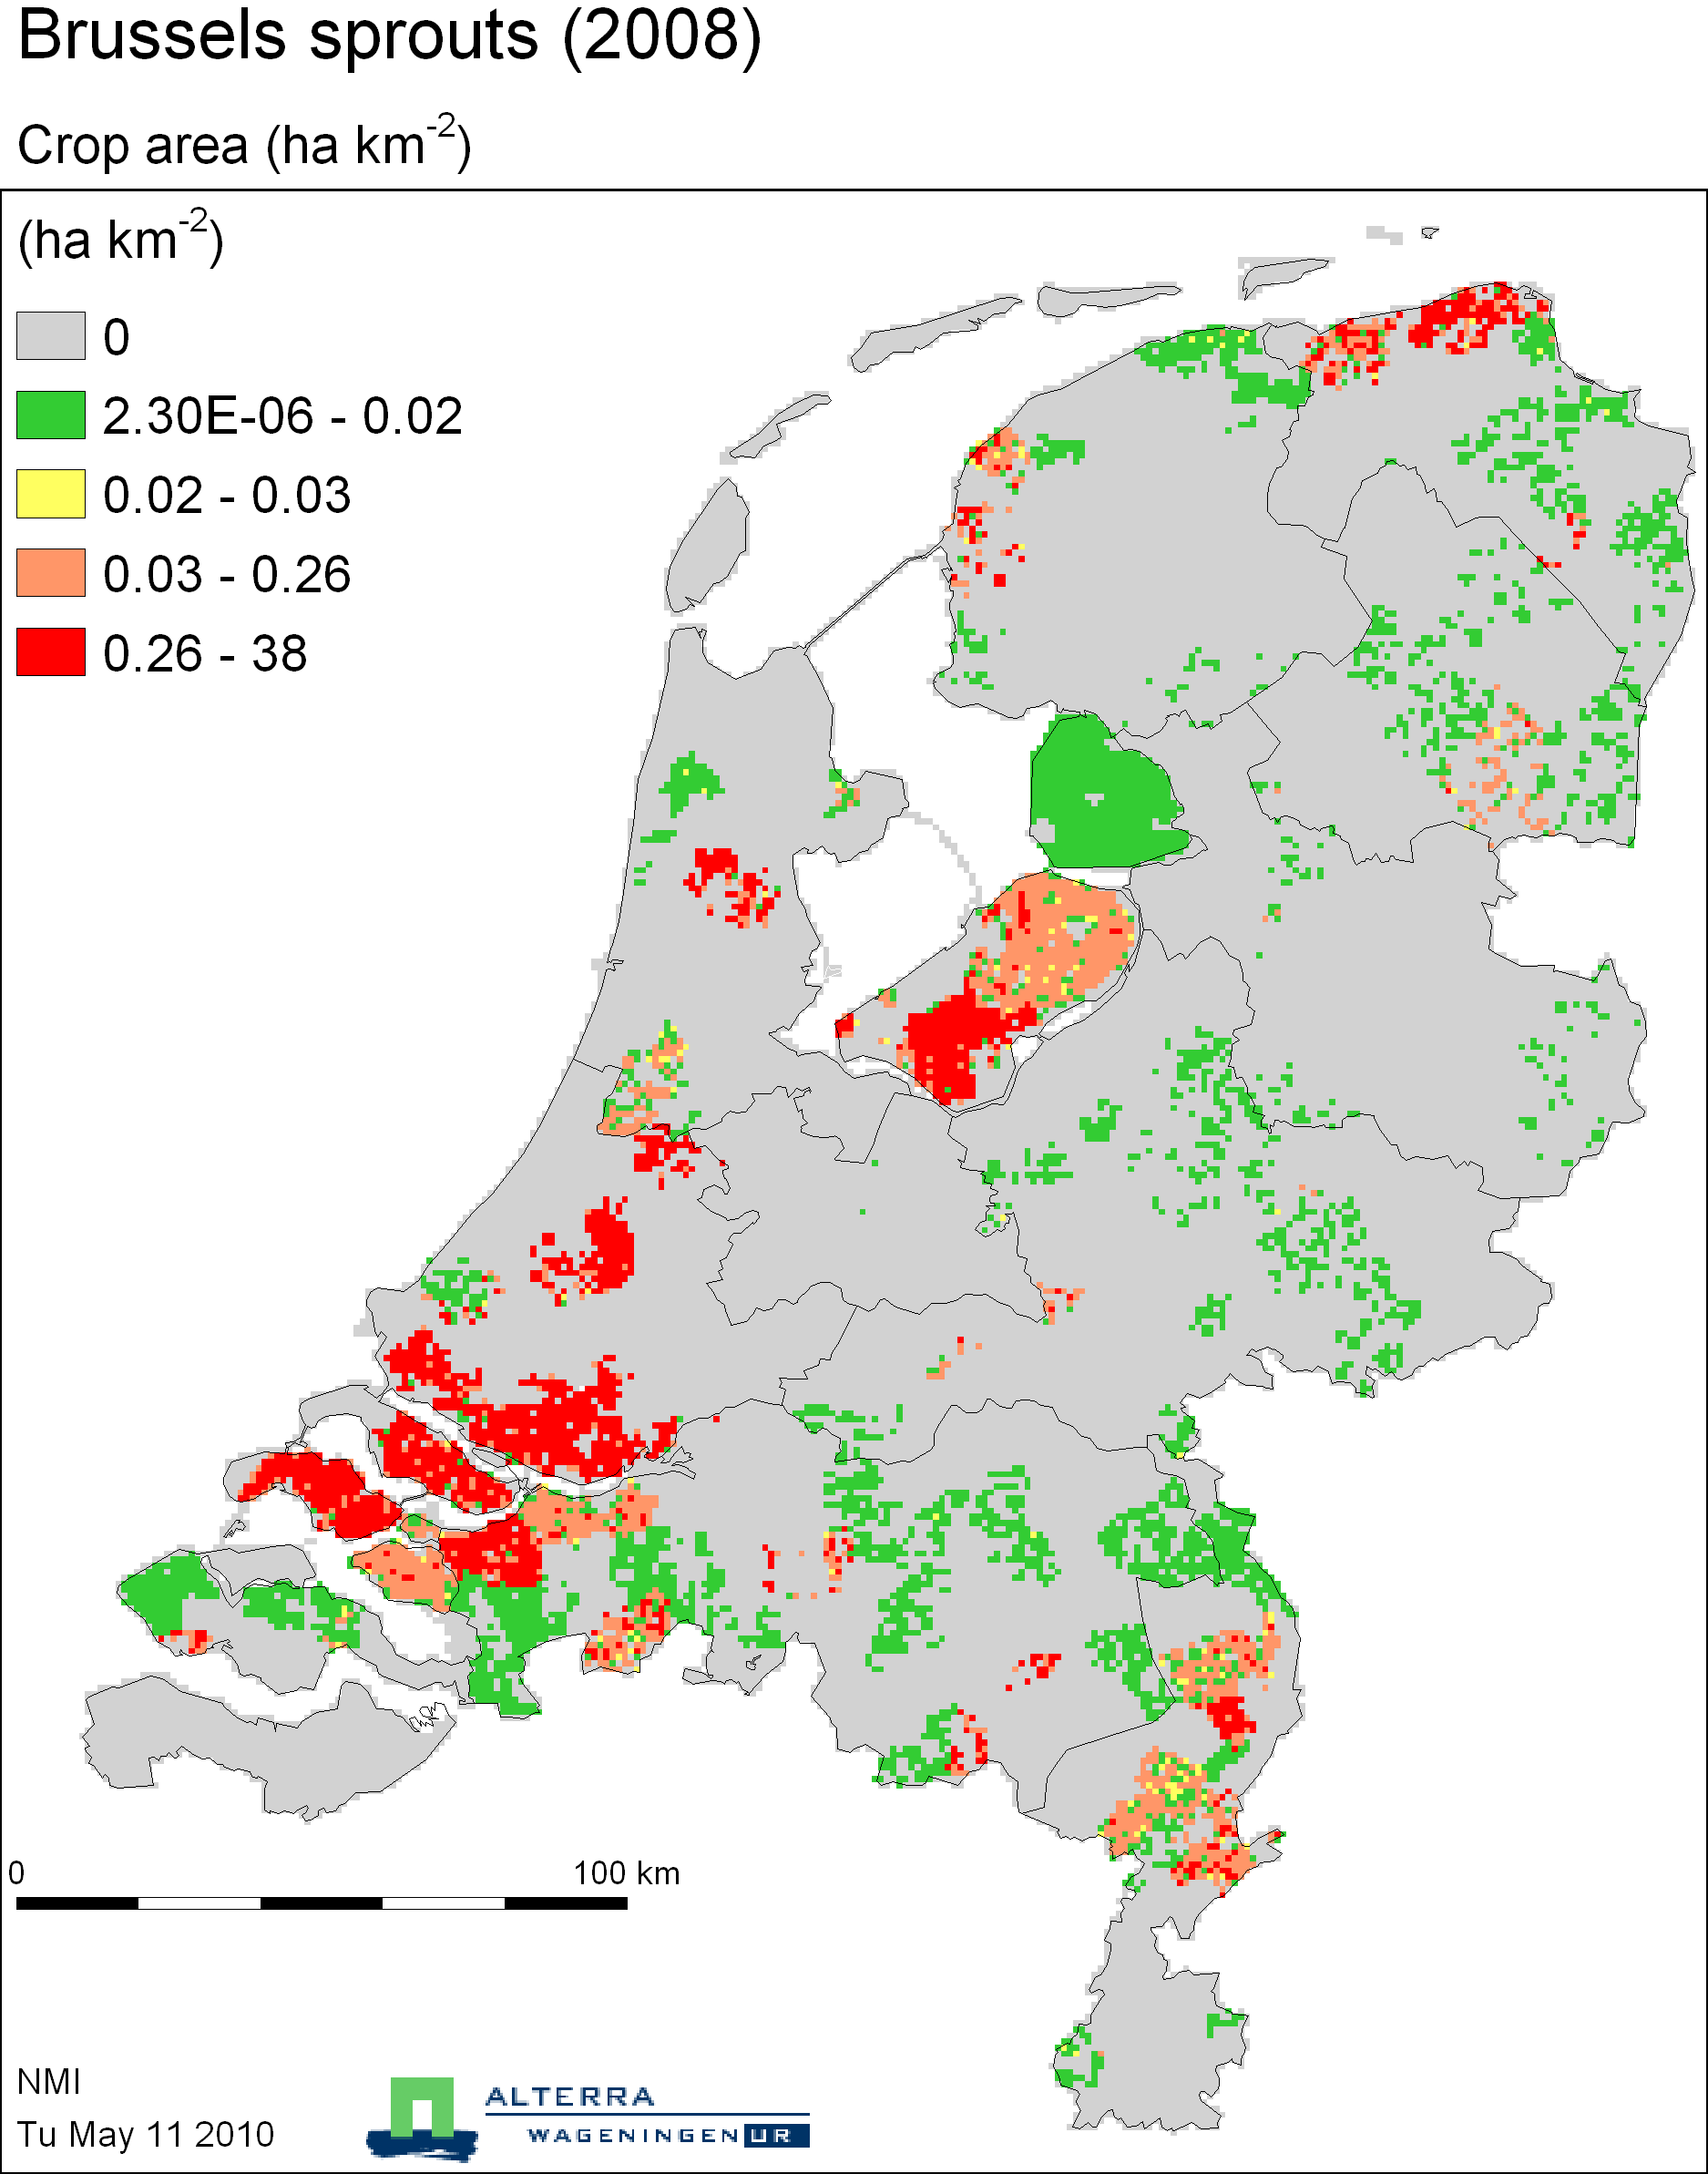

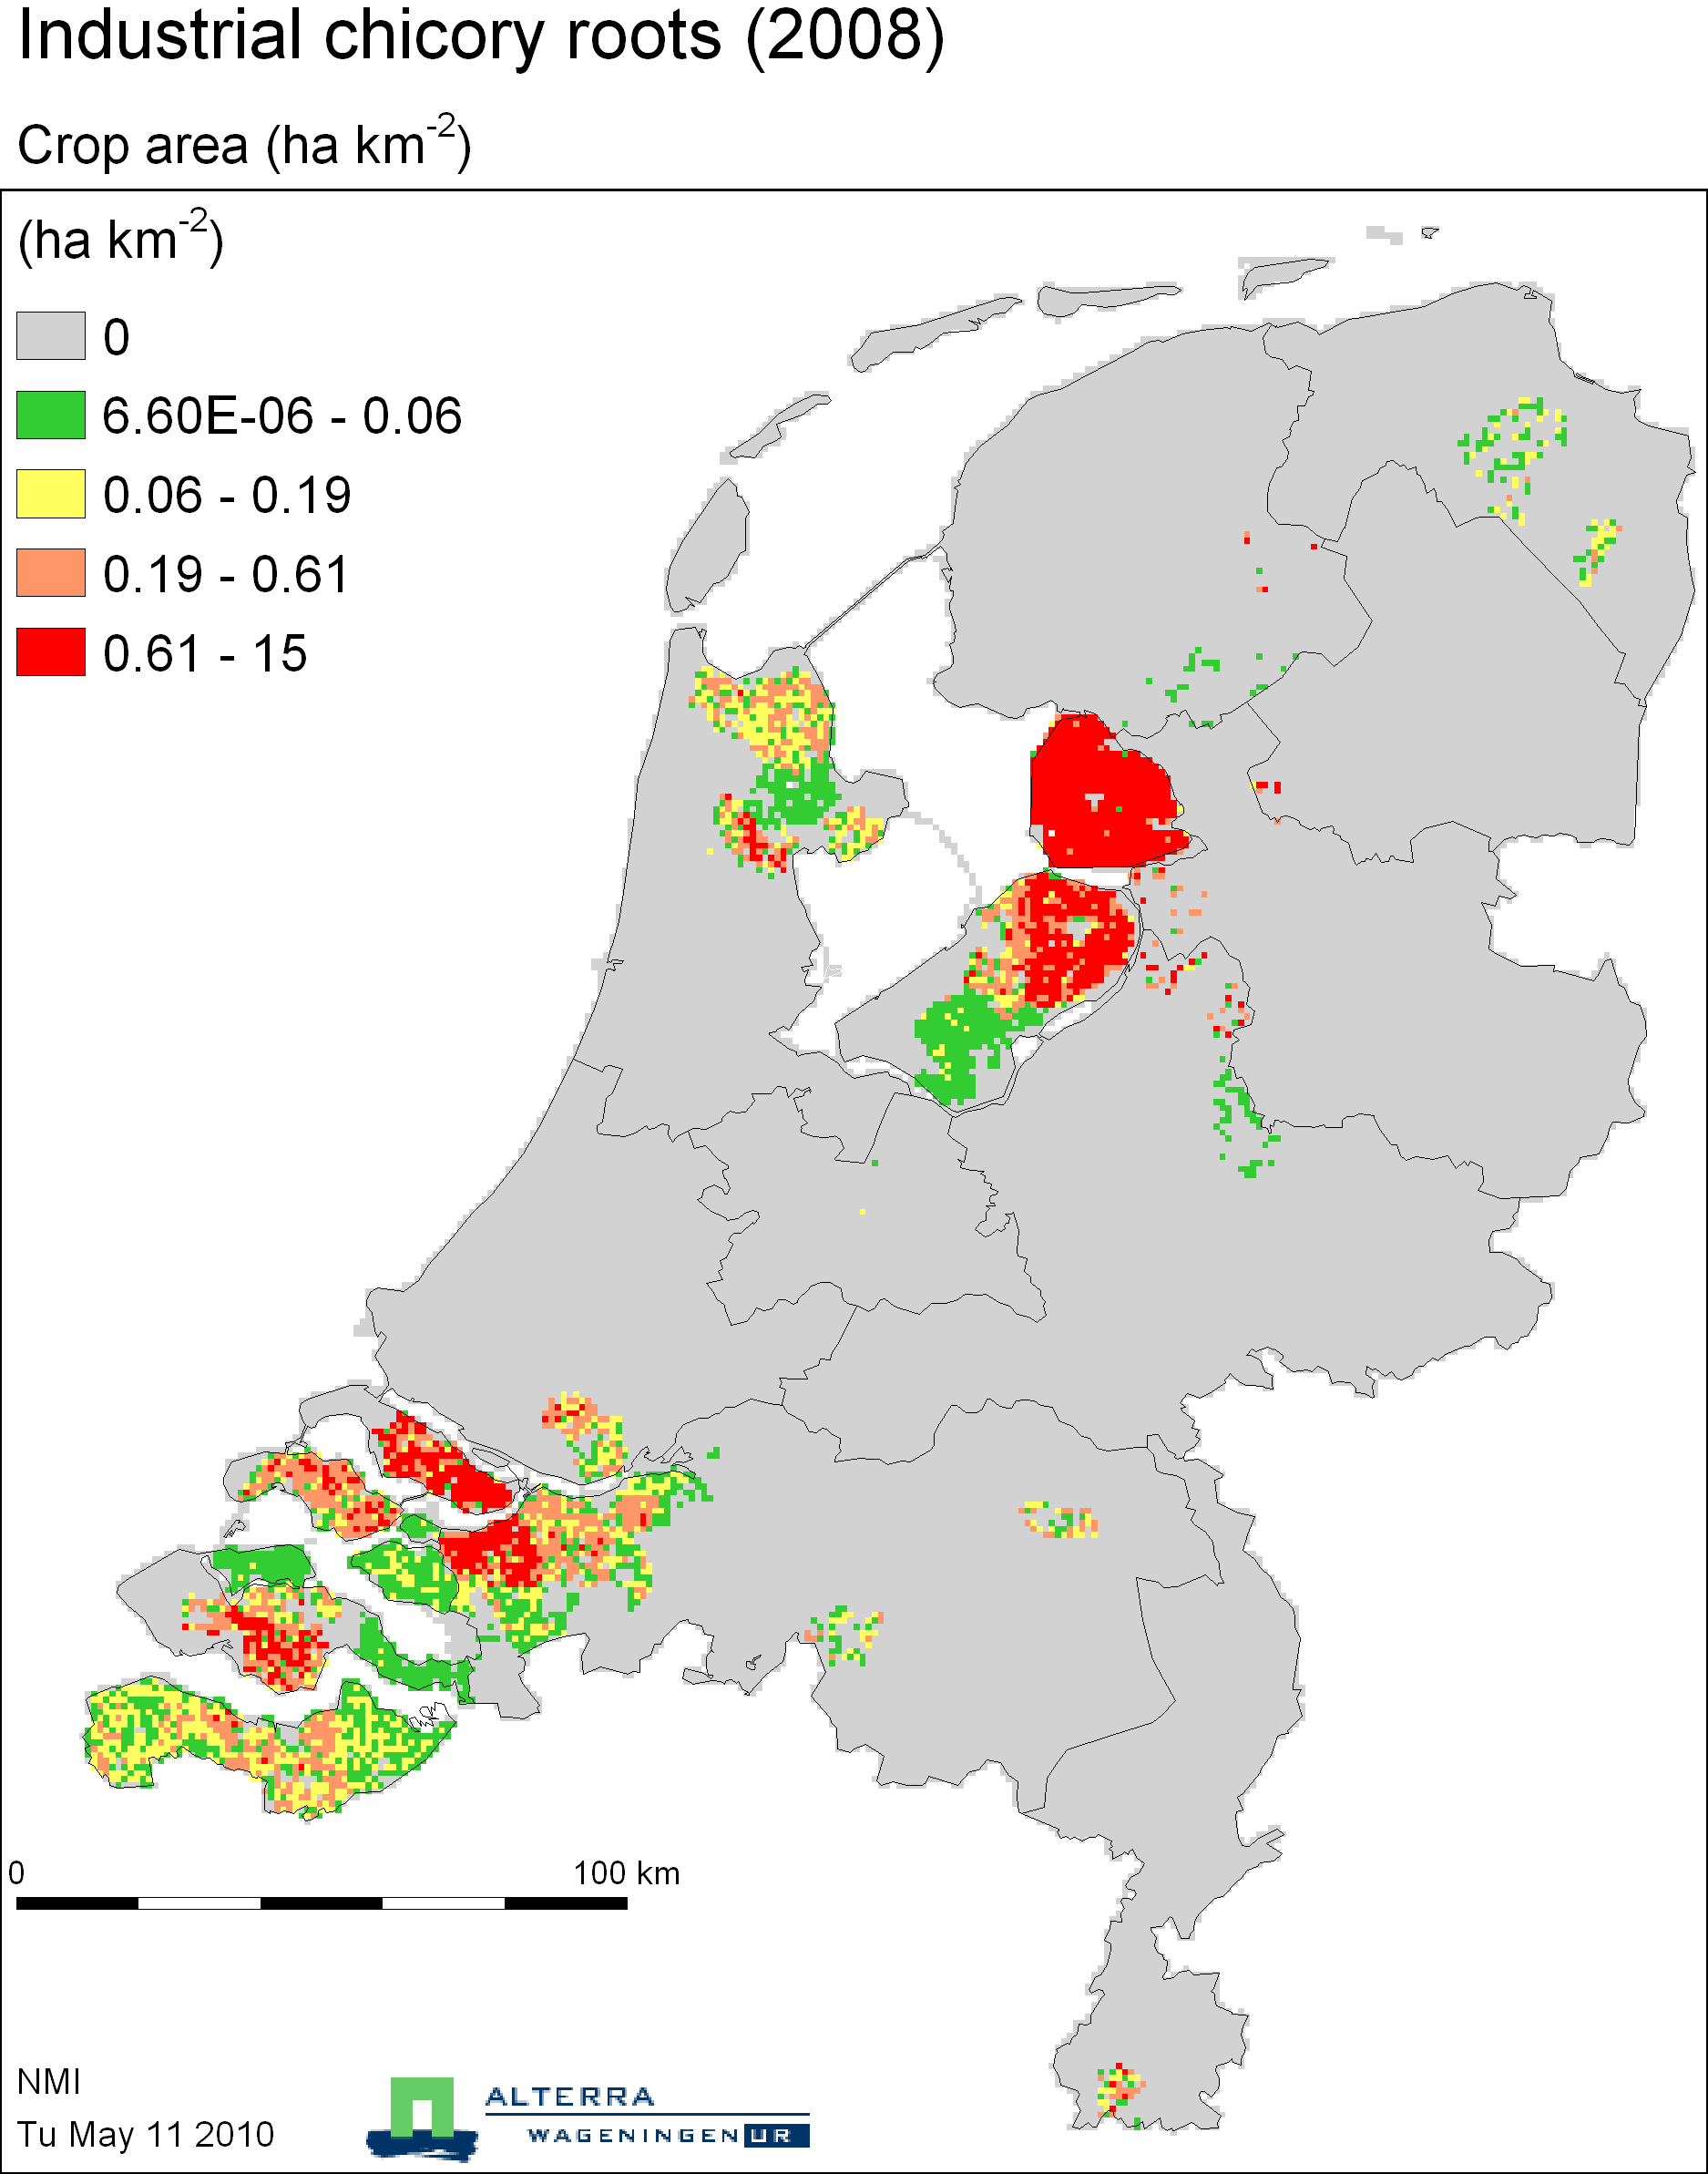

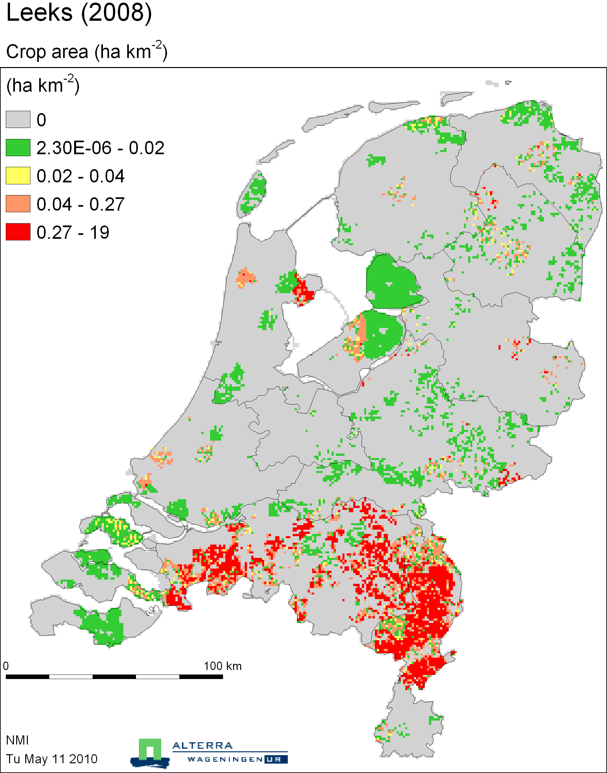

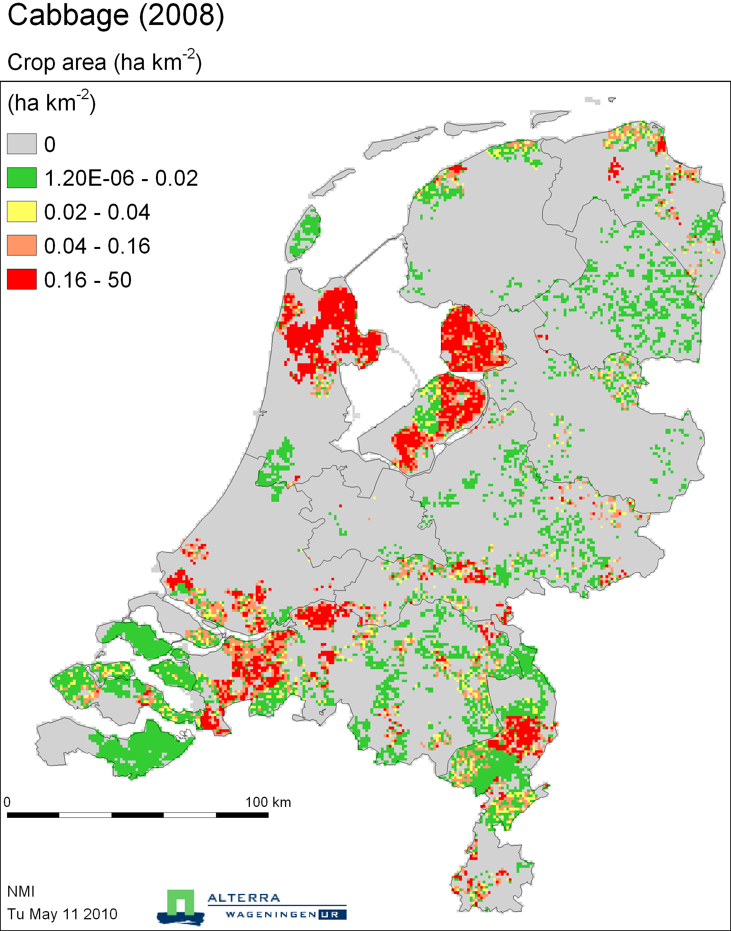

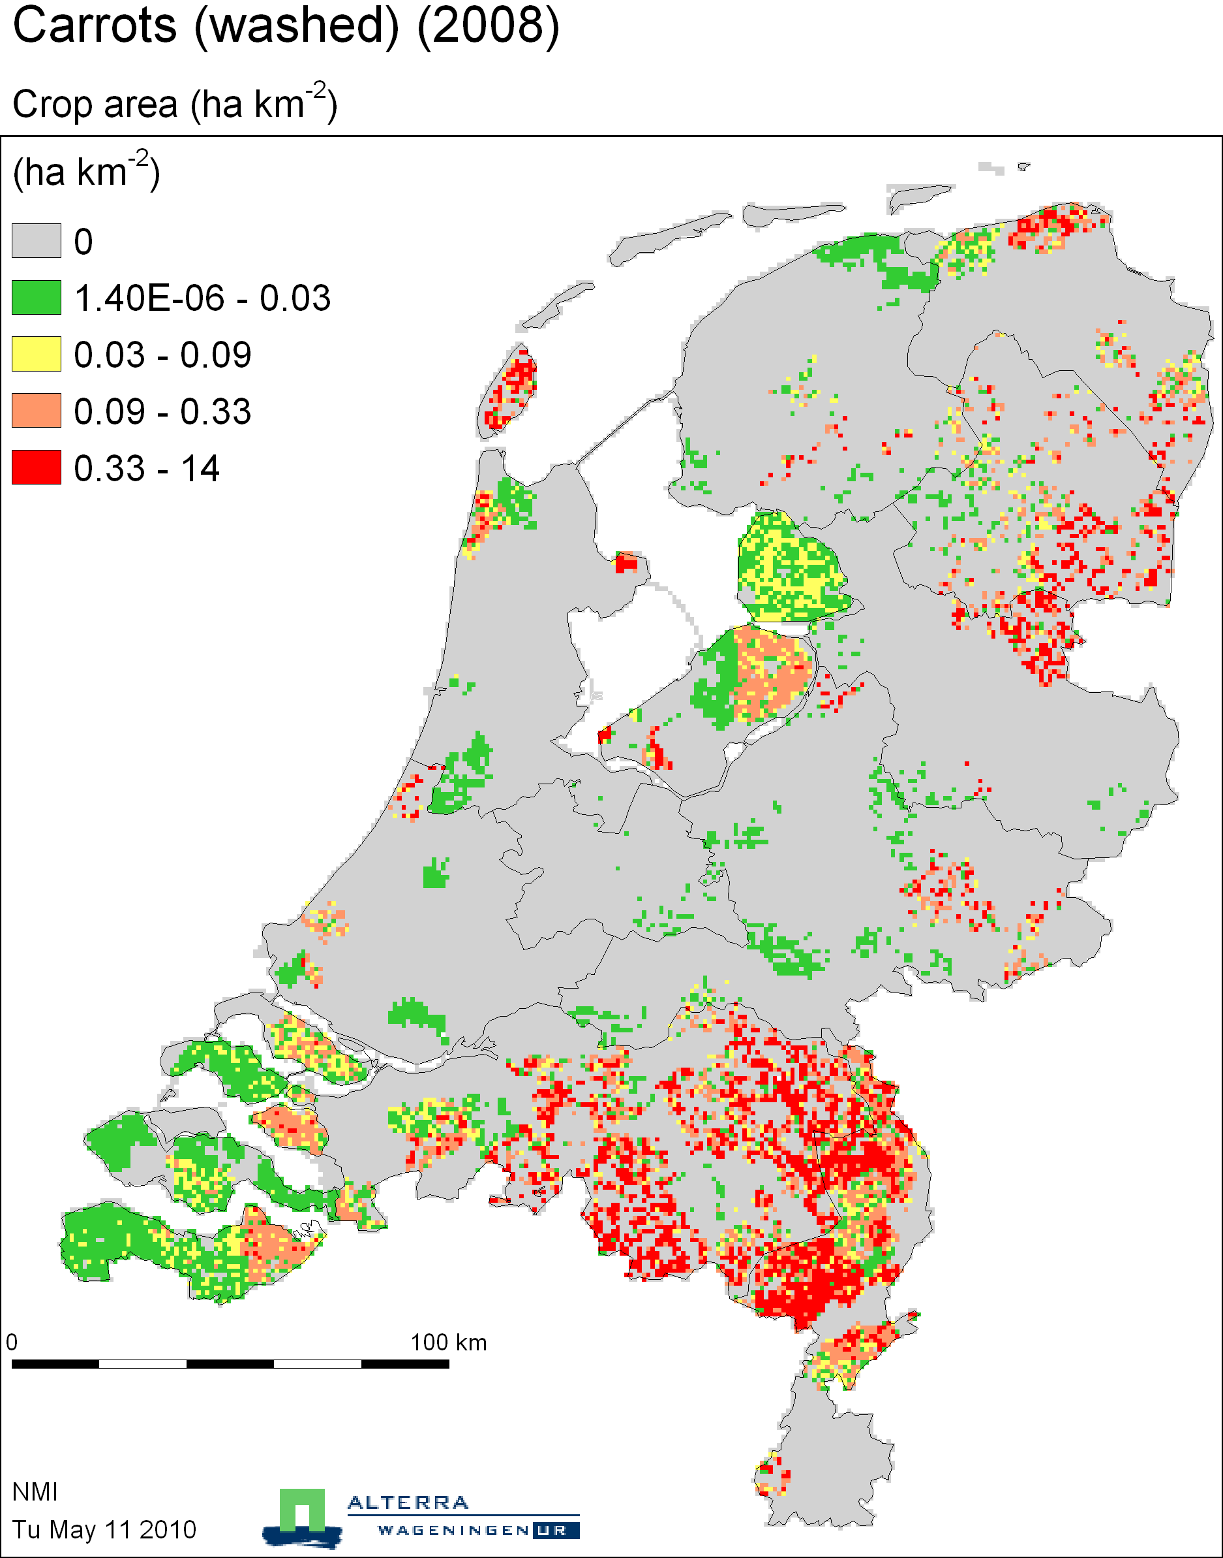

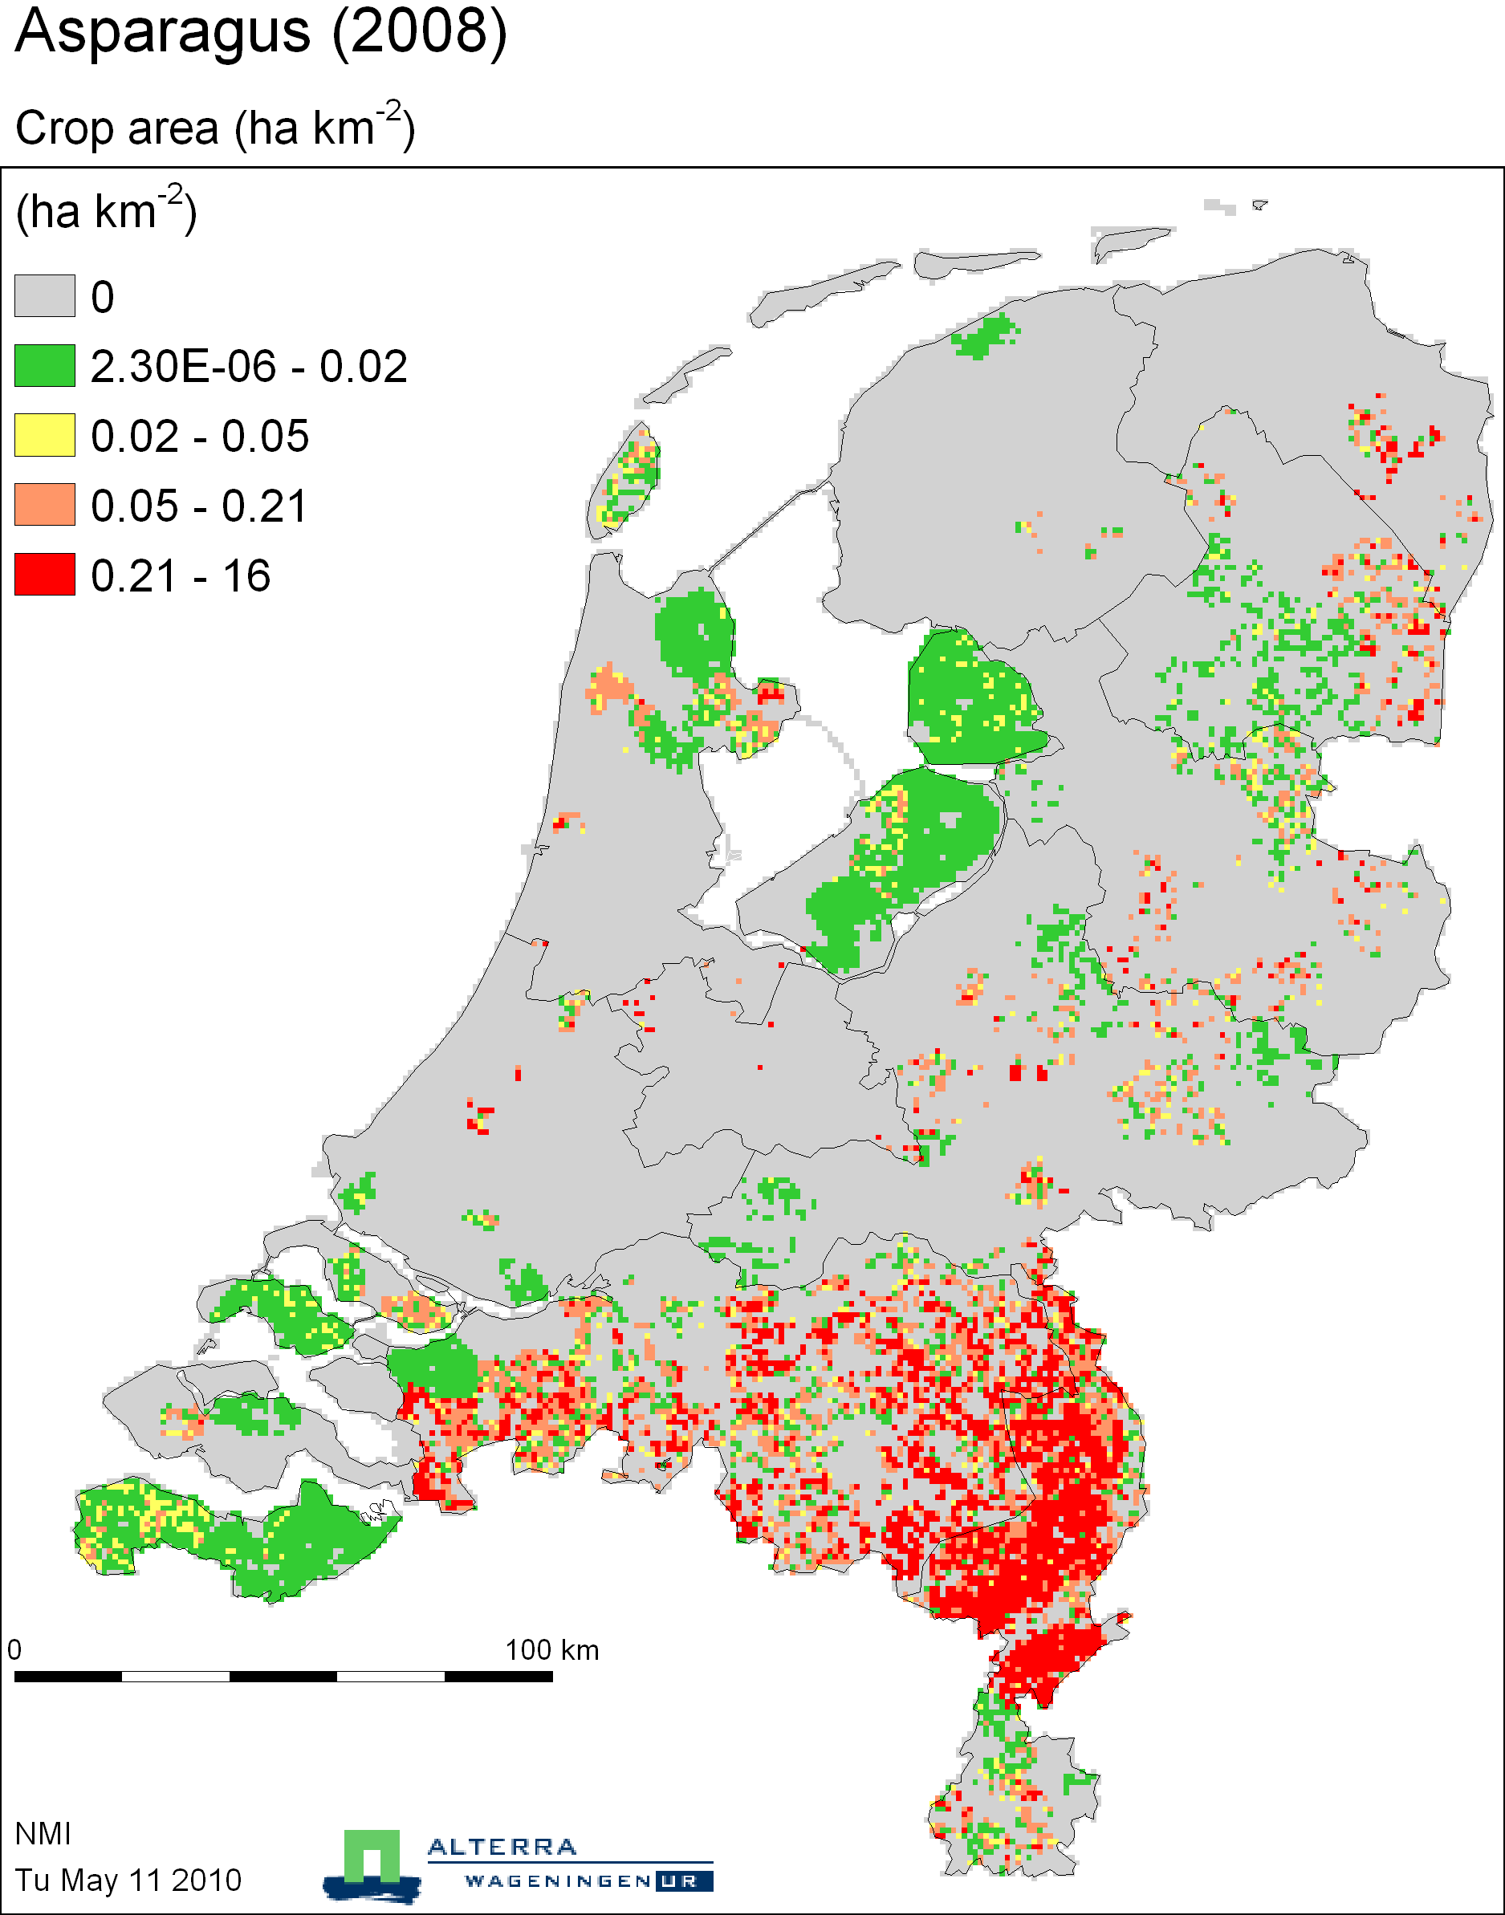

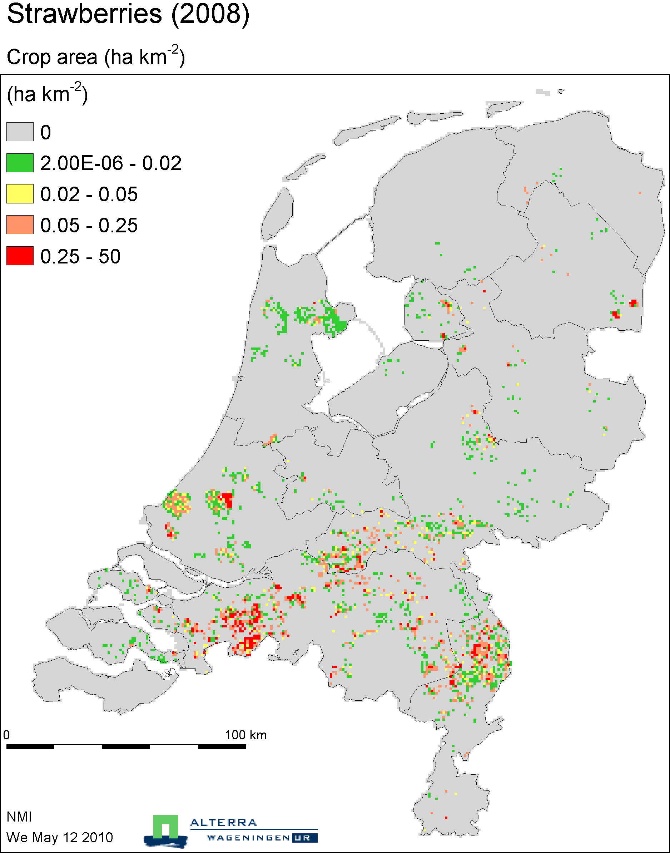

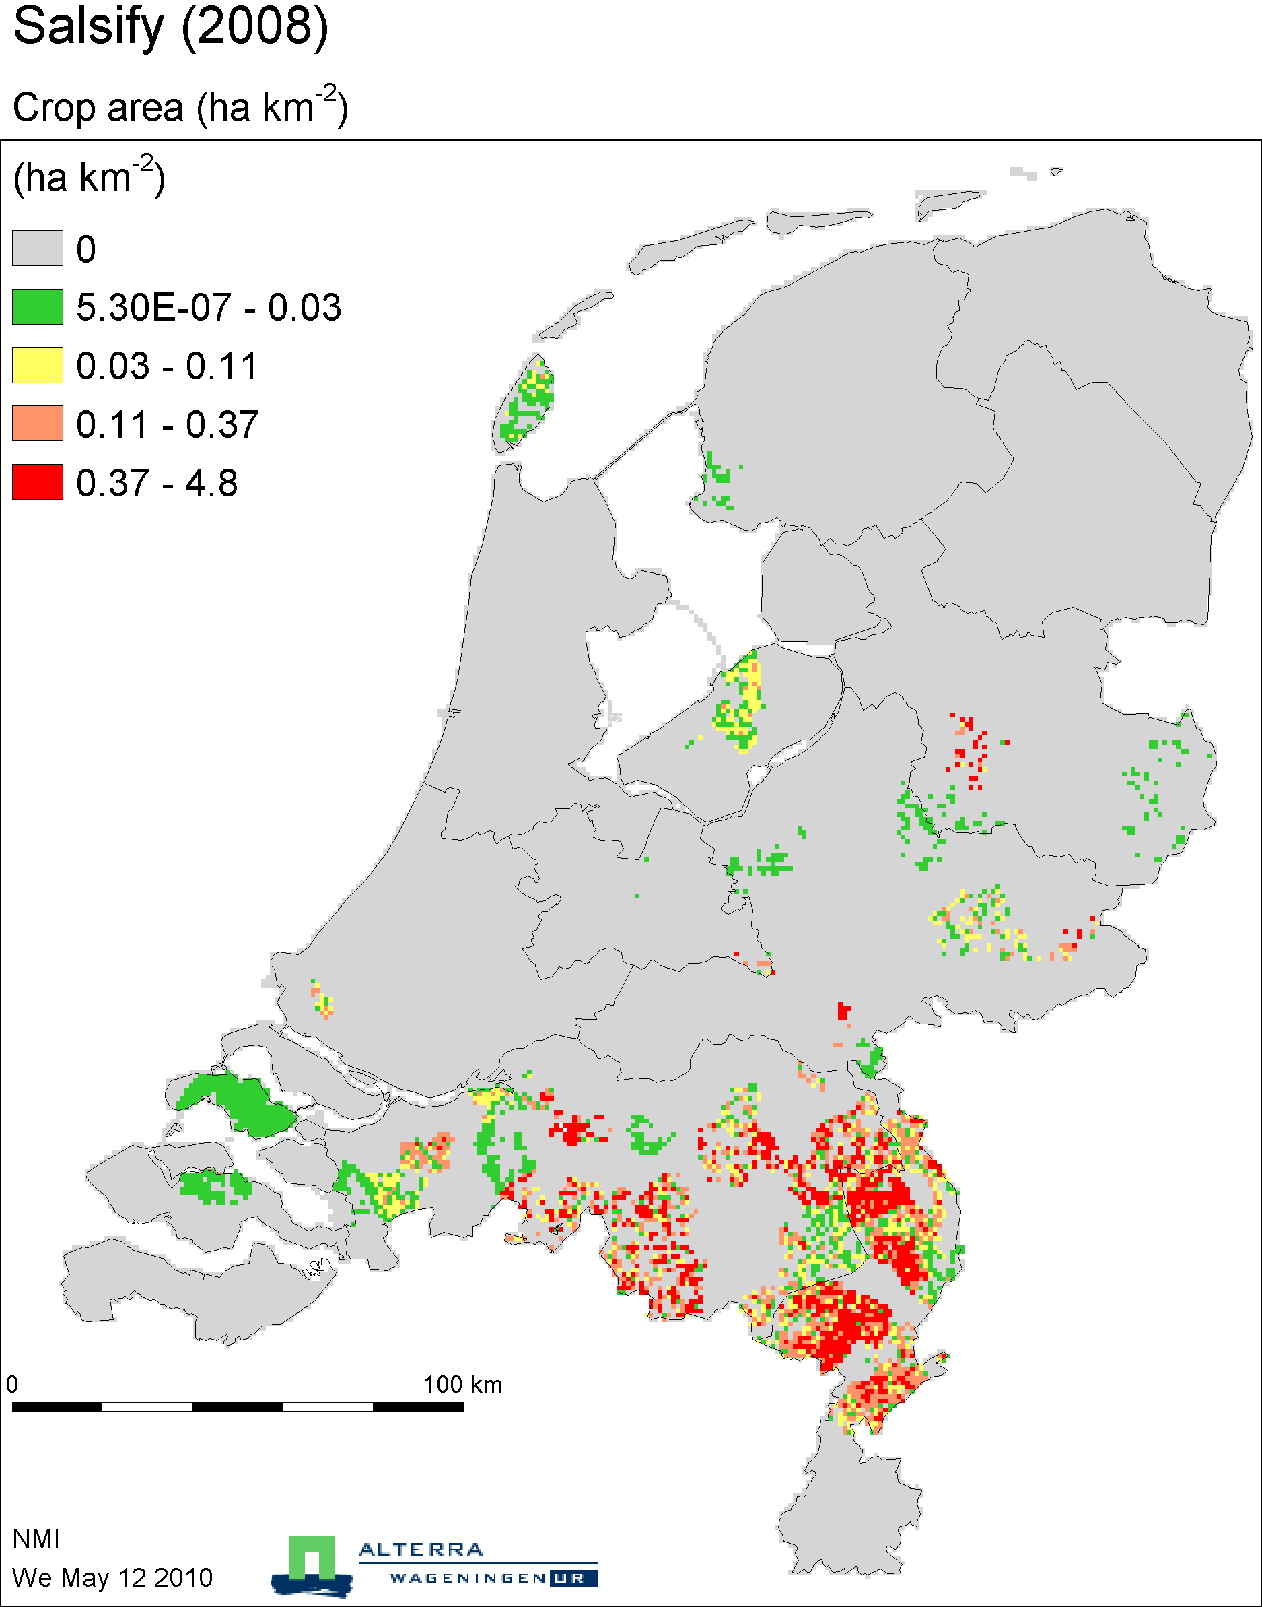

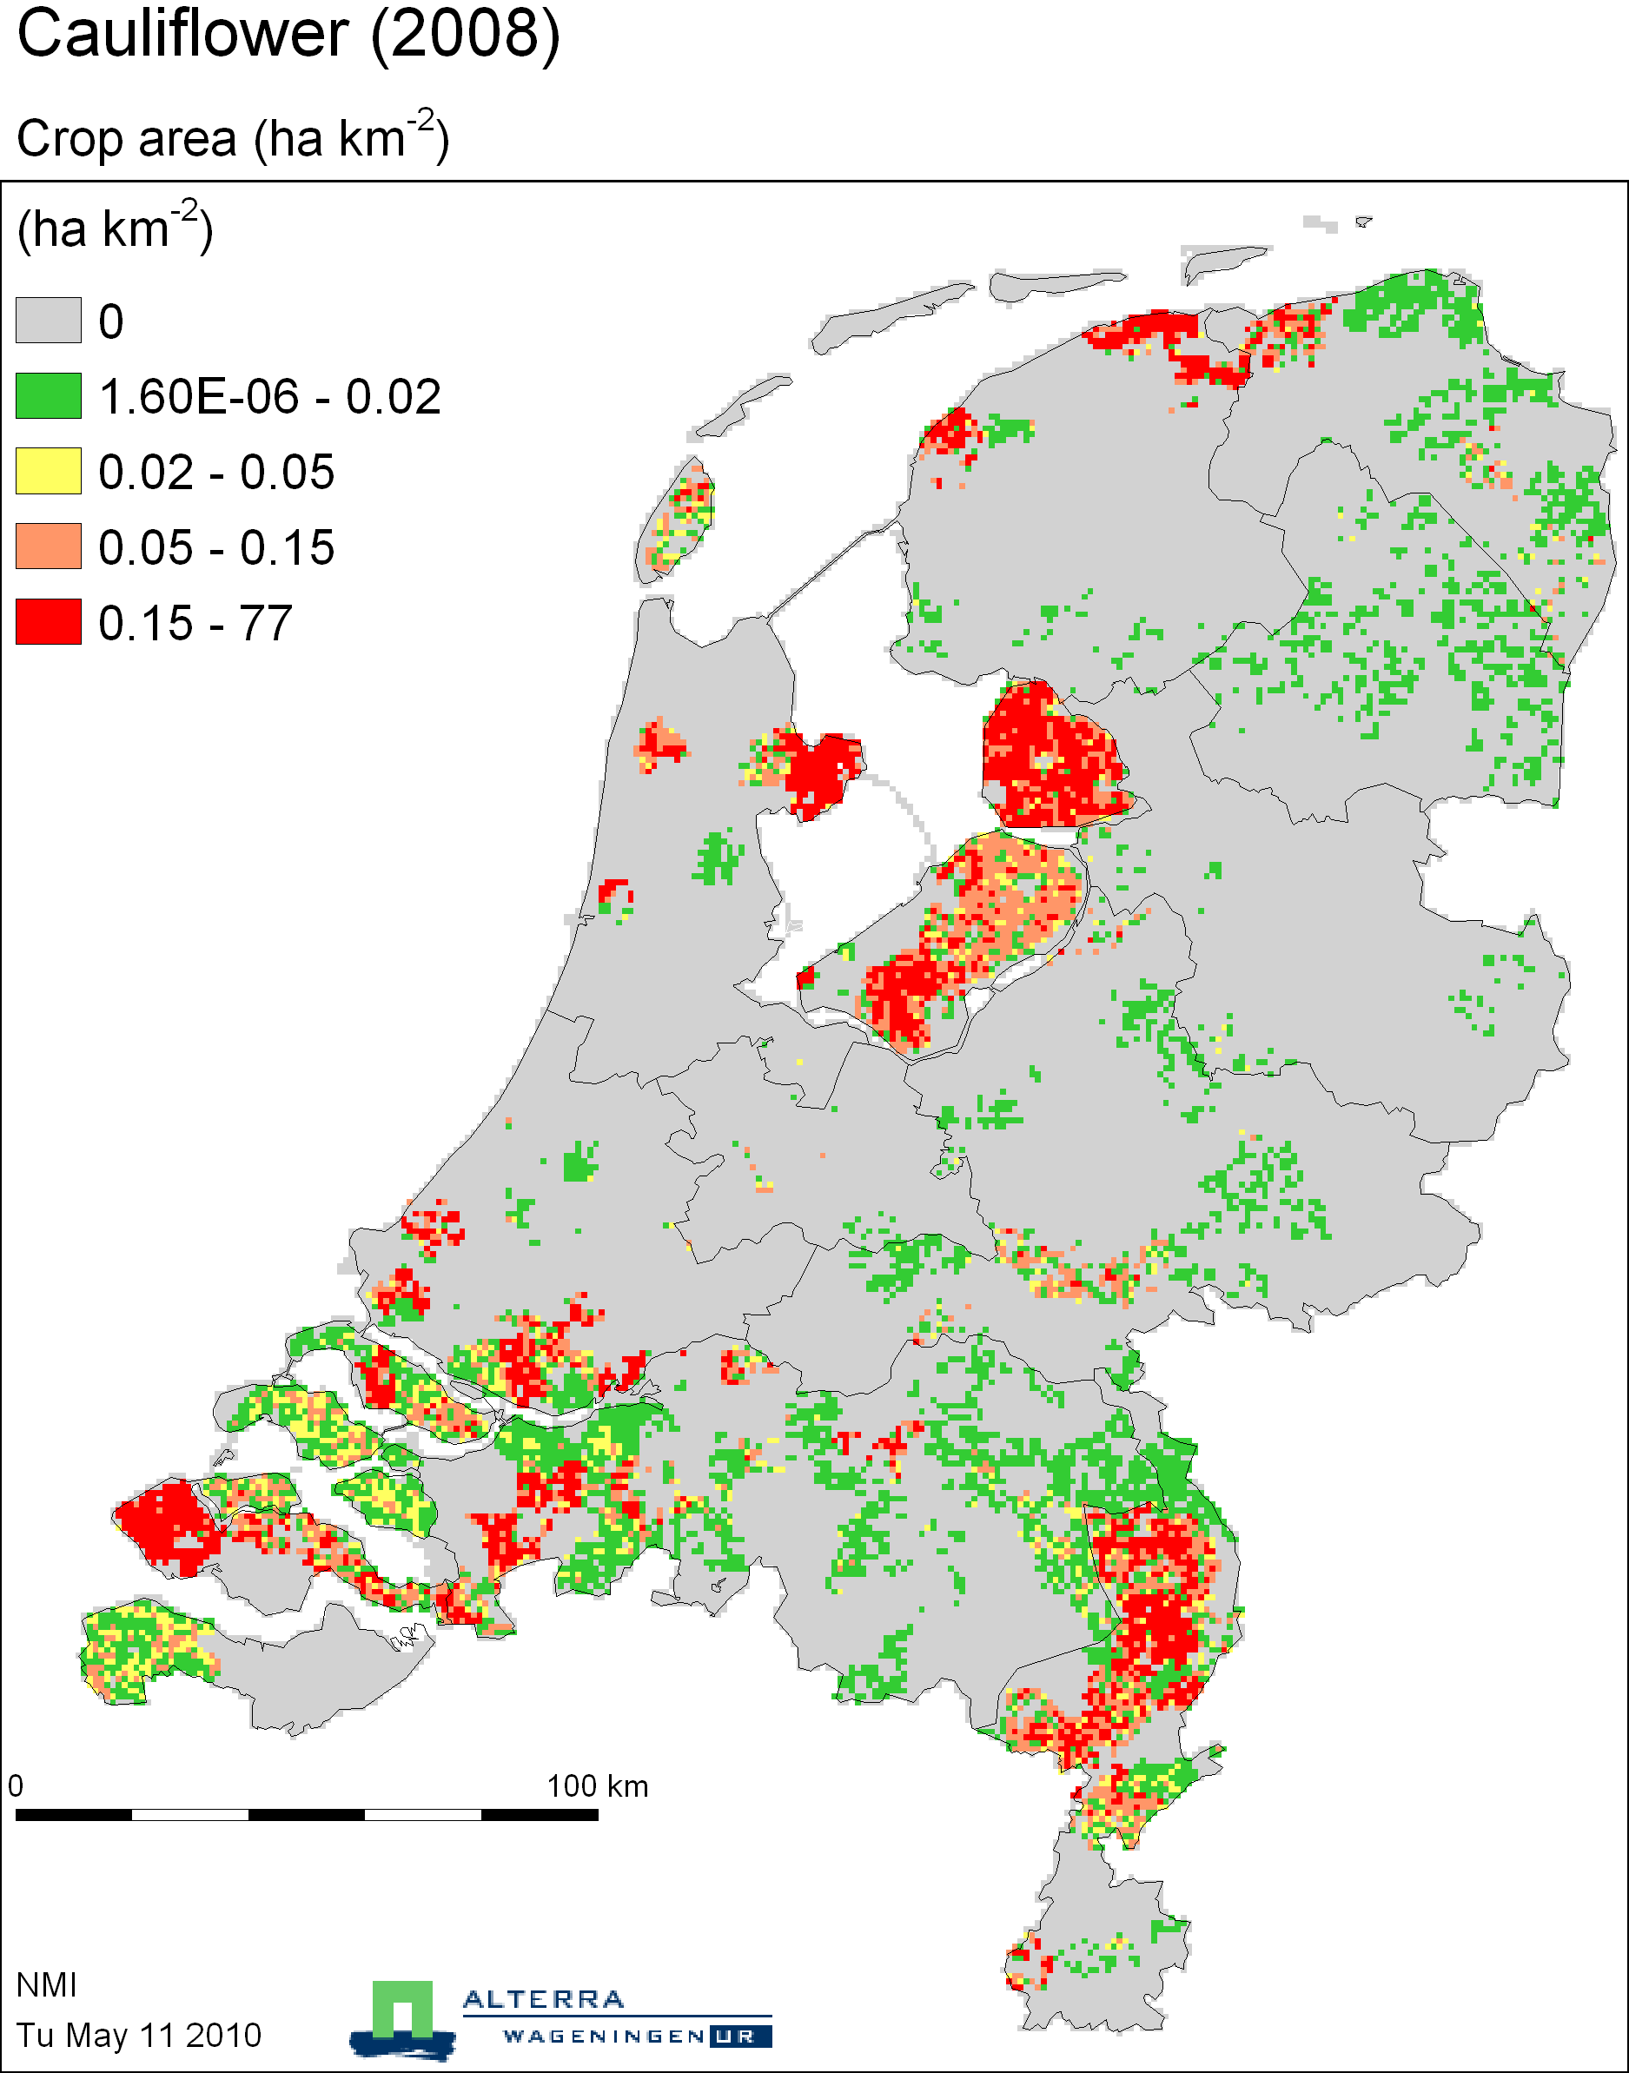

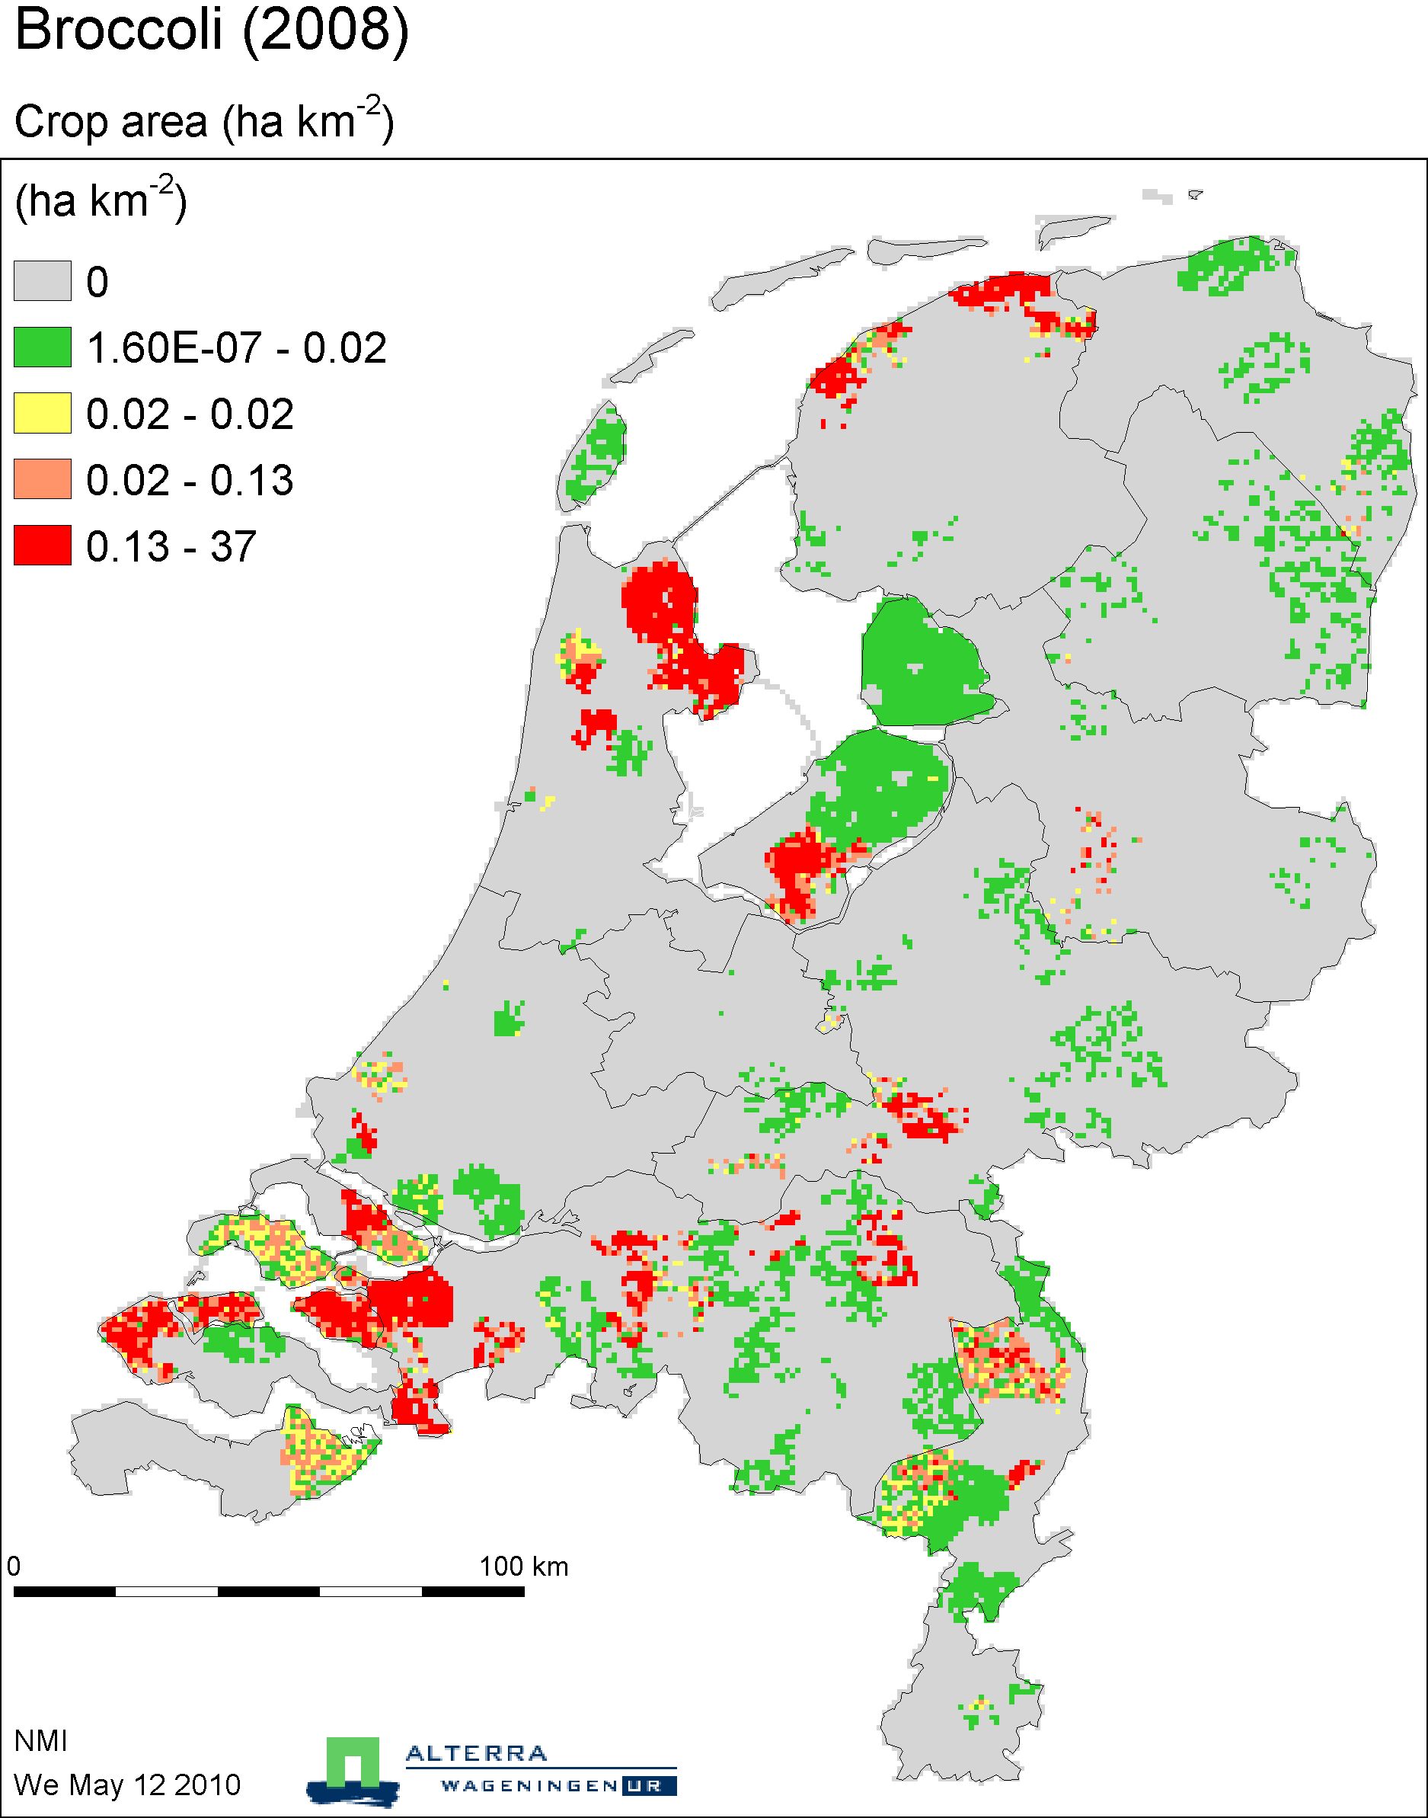

Cattle farming

